Connecting your ORCiD to Enlighten

What is an ORCiD?
Using an ORCiD (Open Researcher and Contributor ID) identifier allows you to be uniquely identified and connected with your research activities. Your ORCiD will follow you throughout your career and can be linked to your outputs, research funding and other research-related activities.
ORCiDs can also work with other identifiers such as ResearcherID and Scopus ID.
ORCiDs are extremely useful: when properly managed your ORCiD provides a single reference point for your research portfolio. This will save you time when applying for grants, reporting to funders, and showcasing your track record, for example.
Researchers at the University of Glasgow are strongly recommended to register for an ORCiD. It is also increasingly required by funders and publishers. It is likely that having an ORCiD will be required for future REF exercises.

Connecting your ORCiD to Enlighten

Step 1: Login to Enlighten
Head to Enlighten: Publications. Once there, click My Publications > Login. Login with your GUID and password.

Step 2: Create an ORCiD (skip to step 3 if you already have an ORCiD)
Once logged in, click the Manage ORCID button on your Enlighten Homepage.
Click ‘Create or Connect your ORCID iD’ then Register now. Once you have registered, proceed to step 3.
When you have created your ORCiD via Enlighten an ORCiD badge is displayed next to your name in any publications within Enlighten. For research and teaching staff your ORCiD will also be displayed on your University staff profile page.

Step 3: Connect your ORCiD iD to Enlighten
Under My Publications, click ‘Manage ORCID Permissions’. Click ‘Create or Connect your ORCID iD at the foot of the page’. Log in to your ORCiD account and allow the University of Glasgow permission to read and publish to your ORCiD account.
Once complete you should be redirected to Enlighten and be greeted with the message ‘Permissions successfully updated for user: [your name]’.

Step 4: Manage ORCiD permissions
You can manage how ORCiD connects with Enlighten using the ‘Manage ORCID permissions’ button under My Publications. We recommend that at a minimum you tick the box ‘Create and update activities on your ORCID record’; this means that any information on Enlighten Publications can be synchronised to your ORCiD profile.

Importing from ORCiD to Enlighten
This step is only applicable if you have publications in your ORCiD account and is most useful for people joining the University of Glasgow.
Once you have connected your ORCiD with Enlighten, click My Publications > Manage Deposits.
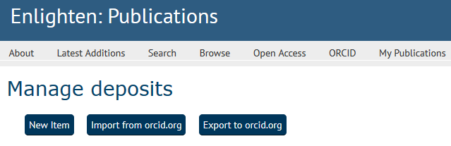
Select Import from orcid.org. You will be presented with a list of publications on your ORCiD profile that you can now import into Enlighten. Tick the items you wish to import and click ‘Import’.
Staff with records already in Enlighten will be notified where a duplicate record has been found. These are highlighted in red and cannot be imported to Enlighten.
Records imported to Enlighten are checked by the Enlighten team. Records will appear on your Enlighten and staff profiles between 1-3 working days.

Exporting from Enlighten to ORCiD
Once you have connected your ORCiD with Enlighten, click My Publications > Manage Deposits.
Select Export to orcid.org. You will be presented with a list of publications on your Enlighten profile that you can now export into ORCiD. Tick the items you wish to export and click ‘Export’.

Beyond Enlighten
Any new publications added to Enlighten will now be added to your ORCiD account, but why stop there?
Why not connect your ORCiD to Researchfish so that your publications are automatically added to your personal portfolio in Researchfish, or display your grants on your ORCiD profile using UberWizard.

