Library
Knowledge Base

Eikon and Datastream Access

Table of Contents
Access to Datastream & Eikon via Citrix Storefront 3
Accessing Eikon and Datastream via the Virtual Desktop 4
Accessing Eikon Datastream through Excel 5
Saving data on Datastream OR Eikon in Excel 6
Logging out of Datastream or Eikon for Excel 7
Accessing Eikon Desktop 7
Sign out 8

Access to Datastream & Eikon via Citrix Storefront
Access to the Thompson Reuters databases Datastream and Eikon is now available via a Citrix Storefront via your web browser. Go to the University Citrix Storefront on https://storefront.gla.ac.uk/Citrix/EikonWeb/
In the User name box enter campus\ your GUID & your password in the password box and click on Log On

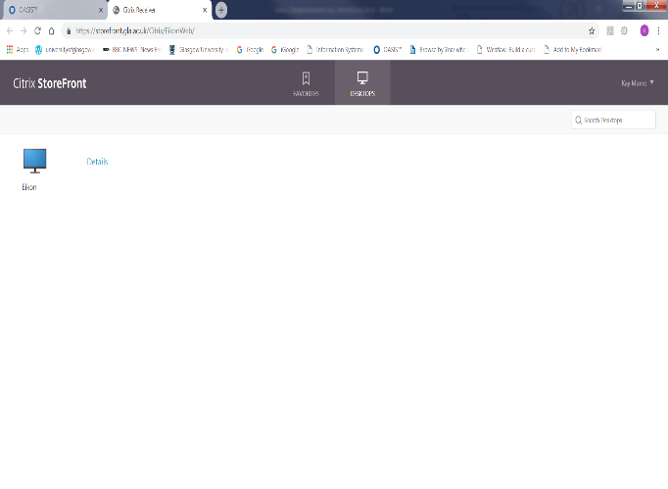
This will open the Citrix Storefront with Eikon.
Click on Eikon and the system may present you with a configuration file (seen at foot of screen) which you must click on to continue.
Normally the Eikon Desktop just opens and logs you in.

Accessing Eikon and Datastream via the Virtual Desktop
The virtual desktop will then appear – click on the Eikon Excel Datastream icon to access Datastream or Eikon via Excel and the Eikon Desktop icon to access Eikon web desktop.

If this Security Warning message appears, click on Open to continue to Eikon Datastream. The system will now try to connect you to Eikon & Datastream databases

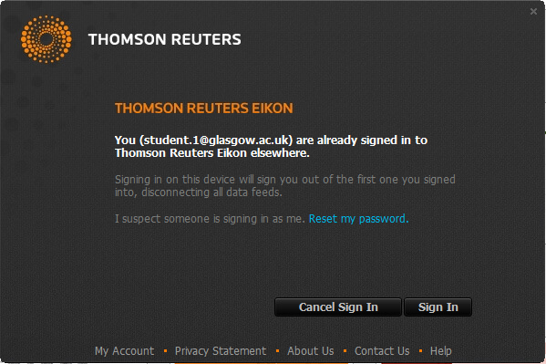

If, the following screen is displayed stating that the ID is already signed in elsewhere, ignore and click on the Sign In to continue to Eikon & Datastream.

Accessing Eikon Datastream through Excel
To access Eikon Datastream through Excel, click on the Eikon Excel Datastream icon on the virtual desktop. Once you have successfully launched Eikon Datastream – you will be presented with the following Excel options – click on Blank workbook to proceed to Excel for Eikon Datastream.
Please note that at this point you should also log in to Microsoft Excel with your University Email address and Password if you want to save any work to your OneDrive filestore. This is the only way to save data from the system.

When you click on Blank workbook Excel will open and you will see two options for accessing Eikon Datastream databases in the Excel Menu Bar. To access Datastream click on Thomson Reuters Datastream tab.

To access Eikon, click on the Thomson Reuters tab (rather than Thomson Reuters Datastream) link on the toolbar at the head of the Excel Screen.

Click on the Home button to access the Eikon desktop which will allow you to explore Eikon data further and view rich asset-specific content, news, research, estimates, prices, and more.
For more information on using Eikon & Datastream on Excel see guide TR Eikon for Microsoft Excel: https://financial.thomsonreuters.com/content/dam/openweb/documents/pdf/financial/eikon-microsoft-office-add-in.pdf

Saving data on Datastream OR Eikon in Excel
To save your work click on File Save As and double click on OneDrive – University of Glasgow.
Please note that you should always log in to Microsoft Excel with your University Email address and Password when you first login to Datastream or Eikon in Excel if you want to save any work to your OneDrive filestore.

Logging out of Datastream or Eikon for Excel
Once you have finished using Eikon or Datastream you MUST sign out of Excel. Click on your name at the top right of the screen, choose Switch Accounts and the click Sign Out and then Sign Out when it appears next to your name.

Accessing Eikon Desktop

If you would prefer to access the Eikon desktop directly, without Excel, you should choose the Eikon Desktop Icon from the virtual desktop. This will allow you to explore Eikon data further and view rich asset-specific content, news, research, estimates, prices, and more. Once you have been successfully connected, the Eikon Search box will appear at the top of virtual desktop – you can search by company, indices etc.
Click on the screen maximise option at the top of the screen for full screen view.

Sign out
When you sign out of Eikon or Datastream on Excel or out of Eikon Desktop, you are automatically returned to the Virtual Desk – to sign out, click on the Logon Icon.

