Information and Literature Searching for MPhil/PhD Students

About

Introduction

Nazlin Bhimani, the tutor, introduces the 'InfoLit' course:

In my role as Research Support and Special Collections Librarian I deliver the intensive “Information and Literature Searching” module for the Centre for Doctoral Education (CDE) at the UCL Institute of Education. The students registered with the CDE undertake research degrees leading to an MPhil/PhD, an EdD, DEdPsy or an MRES.

It is recommended that students take the course in their first year. The full course is offered for three hours/week over a four-week period onsite and as a six-week online module. Students on the EdD and DPsych programmes get some elements of this course on their programmes.

Students are expected practice what is taught in-between sessions so that they can share their experiences with others in class. They are also expected to read articles on the research process and the literature review.

The course is underpinned by the findings from various user behaviour studies, including the User Behaviour in Resource Discovery (2010), the Researchers of Tomorrow (2012), a three-year study involving doctoral students which looked at their research behaviour, and the Digital Literacies as a Postgraduate Attribute study (2013). Concerns raised in the studies are addressed in the course content. Specifically, the learning outcomes ensure that students do not rely heavily on secondary research resources but investigate historical materials, including datasets; students become conversant with physical and digital access to resources including the importance of widening their searches to include content from other libraries; students learn to develop strategies for evaluating information including understanding how information is curated, how it can be appraised for relevance, bias, authenticity and currency and how intellectual property rights, including copyright can affect their use of information. In addition, students learn how to make full use of emerging technologies including social media, to manage information and time and establish their digital identities. These skills, commonly referred to as ‘Information literacy’ skills, include ‘digital literacy’ skills which are required for further research in the workplace and for lifelong learning.

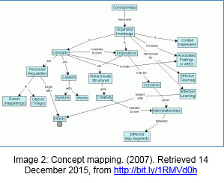
Centrality of the Literature Review
The first session is spent finding out about the students’ research areas and their expectations of the course. After a short presentation defining the literature review and the centrality of the review in the PhD, the research process is introduced by showing how a research question can be deconstructed into key concepts and keywords. In this context, students are introduced to the work of Raymond Williams on etymological research and shown examples of how meanings of words change over time. This is the beginning of looking at the language used in research outputs critically. Students are then introduced to the concept of Boolean logic so that they may begin to think about how they can construct a search. In order to practice this, they are asked to work in groups on a sample thesis title and asked to identify the key concepts and the associated keywords. They are encouraged to use dictionaries and encyclopaedias to help them with this exercise. They are then asked to use Boolean logic to combine keywords and consider what phrases they may use and/or for a search. The exercise allows them to develop strategies for their searching and to consider the importance of constructing searchable and findable thesis titles in order for their work to be cited. Each group then presents their findings which allows for a class discussion.

For homework, students are asked to read the article by P. Beile and D. Boote (2005) on the centrality of the literature review and a critique of it by J. Maxwell (2006). The article is used because as it provides criteria for a literature review and Maxwell’s critique adds relevancy and provides an element of criticality. Students are asked find a thesis on their research area using the open access thesis repositories (EThOS and DART-European E-Theses Portal) and to evaluate the literature review in the thesis against the criteria given in the Beile and Boote article. They are also asked to use Boolean logic to break down their research question into concepts and keywords and to create mind map. These are sent to me to comment on before the next session so that I can get an understanding of their research areas in order to recommend relevant resources.

Searching & Historical Inquiry

The second workshop begins with a discussion of the two articles and how students applied the criteria suggested by Beile and Boote and Maxwell to their sample thesis. The students then present their concept maps to their peers in groups. Each map is different and this allows students to gain an understanding on how they can further develop their maps based on their group’s feedback. Students also begin to see how their maps will help them organise their literature reviews and how a more detailed version of the map can be used for the CDE poster conference held in the summer term when students explain their research to others.

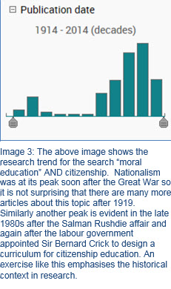
Demos enable students to see how they can use their concepts and keywords to search for literature. They practice how to formulate searches online and how to combine search terms using Boolean operators, truncation and how to search for phrases. The concept of curation is introduced through different databases. Given the hundreds of databases, different types of search engines and subject portals, it is important students understand which of these databases are most relevant and also to understand their search results. Emphasis is placed on investing time at an early stage to learn about the scope, coverage and bias of each database so that they can see better understand the results.

Finally, students learn to evaluate search results as they consider author expertise, evidence used, journal bias, funder bias, audience, currency and relevancy. The ‘importance of reading into the results’ and seeing research trends is emphasised as is the importance of having enough background knowledge, including social and political context, to do this – see image 3. They learn that the research process is iterative and background reading will generate further questions that they will need to research again. Students also find out about different types of resources e.g. grey literature, conference and working papers, reports, peer-reviewed journal articles, open access content etc. For homework, students are asked to review an article using criteria introduced in class and are asked to read Freathy and Parker’s 2010 article on the necessity of historical inquiry in educational research.

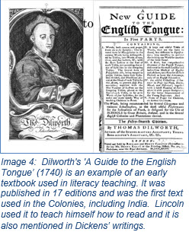
In the second half of the session, students asked to share their evaluation of an article in groups. We then discuss Freathy and Parker’s article and its relevance to educational research. Generally the conclusion reached is that grounding educational research in historiographical literature enables the utilisation of a wider range of original primary sources. It also raises additional questions that cultivate an appreciation of complexity of a multidisciplinary subject and more specifically, the cyclical nature of educational policy. Bearing this in mind, we continue to look at more databases, particularly those related to their subject areas in the social sciences, e.g. psychology, linguistics, history, social care, law etc. and resources at other libraries and archives including Senate House and the British Library. Students are asked to consider what primary sources they will be consulting for their research and to discover ‘local’ collections and ‘grey’ literature or resources that are generated by organisations outside of academia.

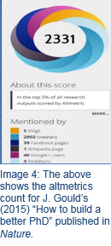
Impact: Bibliometrics & Altmetrics

In the third workshop students are introduced to the concept of impact through bibliometrics or citation measures. This takes the concept of information evaluation further and the class is encouraged to take part in discussions about citation measures for open access content, online content and the problem of measuring impact through citation counts for the different disciplines.

Students are asked compare citations counts on the Web of Science and Google Scholar to kick off this discussion. They are cautioned against downloading content automatically and encouraged to evaluate the content using impact as a measure. This helps them to focus and prioritise their time on the key readings from the outset.takes it further by looking at the alternative metrics or ‘altmetrics’ that can be used to gage impact on the social web. Students download the altmetrics ‘bookmarklet’ which allows them to get the altmetrics for the articles they have found thus far.

New Technologies
In the last session, students are introduced to RSS next so that they can learn to keep up with publications in their area. We end the session with a review of what the key concepts introduced on the course and students are asked to provide feedback. Students are also encouraged to start using bibliographic management software such as EndNote, Mendeley or Zotero.

Having look at existing data, students are then asked to consider how they would manage their own research data using a draft research data management plan (RDM). This allows them to consider both the safety and ethics of storing confidential information.

Finally, an adapted version of the Snakes and Ladders board game for social media allows group work again and enables students to discuss the benefits of using social media as researchers. Students are shown how they can use Twitter for research and engage with other PhD students via #phdchat and other social media tools, including blogs. Students are encouraged to blog so that they can use their blogs as a vehicle for reflection and so that they can write about their PhD journeys and their research areas. This allows them to establish their professional presence online. The benefits of sharing their bibliographies on platforms such as Mendeley and Zotero are also encouraged as a way into networking and perhaps later collaborating with other researchers.

