Literacy Attainment: Historical Resources

Reading Pedagogy

1. A Guide to the English Tongue
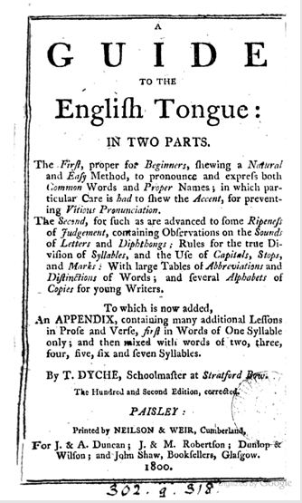
First published in 1707, this speller established the main format used to organise the first stages of learning to read in books of this type, including sub-dividing individual words into syllables. Spellers combined the introduction of vocabulary, definitions of meaning and guides to pronunciation as key elements in learning to read. The author, Thomas Dyche, dedicated the first edition to the Cripplegate Charity School and its pupils. New editions continued to be printed long after his death with the last published edition brought out in 1821. See also, Ian Michael's 1987 book The Teaching of English: from the sixteenth century to 1870.
A facsimile reprint of original ed., London : Butler, 1707 edition of the Dyche is available at the Library Special Collections.

2. The English Spelling-Book
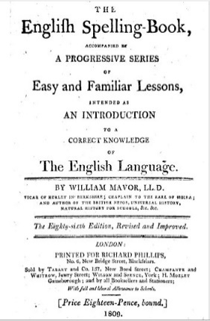
Mavor's English spelling-book was continuously re-issued during the 19th century. Like others of its kind, it acts as an all-in-one manual for learning to read, taking the user from learning the letters, through words of increasing length and complexity, to short passages to read encompassing useful information on topics such as astronomy and history. Its author, William Fordyce Mavor, had worked as a tutor and schoolmaster, and produced a range of textbooks for the emerging school market on different themes.

The Library Special Collections hold a number of editions of this book including the 446th edition published in 1840.

3. The First Book of Lessons for the Use of Schools
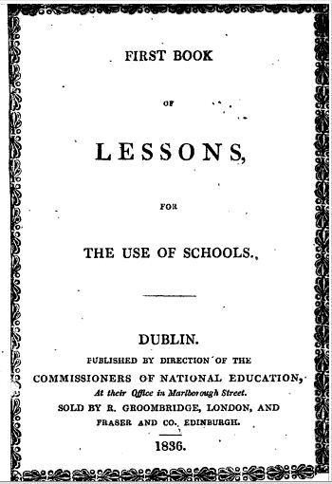
The Books of Lessons produced by the Commissioners for National Education in Ireland were the most widely used series of readers in the mid-19th century. Specially commissioned in order to avoid conflict between Protestant and Catholic communities over how reading was taught in Irish schools, passages chosen for inclusion gave "useful" advice on household and political economy, on running an allotment garden and other topics presumed to be of interest and relevance to the working poor as much as to their children. Backed by government subsidy and published at a discounted rate, the combination of price and the length of the series may well have accounted for their wide distribution. Other publishers complained that this amounted to unfair competition. See also D. Layton's 1973 book, Science for the People, for a detailed assessment of the science content of the Fifth Book of Lessons.

The Library Special Collections has the following holdings of this series:
Lessons for the use of schools. Bk. 2. Sequel no. 1 (1868)
Lessons for the use of schools. Bk. 5 (1863)
Lessons for the use of schools. Bk. 4 (1859)

4. Laurie's Graduated Series of Reading Lesson Books
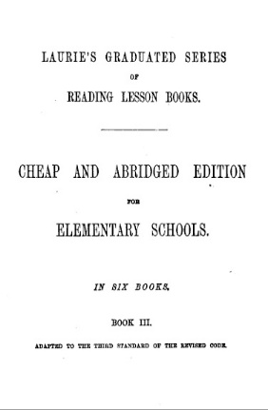
When Robert Lowe introduced the Revised Code, his intention was to ensure that all children leaving school aged ten would be able to read "a short ordinary paragraph in a newspaper or modern narrative". The Revised Code led to the production of a range of textbooks designed to help teachers achieve this objective more efficiently. This often led to a clearer articulation of the author's approach to reading pedagogy, and a more carefully constructed sequence to the way in which reading was taught. Laurie's series of reading books exemplifies this. For an account of the impact of the Revised Code on pedagogy see D. Vincent's "The Domestic and the Official Curriculum in Nineteenth Century England" in Opening the Nursery Door (1997) edited by Mary Hilton, Morag Styles and Victor Watson.

5. The Teacher's Assistant; consisting of lectures in the catechetical form
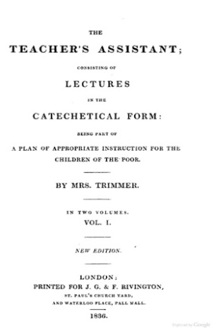
This book is one of a number produced by Mrs Trimmer to help those interested in setting up an elementary school. She offered advice on how to organise purposeful activities in class that are appropriate for the age group and skill levels of the pupils. In this case, the text is organised as a series of lessons intended to help children understand the purpose of the passages they were being asked to read. Although Mrs Trimmer was widely mocked by some of her contemporaries for her religiosity and by a later generation of educationalists for a style of rote learning that had gone out of fashion, at the time she published, the range of her texts showed a much clearer understanding of how children learn than many of her contemporaries. Many of her suggestions focused on engaging children's attention, not just lecturing them as if they were mini adults.
The Library has many of Sarah Trimmer's works, including the periodical she established, Guardian of Education which ran from 1802-1806. A full list of the holdings can be viewed on the Library Catalogue.

Mrs Sarah Trimmer

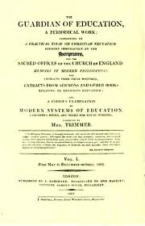
The Guardian of Education was edited by Sarah Trimmer and published from June 1802 to September 1806. The journal has advice by Mrs Trimmer on bringing up children (she was a mother of six boys and six girls herself) and was dedicated to reviewing children's literature.

The Newsam Library has many of Sarah Trimmer's works, including The Guardian of Education. A full list of the holdings can be viewed on the Library Catalogue.

