Literacy Attainment: Historical Resources

Education Policy

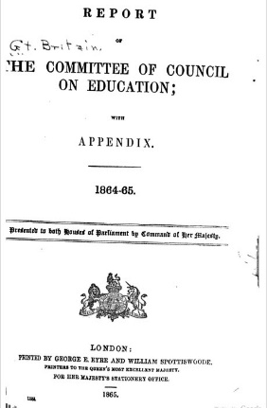
1. Minutes and Annual Reports of the Committee of Council on Education
The Committee of Council on Education was the sub-committee of the Privy Council which was set up to exercise oversight over the monies granted by parliament to the voluntary sector to support the expansion of Elementary Education. This Committee established the system of school inspection, teacher certification and the pupil teacher scheme. Much of its business was reported to parliament as minutes rather than debated. Its activities were recorded in minutes, published annually, which then became The Annual Report. Its publications can be searched online via House of Commons Parliamentary Papers (HCPP).

The Library Special Collections hold the publications of the Committee of Council on Education (1859-1900 in 45 volumes). The publication begins as Report of the Committee of Council on Education and continues as Minutes of the Committee of Council on Education. The title changes again in 1873/74 to: Report of the Committee of Council on Education (England and Wales); and until this date reports also dealt with Scotland.

2. Report of the Commissioners appointed to inquire into the State of Popular Education in England
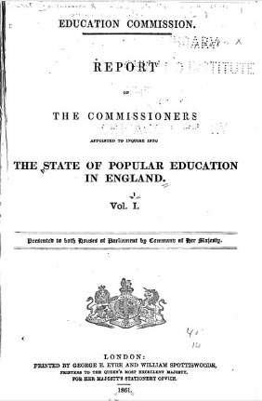
Known as the Newcastle Commission, this parliamentary inquiry was set up following successive defeats in parliament for proposals to establish a national system of education. Six Commissioners investigated the spread of education under the voluntary system with a particular emphasis on "the neglected regions", those areas where voluntary effort had not led to the founding of sufficient schools to serve the needs of the local population. The Commission also conducted a survey of opinions on the value of education and its sufficiency amongst local dignitaries. The Report highlighted the need to provide working class children with a solid grasp of reading and writing by the age of ten, arguing current practice was weak. They recommended using local taxation to fund schools on a payment by results basis. This proposal was not adopted. (See also Speech on National Education by John Russell).

3. Report from the Select Committee on Education, 1865
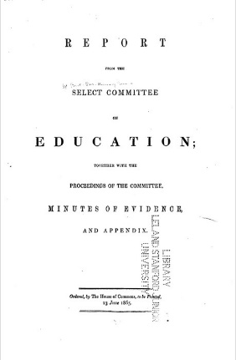
Known as the Pakington Inquiry, this Select Committee was convened under the chairmanship of Sir John Pakington, a Tory MP and campaigner for a national system of education. The Inquiry examined "the constitution of the Committee of Council on Education and the system under which the business of the Office is conducted", including the administration of grants to schools. Amongst others, the Inquiry took evidence from present and former members of the Committee of Council on Education, including Lord Granville and Robert Lowe, who were respectively President and Vice-President of the Committee during the introduction of the policy of "Payment by Results". The Committee also took evidence from Ralph Lingen, Kay Shuttleworth's successor as the Secretary of the Education Office. The evidence reveals the difficulties in administering education under the then system, and gives some insights into the priorities of those most closely involved in the task.

4. Letter to a Country Gentleman on the Education of the Lower Orders (1808)
Published in 1808 by John Weyland (1774-1854), the book mounts an economic argument against state involvement in the supply of education for those too poor to afford to pay for it themselves. The unwillingness to pay was a key element in parliamentary opposition to publicly funding a national education system in the first half of the 19th century. This book was written in response to Samuel Whitbread's unsuccessful attempt to introduce legislation to establish a system of parochial schools in England that would duplicate the system already in place in Scotland. The book was extensively reviewed in contemporary periodicals. Together they encapsulate the range of arguments over education which were voiced at the time and help explain the discursive context that slowed the introduction of a national system of education into England and Wales and maintained the voluntary sector as a key co-funder. Its author, John Weyland, was a barrister and magistrate who briefly became MP for Hindon (1830-32) and in 1811 founded the British Review, and London Critical Journal.

See also, T. Laqueur (1976) Religion and respectability: Sunday schools and working class culture 1780-1850.

