Vertebrate Palaeontology and Evolution study pack

This resource is designed to familiarise you with the structure, diversity and evolutionary history of vertebrates through analysing images of specimens held at UCL’s Grant Museum of Zoology. It contains seven chapters: an introduction to vertebrate diversity, Fishes, the fish-tetrapod transition, Amphibians and Amniotes, Lepidosaurs and Chelonians, Archosaurs, and Birds and flight. All images have accompanying text, including information about the specimen plus hints about what to look for and the questions to consider when analysing the images. Please note that this resource does not look at mammals in detail – instead, this fascinating group are given a more thorough treatment in another Object Based Learning for Higher Education (OBL4HE) resource entitled ‘Vertebrate Diversity’ and the Virtual Educational Resource for the Biosciences (VERB) resource ‘Eutherians’.

- Verb Diversity: https://open-education-repository.ucl.ac.uk/id/eprint/204
- Eutherians (VERB): https://open-education-repository.ucl.ac.uk/id/eprint/210

Scalebars are provided throughout (except for models). Please note that there are two different scale bars used, one with 1cm divisions and one with 0.5cm divisions.

Multiple images of specimens are provided to try to illustrate the various anatomical features. However, please note that the limitations of photography (especially for specimens in cases or bottles) means that some distortion may occur or parts may be concealed or generally hard to determine.

To download this resource in its entirety, see the resource's collection page: https://open-education-repository.ucl.ac.uk/195/

Disclaimer: 'Vertebrate Palaeontology and Evolution' was originally designed by UCL staff as an internal teaching resource. The subsequent release of 'Vertebrate Palaeontology and Evolution' as an OER means that any changes to the product received relative to the original content may not reflect the desires of UCL teaching staff, or the original quality of the resource.

CC BY-NC-SA 4.0 International Licence: 'Vertebrate Palaeontology and Evolution' has been released as an open educational resource (OER) on a Creative Commons 'Attribution Non-commercial Share Alike' license. This means that once downloaded, content can be modified and improved to complement a particular course. This requires, however, that improvements are recycled back into the OER community, and full attribution is made to UCL. All content present at the time of download must be accordingly credited and, in turn, novel content must be appropriately licensed. For more information, please refer to the license deed by visiting: https://creativecommons.org/licenses/by-nc-sa/4.0/legalcode

Contents
Chapter 1: Vertebrate Structure 3
1.1 Dipturus batis 3
1.2 Lepidotes minor 5
1.3 Amia 7
1.4 Bufo 11
1.5 Chelys frimbriata (Matamata) 15
1.6 Dimetrodon 23
1.7 Varanus niloticus (a monitor lizard) 25
1.8 Crocodylus 29
1.9 Alligator mississippiensis 32
1.10 Compsognathus longiceps 34
1.11 Parrot 35
1.12 Oceanodroma leuchorrhoa (petrel) 39
1.13 Hipparion brachypus 44
1.14 Palaeotherium sp. 47
Chapter 2: Fishes 49
2.1 Pteraspis 49
2.2 Models of Pteraspis 49
2.3 Acanthodes 51
2.4 Gyrocanthus 52
2.5 Bothriolepis canadensis 53
2.6 Model of Bothriolepis 54
2.7 Cladoselache 56
2.8 Megalodon 57
2.9 Carcharodon angustidens 58
2.10 Myliobatis 59
2.11 Orodus (pavement tooth shark) 60
2.12 Rhinoptera 61
2.13 Palaeoniscus 61
2.14 Sturgeon 62
2.15 Lepidotes minor 65
2.16 Scombrocolupea 66
2.17 Clupea 66
2.18 Other taxa 67
Chapter 3: The fish-tetrapod transition 68
3.1 Coelocanth 68
3.2 Dipterus 69
3.3 Dipnoi 69
3.4 Rhizodus 70
3.5 Osteolepis 71
3.6 Eusthenopteron 72
3.7 Megalocephalus 74
3.8 Trematosaurus sp. 75
3.9 Rhinesuchoides 76
3.10 Paratosaurus peabodyi (Wellesaurus) 78
3.11 Dendrerpeton pyriticum 80
3.12 Cochleosaurus sp. 80
3.13 Broilellus texensis 81
3.14 Diplocaulus sp. 83
3.15 Palaeoherpeton sp. 84
3.16 Seymouria 86
3.17 Other taxa 88
Chapter 4: Amphibians & Amniotes 89
4.1 Loxomma 89
4.2 Amphibamus grandiceps 91
4.3 Dissorophus multicinctus 92
4.4 Palaeobatrachus goldfussi 95
4.5 Cryptobranchus [The giant salamander] 96
4.6 Amphiuma neaus 98
4.7 Ichthyophis 99
4.8 Diadectes sp. 100
4.9 Labidosaurus sp. 104
4.10 Procolophon sp. 107
4.11 Hypsognathus fenneri 109
4.12 Other taxa 111
Chapter 5: Lepidosaurs and Chelonians 111
5.1 Plesiosaurus microcephalus 111
5.2 Plesiosaurus sp. 113
5.3 Sphenodon (the tuatara) 115
5.4 Homoeosaurus sp. 118
5.5 Homoeosaurus maximilliani 120
5.6 Amphisbaena sp. 121
5.7 Amphisbaena skull 123
5.8 Eunectes murina (the anaconda) 125
5.9 Cholydra serpentina (Ridley's sea turtle) 127
5.10 Eretmochelys imbricata (Hawksbill turtle) 128
5.11 Testudo hermanni (a terrestrial tortoise) 130
5.12 Other taxa 133
Chapter 6: Archosaurs 134
6.1 Hyperodapedon gordoni 134
6.2 Euparkeria 136
6.3 Sphenosaurus 136
6.4 Crocodylus 137
6.5 Tomistoma 140
6.6 Scaphognathus crassirostrus 142
6.7 Pterodactylus antiquus 143
6.8 Coelophysis sp. 144
6.9 Megalosaurus bucklandi 147
6.10 Dinosaur footprint 147
6.11 Theropod egg 149
6.12 Iguanodon sp. 150
6.13 Dinosaur skin 152
6.14 Other taxa 153
Chapter 7: Birds and flight 154
7.1 Noctule bat 154
7.2 Archaeopteryx 156
7.3 Rhea 158
7.4 Fulmaris glacialis (the Fulmar) 161
7.5 Penguin (species unknown) 165
7.6 Gallus 170
7.7 Other taxa 171
Glossary 172

Chapter 1: Vertebrate Structure

This chapter will introduce you to the structure and diversity of various vertebrates.

1.1 Dipturus batis

This belonged to a skate. Skates are found in the east Atlantic, Arctic ocean and Mediterranean. They can reach lengths of 2.4 metres. They live at depths of between 30 and 600 metres, and typically feed on fish, crabs, lobsters and octopuses. This specimen is the jaw and tooth battery.

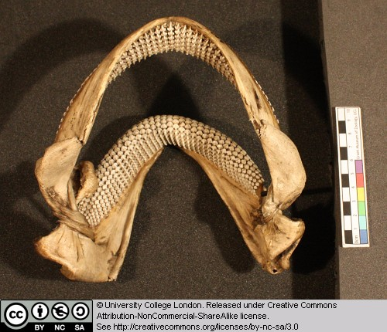
Figure 1 Above: Dipturus jaws seen from above and behind.

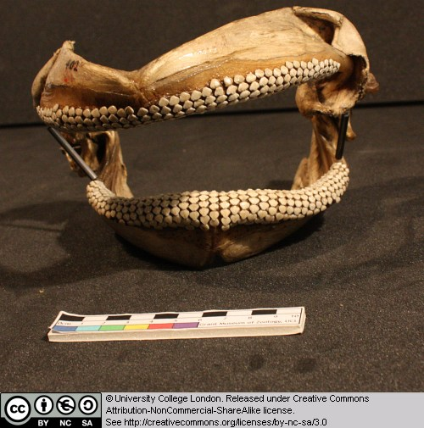
Figure 2 Above: Dipturus jaws seen from the front.

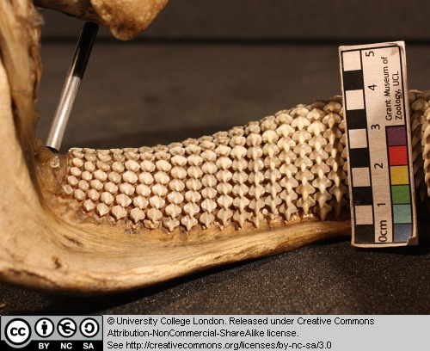
Figure 3 Above: Close-up of teeth in the lower jaw, seen from behind.

Note that, unlike ourselves, the upper jaw is not firmly fused to the braincase (not present here) of the sharks and rays.

Can you work out which parts are the palatopterygoquadrate and which represent Meckel’s cartilage? [hint – the palatopterygoquadrate is often described as ‘hatchet’-shaped].

1.2 Lepidotes minor

Lepidotes is a ray-finned fish from the Jurassic.

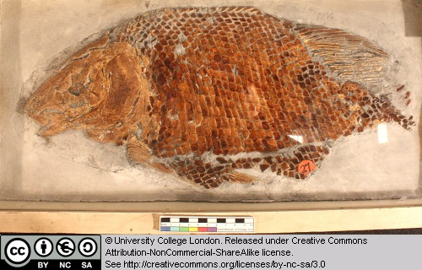
Figure 4 Above :Whole fossil specimen of Lepidotes.

Try to identify the various fins and the operculum (gill shield).

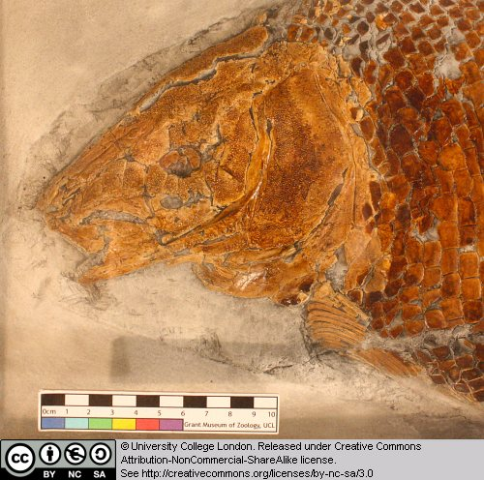
Figure 5 Above: Close-up of the head of Lepidotes fossil.

1.3 Amia

Amia (the bowfin) represents a group of ray-finned fish that are closely related to, but lie just outside of, the teleost radiation. Teleosts have a tendency to reduce the amount of sheet-like dermal bone covering their skulls – this has enabled them to modify their jaw mechanisms. Amia retains much of the primitive dermal bone.

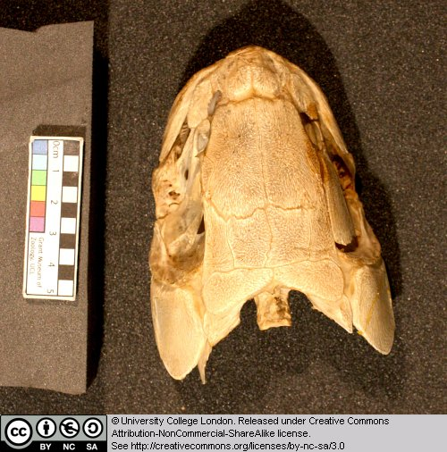
Figure 6 Above: Head of Amia as seen from above.

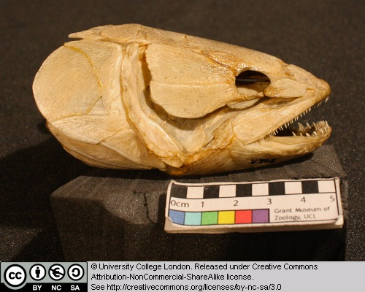
Figure 7 Above: Head of Amia as seen from the right.

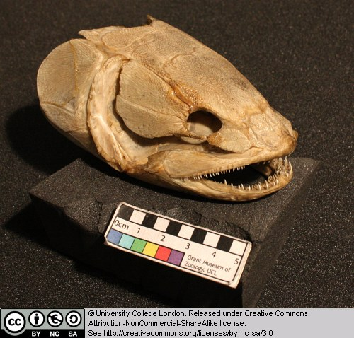
Figure 8 Above: Head of Amia as seen from the front right.

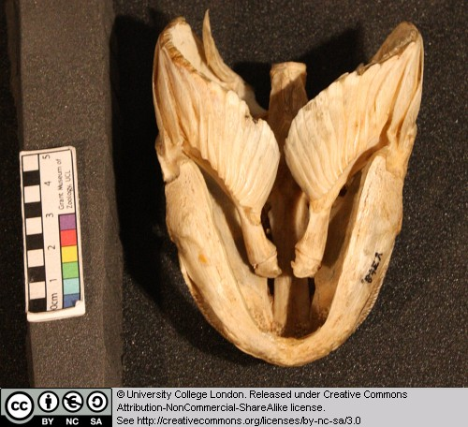
Figure 9 Above: Head of Amia as seen from below (the front if to the bottom of the picture).

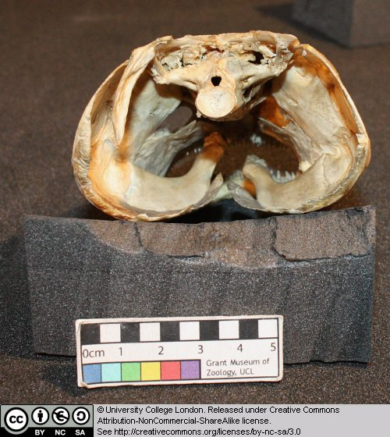
Figure 10 Above: Head of Amia as seen from behind.

Try to identify the dermal jaw bones (the premaxilla, maxilla and dentary) that possess teeth. Identify the eye socket (the orbit). Is a bony opercular plate (gill cover) present?

1.4 Bufo

This is the skeleton of a large extant toad.

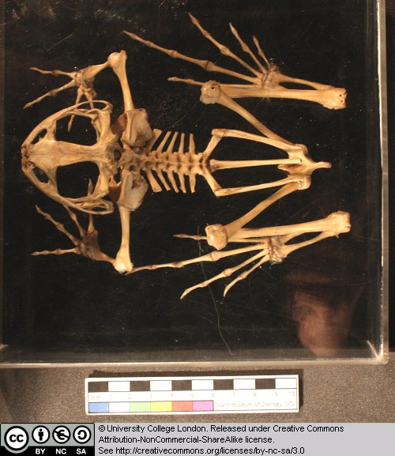
Figure 11 Above: Skeleton of Bufo, seen from above.

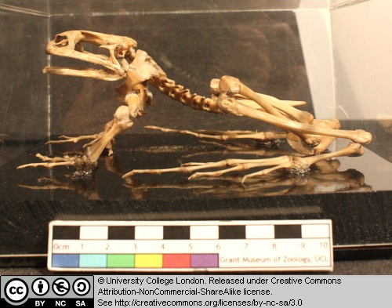
Figure 12 Above: Skeleton of Bufo, seen from the left.

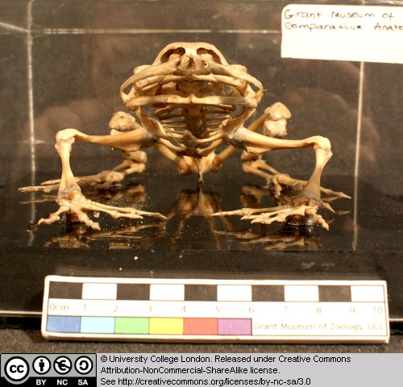
Figure 13 Above: Skeleton of Bufo, seen from the front.

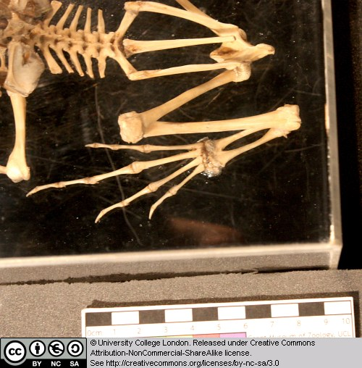
Figure 14 Above: Close-up of the pelvic region of Bufo, seen from above.

Note that the dorsal (trunk) vertebrae lack ribs. Identify the shoulder girdle, fore limb, pelvic girdle and hind limb elements as far as you can.

1.5 Chelys frimbriata (Matamata)

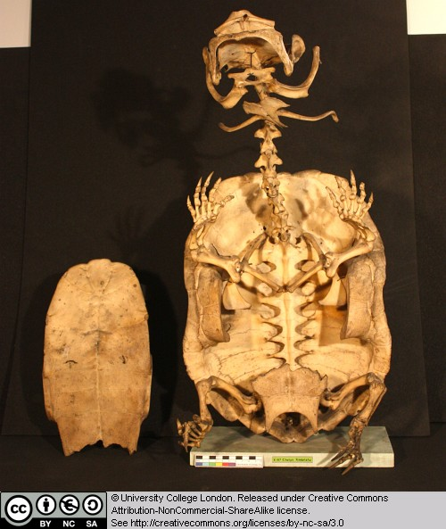
Figure 15 Above: Skeleton of Chelys, seen from below. The plastron (chest plate) has been removed and lies to the side.

The matamata is a pleurodiran turtle. This means that it is a member of the turtle group that bend their necks sideways in order to retract the head inside the shell. However, the length of the neck in the matamata must make it difficult or impossible for this animal to hide its head in this way. The matamata is an aquatic predator. It has a lure on the tip of its snout that tempts small fish to come close to its mouth. The wide mouth is then opened rapidly and the fish is pulled into it by the inflow of water. Clues to this lifestyle can be seen in the skeleton – but this can wait until a later chapter.

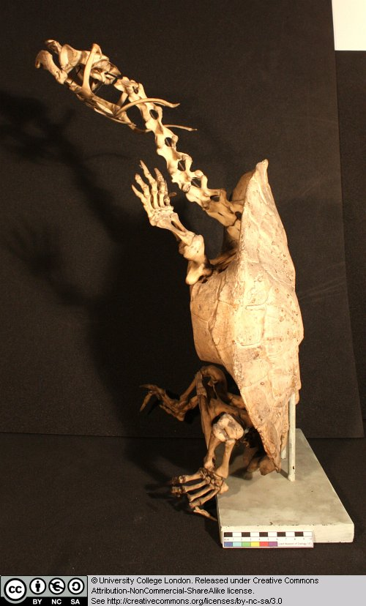
Figure 16 Above: Skeleton of Chelys, seen from the left.

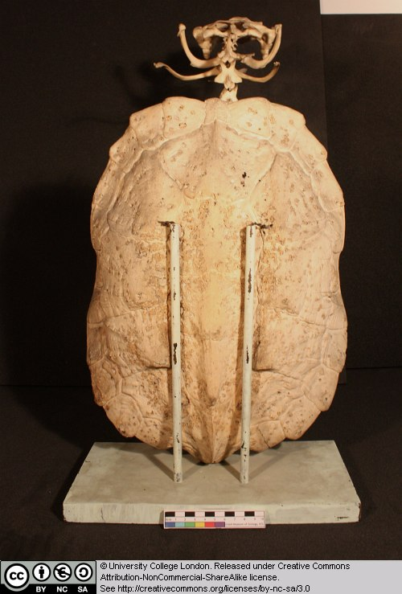
Figure 17 Above: Skeleton of Chelys, seen from behind.

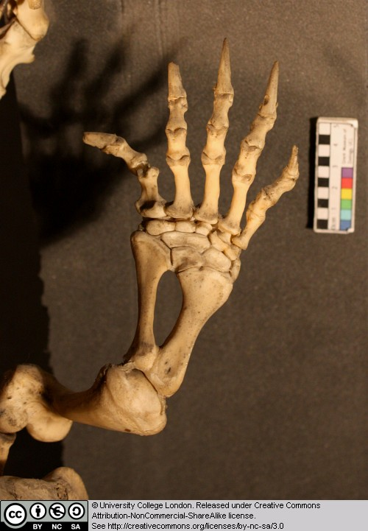
Figure 18 Above: Close-up of the forelimb of Chelys seen from above.

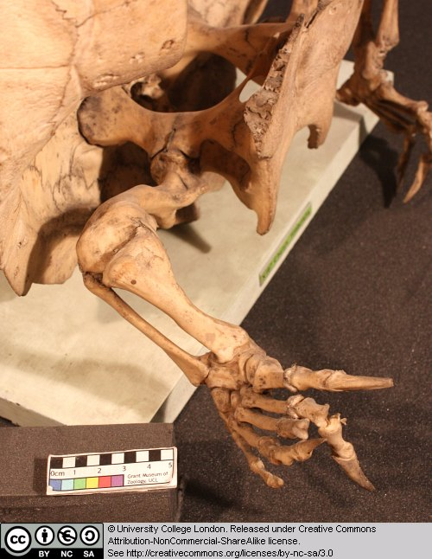
Figure 19 Above: Close-up of the hindlimb of Chelys seen from above and to the side.

Examine the limb structure and try to identify humerus, ulna, radius, manual (hand) phalanges, femur, tibia, fibula and pedal (hind foot) phalanges. Note also the ridges and projections on the neck vertebrae. Examine the armoured shell (both the dorsal carapace and the ventral plastron).

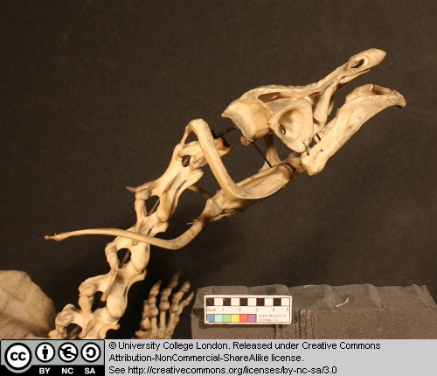
Figure 20 Above: Close-up of the skull of Chelys seen from the side

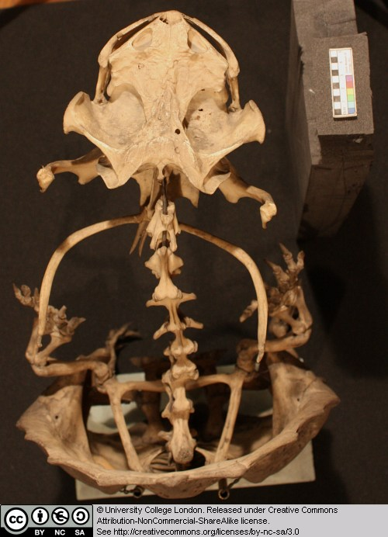
Figure 21 Above: Close-up of the skull of Chelys seen from above.

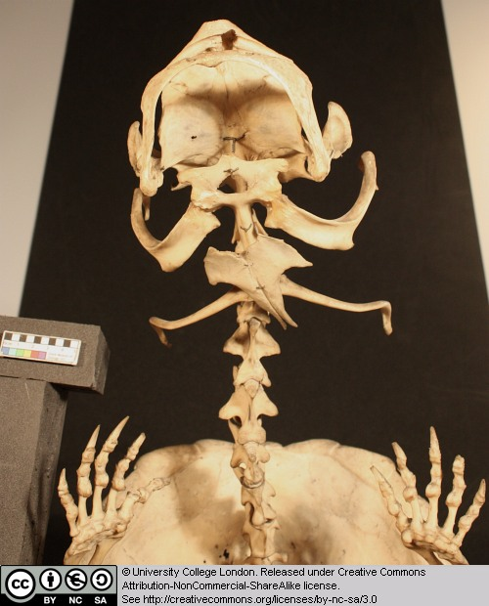
Figure 22 Above: Close-up of the forelimb of Chelys seen from below.

Identify the nasal openings and eye sockets in the skull.

More on the matamata (including a number of images of a live animal) can be seen here.

1.6 Dimetrodon

This box contains vertebrae from Dimetrodon – a famous sail-backed predator from the Permian (we’ll meet it again later in the course). Here several vertebrae are shown in left lateral, anterior and dorsal views.

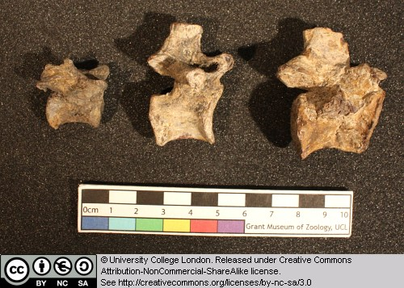
Figure 23 Above: Vertebrae of Dimetrodon, seen from the left (the front is to the right).

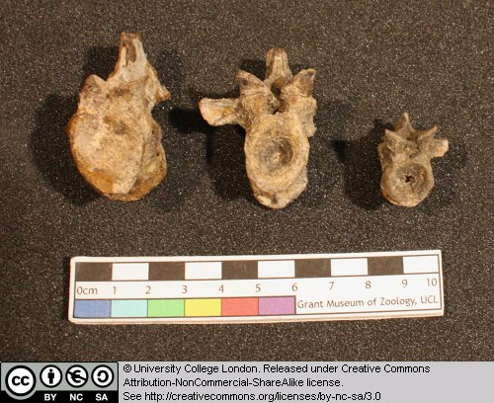
Figure 24 Above: Vertebrae of Dimetrodon, seen from the front.

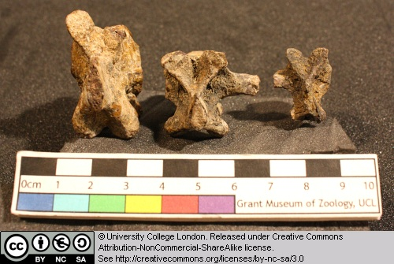
Figure 25 Above: Vertebrae of Dimetrodon, seen from above (the front is to the top).

This provides a good opportunity to learn some of the basic features of amniote vertebrae. Identify the following features: centrum, neural arch, spinal canal, neural spine, transverse processes (attachment points for the ribs).

1.7 Varanus niloticus (a monitor lizard)

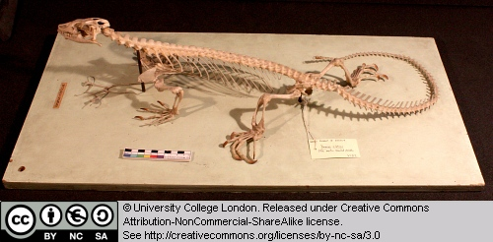
Figure 26 Above: Skeleton of Varanus, seen from the left.

This is the skeleton of a varanid lizard from Africa. Varanids are highly derived lizards that may be closely related to the gigantic extinct marine mosasaurs of the Mesozoic, and modern snakes.

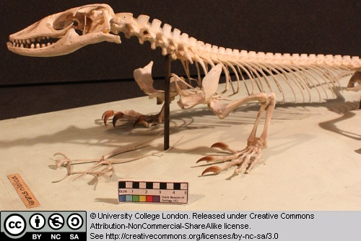
Figure 27 Above: Front half of the skeleton of Varanus, seen from the left.

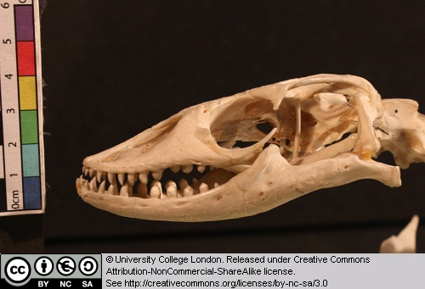
Figure 28 Above: Skull of Varanus, seen from the left.

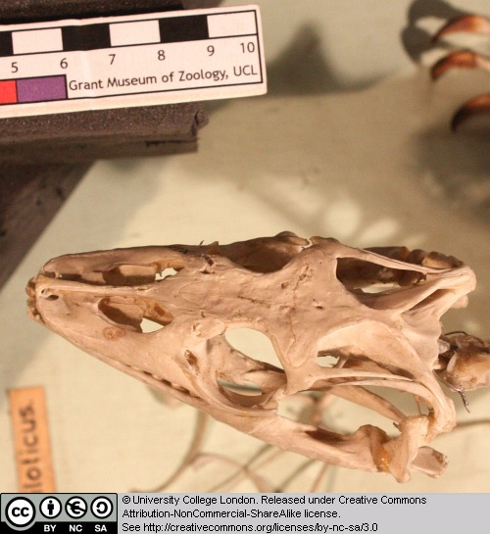
Figure 29 Above: Skeleton of Varanus, seen from the above.

Can you identify the eye sockets and nasal openings?

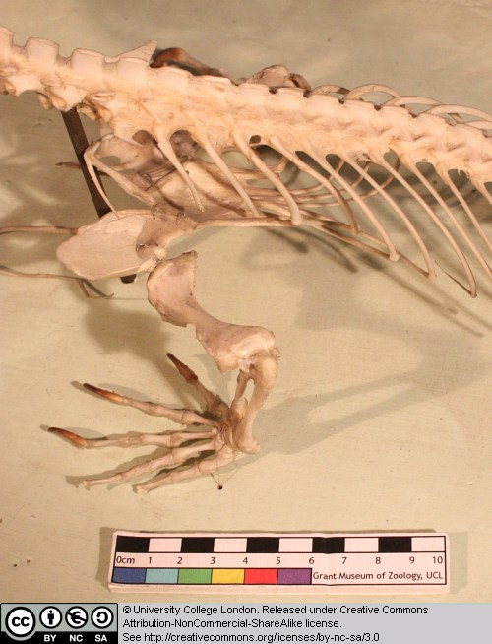
Figure 30 Above: Spine and forelimb of Varanus, seen from above and left.

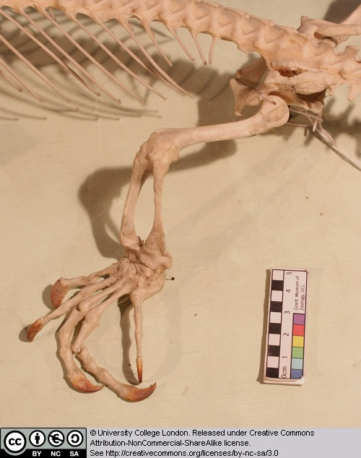
Figure 31 Above: Hindlimb of Varanus, seen from the left.

Note the sprawling limb posture (the limbs extend out to the sides, rather than being held vertically beneath the body, as in ourselves).

1.8 Crocodylus

This is the skull of an extant crocodile.

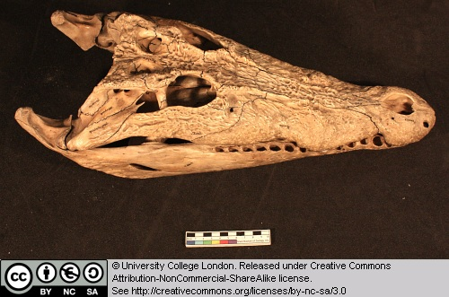
Figure 32 Above: Skull of Crocodylus, seen from above and to the left.

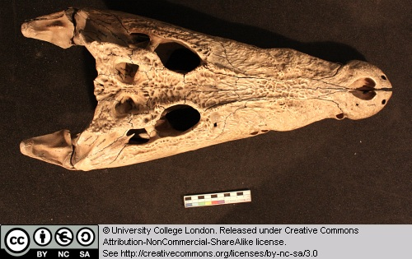
Figure 33 Above: Skull of Crocodylus, seen from above.

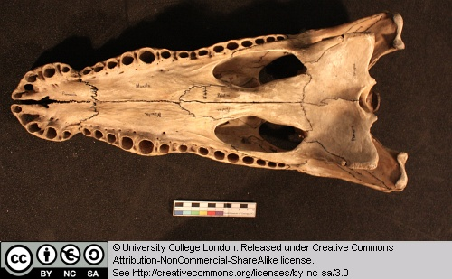
Figure 34 Above: Skull of Crocodylus, seen from below.

Identify the nasal openings and eye sockets. Identify the three tooth bearing bones – premaxilla, maxilla and dentary.

Can you find the rounded ‘occipital condyle’ at the back of the skull where it would have articulated with the first neck vertebra? Just above this is the ‘foramen magnum’ – the opening where the spinal cord enters the skull and joins the brain.

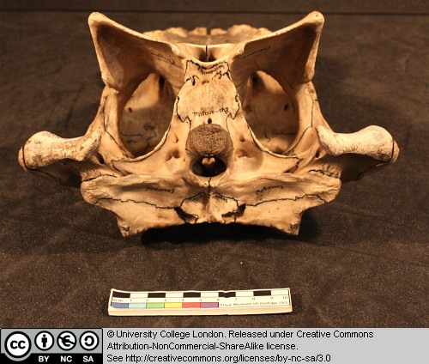
Figure 35 Above: Skull of Crocodylus, seen from behind (the skull roof is below and palate uppermost).

We will be revisiting crocodiles again and in more detail in a later practical.

1.9 Alligator mississippiensis

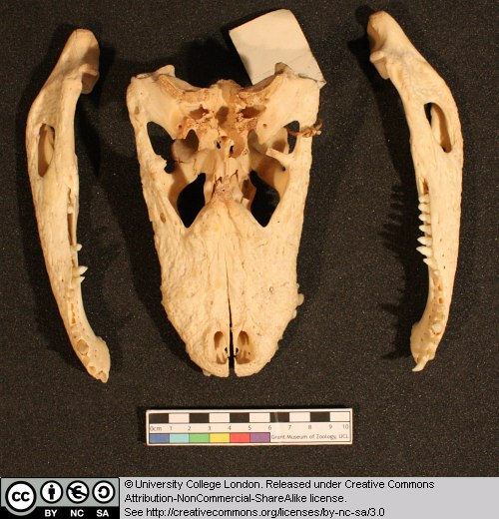
Figure 36 Above: Skull of Alligator, seen from above and with the lower jaws to the side.

This is the skull (and jaws) of the extant alligator

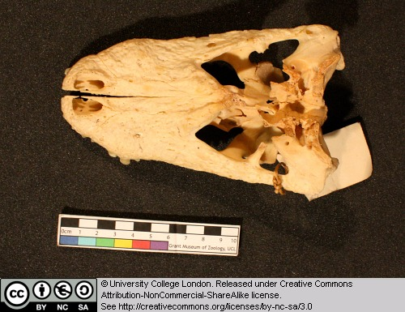
Figure 37 Above: Skull of Alligator seen from above.

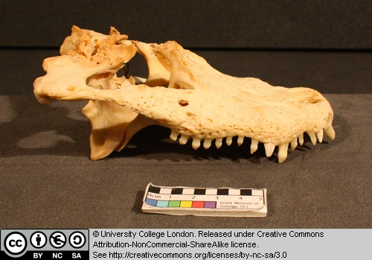
Figure 38 Above: Skull of Alligator seen from the right.

Identify the nasal openings and eye sockets. Identify the three tooth bearing bones – premaxilla, maxilla and dentary. Can you find the rounded ‘occipital condyle’ at the back of the skull where it would have articulated with the first neck vertebra? Just above this is the ‘foramen magnum’ – the opening where the spinal cord enters the skull and joins the brain. In the image below the skull is inverted and lies on its dorsal surface, with the palate uppermost.

Figure 39 Above: Skull of Alligator seen from behind (the skull roof is at the bottom and the palate is uppermost).

1.10 Compsognathus longiceps

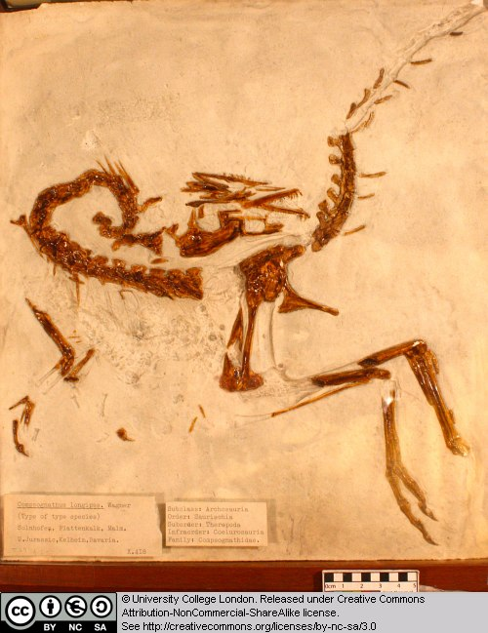
Figure 40 Above: Cast of Compsognathus, preserved with the left side uppermost.

This is a cast of a small theropod dinosaur from the Late Jurassic of Germany.

Try to identify as many of the elements as you can.

1.11 Parrot

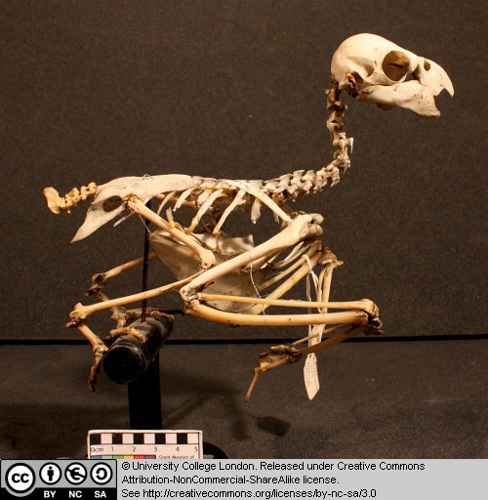
Figure 41 Above: Skeleton of a parrot seen from the right.

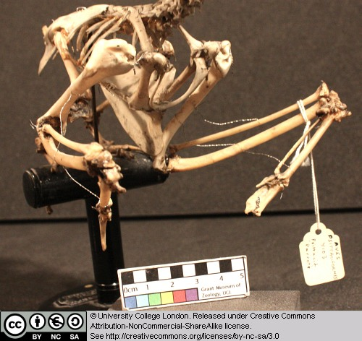
Figure 42 Above: Chest area of a parrot seen from the front right.

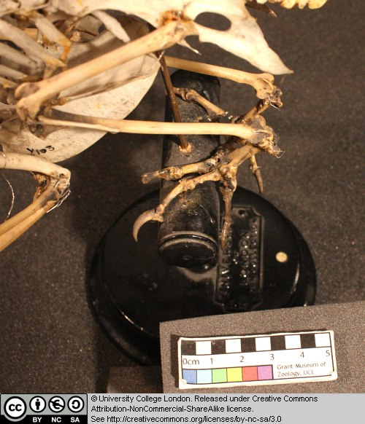
Figure 43 Above: Hindlimb of a parrot seen from above and to the left.

Bird skeletons are delicate. Try to identify the following features:

The rib cage and sternum (breast bone area) where the major flight muscles attach.

The form of the wing bones (try to identify the humerus, ulna and radius, and fused finger bones).

The short femur.

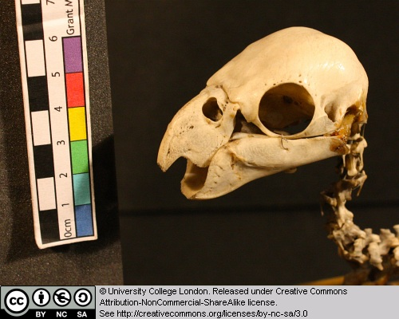
Figure 44 Above: Skull of a parrot seen from the left.

Can you detect a hinge-like region between the beak and posterior portion of the skull?

1.12 Oceanodroma leuchorrhoa (petrel)

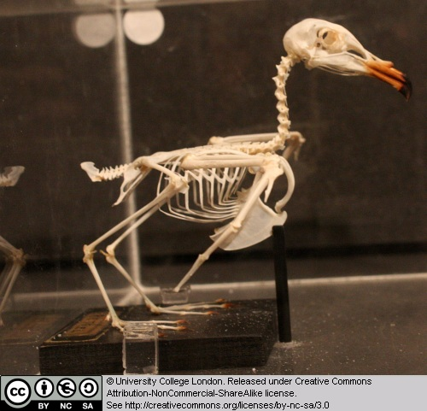
Figure 45 Above: Skeleton of Oceanodroma seen from the right.

This is the skeleton of a sea bird found around the coasts of western and northern Europe.

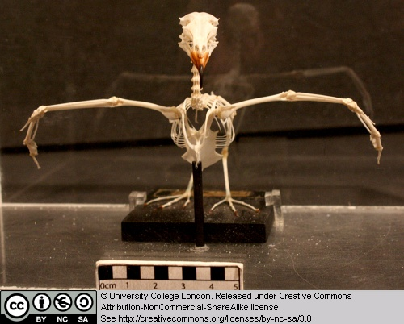
Figure 46 Above: Skeleton of Oceanodroma seen from the front.

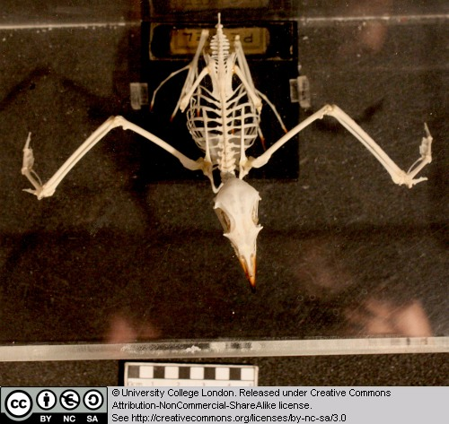
Figure 47 Above: Skeleton of Oceanodroma seen from above.

Examine the following features:

The rib cage and sternum (breast bone area) where the major flight muscles attach.

The form of the wing bones (try to identify the humerus, ulna and radius, and fused finger bones).

The short femur.

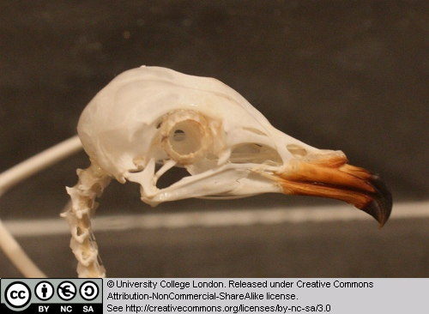
Figure 48 Above: Skull of Oceanodroma seen from the right.

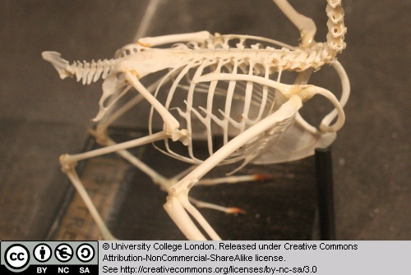
Figure 49 Above: Body of Oceanodroma seen from above right.

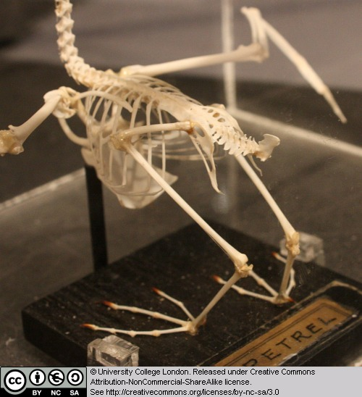
Figure 50 Above: Posterior part of the keleton of Oceanodroma seen from above left.

1.13 Hipparion brachypus

Although we do not look at mammals in detail in this course, we have included a couple of specimens here because we are looking at the diversity of vertebrates.

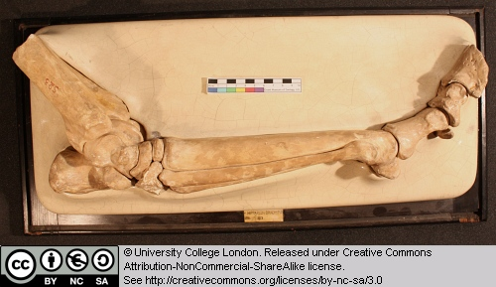
Figure 51 Above: Cast of hindlimb of Hipparion seen from the right.

This is a cast of the pes (hind foot) and distal end of the tibia of an equid (horse family). Note the reduction of the pedal digits, and the stout column-like nature of the limb bones.

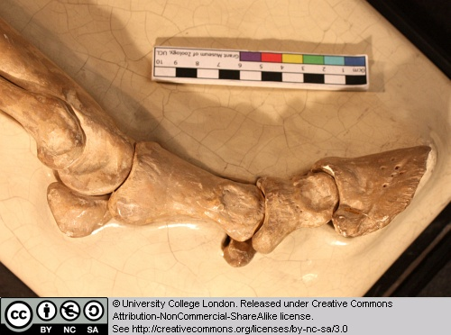
Figure 52 Above: Close-up of the foot of Hipparion seen from the right.

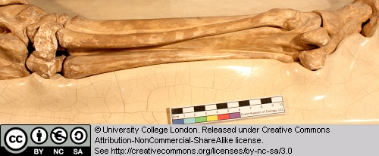
Figure 53 Above: Close-up of the metatarsals of Hipparion seen from the right.

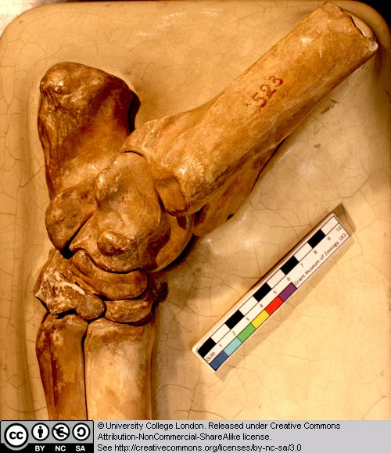
Figure 54 Above: Close-up of ankle joint of Hipparion seen from the right.

1.14 Palaeotherium sp.

Although we do not look at mammals in detail in this course, we have included a couple of specimens here because we are looking at the diversity of vertebrates. This is the skull of an equid (horse) from the middle Miocene of North America.

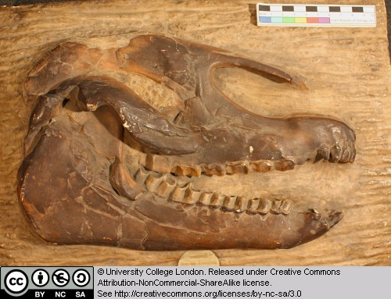
Figure 55 Above: Cast of the skull of Palaeotherium seen from the right.

Try to identify the main openings in the skull, such as the eye and external nostril. Note the cusps on the teeth and the arrangement of the teeth in the jaws. Compare these teeth with those in a crocodile. Mammals typically have complex teeth for grinding/slicing their food.

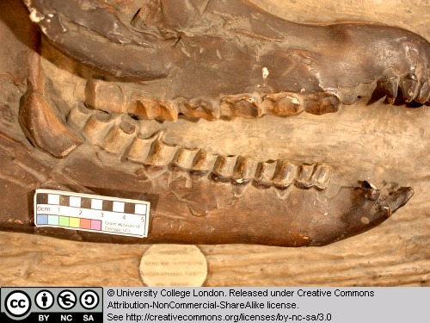
Figure 56 Above: Close-up of the teeth of Palaeotherium seen from the right.

Chapter 2: Fishes

This chapter will introduce you to various early vertebrates and fish. In particular, it covers some jawless forms, acanthodians, placoderms, sharks and rays, and several ray-finned fish. It is not essential that you look at the specimens in any particular order.

2.1 Pteraspis

Pteraspis is a small (usually just a few centimetres long) jawless fish from the Late Devonian of the U.K. This slab shows fragments of head-shield and several more complete individuals. Compare these specimens with the model (next section).

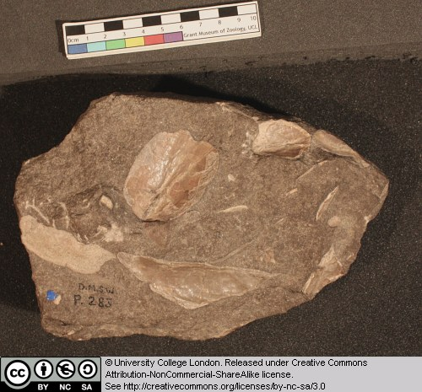
Figure 57 Above: Various elements of Pterapsis.

2.2 Models of Pteraspis

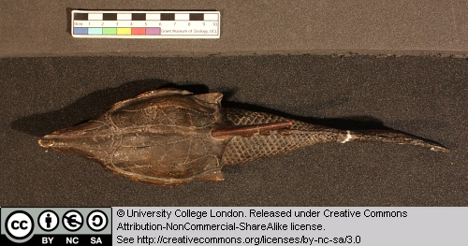
Figure 58 Above: Model Pterapsis seen from above.

This model of the jawless vertebrate Pteraspis are somewhat larger than the real animal, but give a fairly accurate idea of what we know about this form. Note the following features:
- The large head-shield.
- The smaller scales covering the posterior half of the animal.
- The hypocercal tail.
- The dorsal and lateral spines.

Can you identify the eyes, mouth, single combined gill opening, and nasal openings?

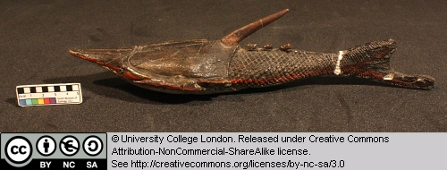
Figure 59 Above: Model Pterapsis seen from the right.

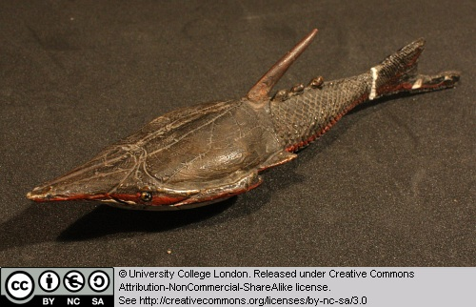
Figure 60 Above: Model Pterapsis seen from the front right.

2.3 Acanthodes

Acanthodian fish first appear in the Late Ordovician and die out in the Early Permian. They are of particular interest because they represent some of the earliest jawed vertebrates and may therefore provide clues to the origin of this highly successful feeding structure.

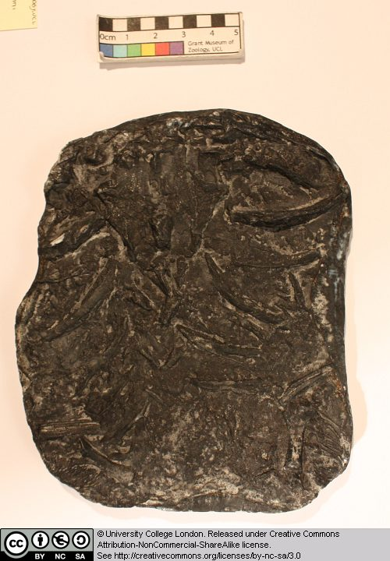
Figure 61 Above: Elements of Acanthodes.

This specimen of Acanthodes is not easy to interpret, but includes material from the jaws and gills. See if you can identify any of the jaw and gill elements.

2.4 Gyrocanthus

Gyrocanthus is an acanthodian fish (see Acanthodes for more details) from the Carboniferous.

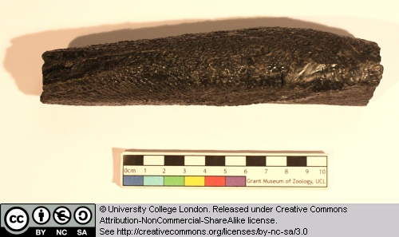
Figure 62 Above: Fin spine of Gyrocanthus seen from the side.

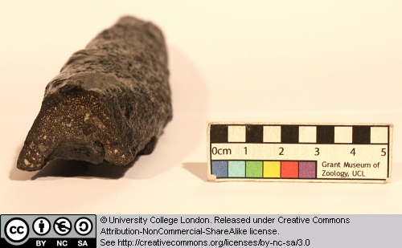
Figure 63 Above: broken distal end of the fin spine of Gyrocanthus.

This specimen is a fin-spine. Acanthodians are characterised by possessing a prominent spine along the leading edge of many of their fins.

2.5 Bothriolepis canadensis

This specimen is the head-shield of a placoderm in dorsal view. Placoderms were heavily armoured jawed fish that thrived during the Devonian. They had a nearly global distribution, and lived in marine and freshwater habitats. They range in size from a few centimetres to 10 metres or longer. One unique feature of the placoderms is the joint between the head-shield and the main trunk of the animal.

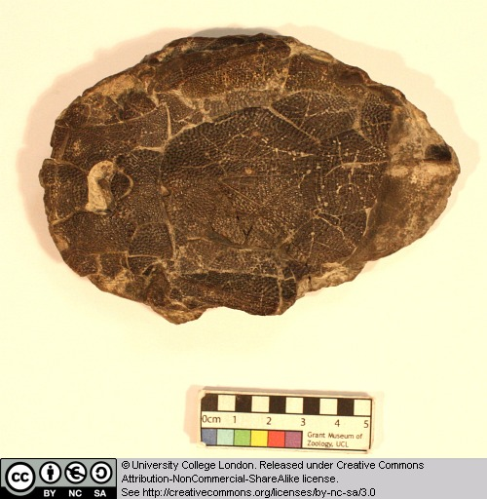
Figure 64 Above: Head shield of Bothriolepis seen from above (the front is to the left).

Bothriolepis itself grew to about 25cm in length. It is of Late Devonian age, and has been found on virtually every continent. Note the texture and pattern on the head-shield armour.

Compare this specimen with the models of Bothriolepis.

2.6 Model of Bothriolepis

This model provides a reasonably accurate picture of the appearance of the placoderm Bothriolepis. Compare this model with the head-shield preserved in the specimen of Bothriolepis.

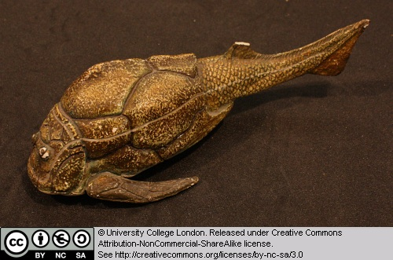
Figure 65 Above: Model of Bothriolepis seen from the left.

Identify the following features:
- The head-shield and its junction with the trunk.
- The lower jaw and mouth.
- The prominent eyes (this is characteristic of the placoderm subgroup known as Antiarchs).
- The pectoral fins.

What other fins can you identify?

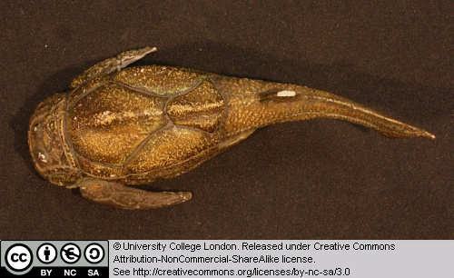
Figure 66 Above: Model of Bothriolepis seen from above.

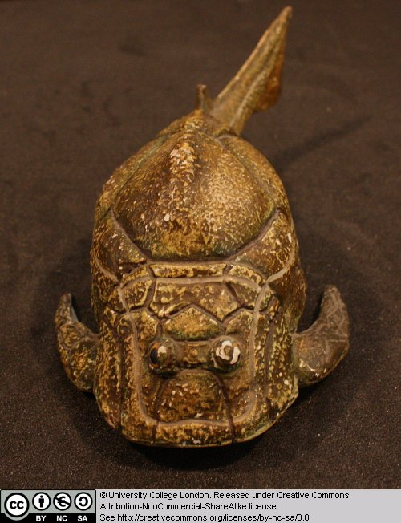
Figure 67 Above: Model of Bothriolepis seen from the front.

2.7 Cladoselache

Cladoselache is a shark from the Late Devonian of North America. This shark reached about 1 metre in length and probably fed on small fish.

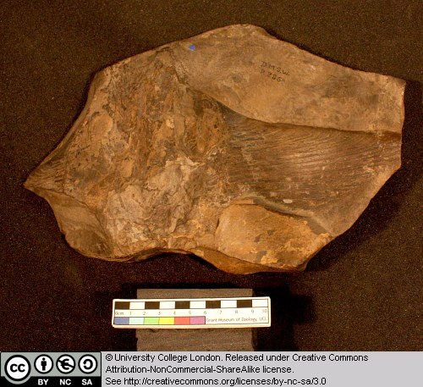
Figure 68 Above: Pectoral fin of Cladoselache.

Note the structure of this pectoral fin

2.8 Megalodon

Megalodon is a large shark from the Tertiary (see also Carcharodon). This specimen is a large triangular tooth. Note the shiny enamel, and the fine serrations.

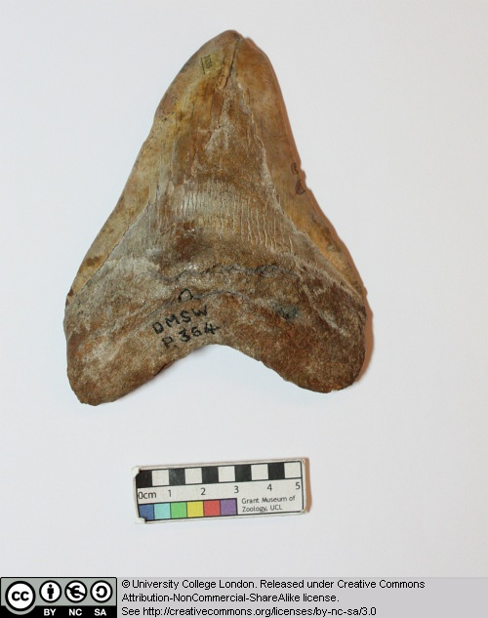
Figure 69 Above: Tooth of Megalodon.

2.9 Carcharodon angustidens

Carcharodon is a shark genus that includes the Great White shark. Some species, during the Tertiary, grew to gigantic sizes, though the evidence for this is mainly based on the discovery of large teeth. Do large teeth necessarily mean that this animal was a major predator of other large-bodied animals?

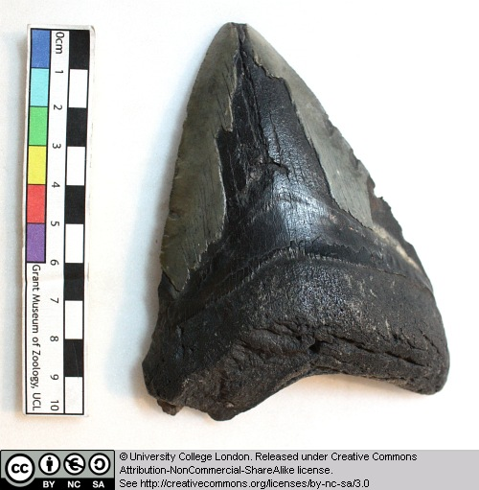
Figure 70 Above: Tooth of Carcharodon.

Note the shiny enamel and fine serrations.

2.10 Myliobatis

Myliobatis is a genus of ray that first appeared in the Late Cretaceous. It includes extant species such as the Eagle Ray, from the east Atlantic and around Britain. The Eagle ray can grow up to 1.8 m long. It feeds on molluscs and crustaceans from the sea floor.

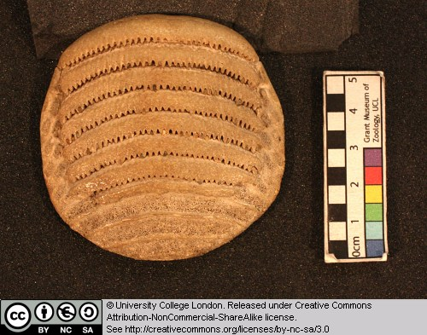
Figure 71 Above: Tooth plate of Myliobatis seen from below (the front of the plate is to the top).
This specimen is one of the crushing tooth-plates with a rasp-like surface.

2.11 Orodus (pavement tooth shark)

This is a member of the Holocephali (rat-fish), a third group of cartilaginous fish. Orodus comes from the Lower Carboniferous and therefore represents a very early member of this rat-fish radiation.

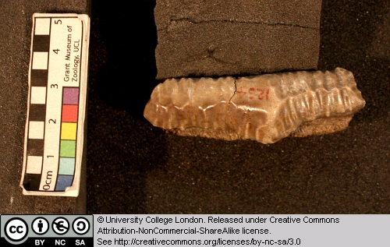
Figure 72 Above: Single tooth of Orodus seen from the side.

This specimen is a tooth.

2.12 Rhinoptera

Rhinoptera is an extinct ray that lived between the Late Cretaceous and Pliocene. It has been found in Europe, Africa, North and South America.

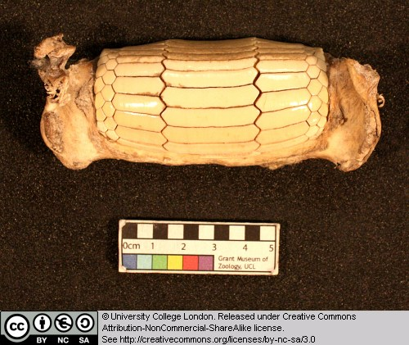
Figure 73 Above: Tooth battery of Rhinopters seen from below.

This specimen is a crushing tooth battery.

2.13 Palaeoniscus

Early members of the ray-finned fish radiation (i.e. those present during the late Palaeozoic) are sometimes referred to collectively as ‘palaeoniscids’. It is from somewhere within this early assemblage that we believe the ancestors of more advanced forms (sturgeons, gars, the Bowfin and ultimately the teleost fish) arose.

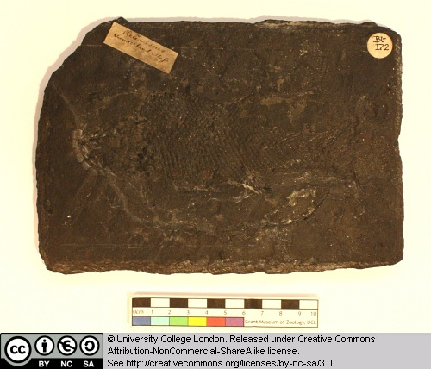
Figure 74 Above: Cast of a fossil of the fish Palaeoniscus, the head is to the left.

Palaeoniscus comes from the Late Permain of Germany. Note the major fins and head structures etc. and the presence of the primitive heterocercal tail.

2.14 Sturgeon

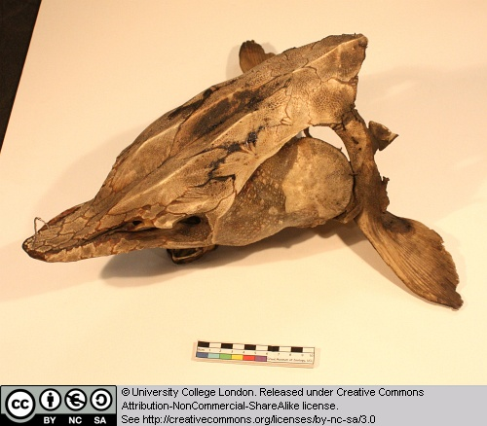
Figure 75 Above: Head of a sturgeon, seen from above left.

This mass of elements represent parts of the skeleton and armour of an extant sturgeon. Try to identify some of these elements.

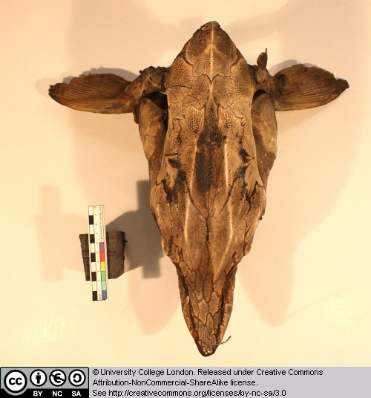
Figure 76 Above: Head of a sturgeon, seen from above.

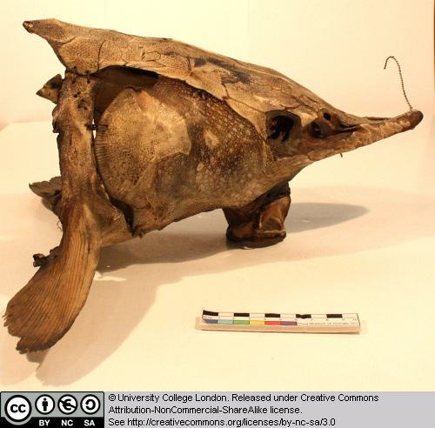
Figure 77 Above: Head of a sturgeon, seen from the left.

2.15 Lepidotes minor

Lepidotes is a ray-finned fish from the Jurassic. It is relatively advanced compared to the palaeoniscid-like forms, but retains several plesiomorphic features with regard to teleosts. Note the scale pattern and other major features such as fins, operculum, head structures and so on.

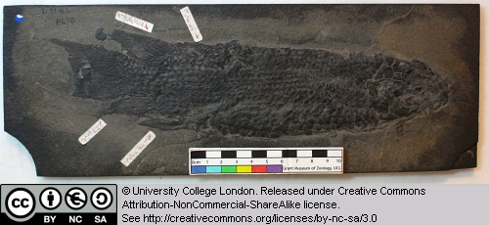
Figure 78 Above: Fossil of the fish Lepidotes, seen on the left side (the head is to the right).

2.16 Scombrocolupea

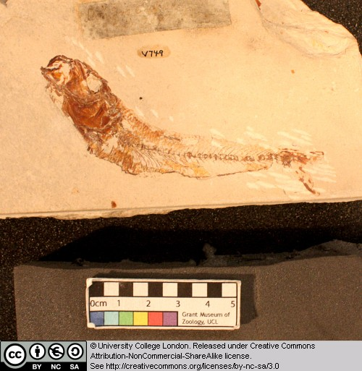
Figure 79 Above: Fossil of the fish Scombrocolupea, seen from the left.

This ray-finned fish belongs to the same group of teleosts as the perch, sailfish, tuna and mackerel.

2.17 Clupea

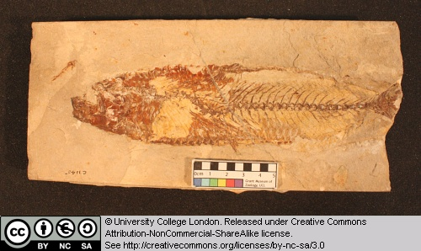
Figure 80 Above: Fossil of the fish Clupea, seen from the left.

Clupeiformes is the order of Ray-finned fish that includes herrings, anchovies and sardines. They tend to be fairly small open water or coastal fish, that feed on plankton, small fish and crustaceans.

2.18 Other taxa

The skate Raja batis, the fossil fish Lepidotes minor and the modern bowfin Amia were all featured in Chapter 1.

Chapter 3: The fish-tetrapod transition

This chapter examines the lobe-finned fish and some early tetrapods.

3.1 Coelocanth

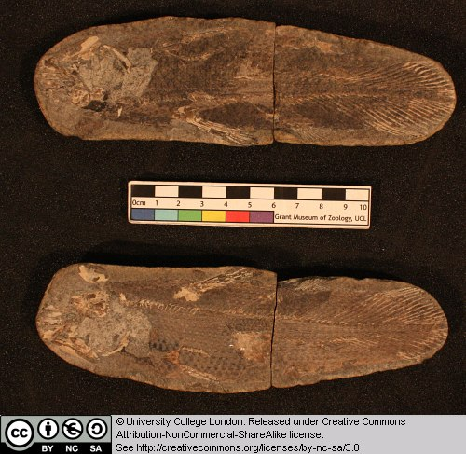

This is a fossil coelacanth from a nodule, preserved in four parts. Note the presence of some skull bones, scales, vertebrae and fin rays. Can you identify the dorsal fins and symmetrical tail that are typical of derived sarcopterygians?

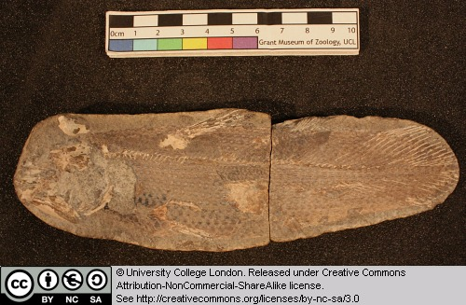

Coelocanths are still alive today (as seen here for example) with populations in the Indian Ocean around South Africa and Indonesia.

3.2 Dipterus

This is a lungfish from the Devonian. It is essentially complete. Try to find the following features: the head and eye region, the paired fins, the dorsal fins, the tail (is it symmetrical or heterocercal?).

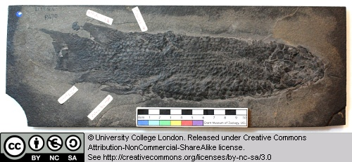

Note the scale pattern on this animal.

3.3 Dipnoi

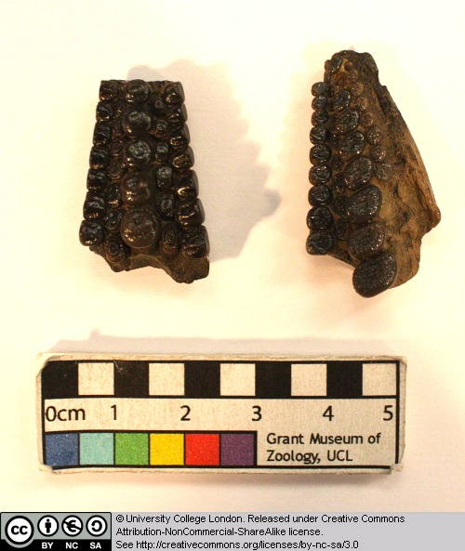

These specimens are tooth plates belonging to lungfish. What types of food can lungfish tackle with such a dentition?

3.4 Rhizodus

Rhizodonts were large sarcopterygian fish from the Carboniferous. Some grew to gigantic sizes (7 metres long), and can be recognised by their large rounded plate-like scales and their long curved teeth. It has been proposed that rhizodonts may have lunged up onto shores and river banks in order to grab terrestrial prey.

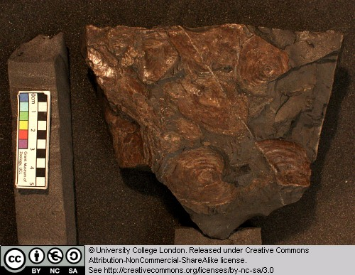

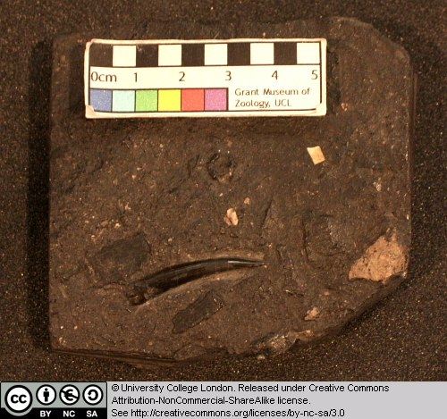

3.5 Osteolepis

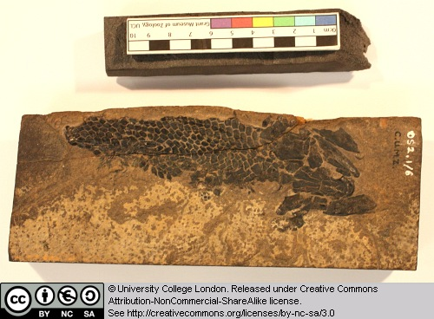

This is a nearly complete specimen, lacking the tail. Osteolepis is a relatively primitive member of the osteolepiform fish group that includes Eusthenopteron, Panderichthys and tetrapods. Note the scales and the general form of the head.

3.6 Eusthenopteron

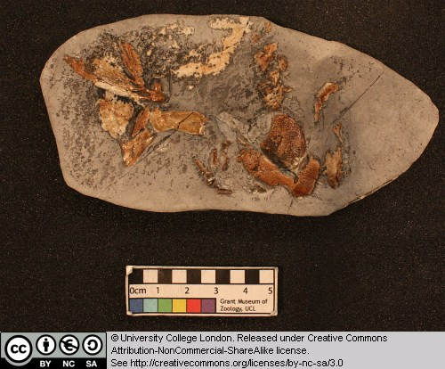

This is the skull and pectoral fin of a derived osteolepiform fish. Pay particular attention to the structure of the main fin elements. Can you identify the three main bones that, in tetrapods, would be called the humerus, radius and ulna?

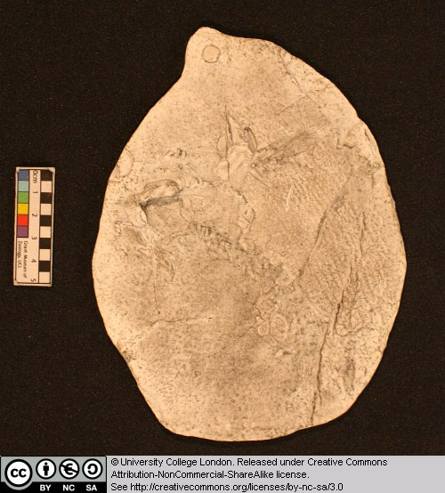

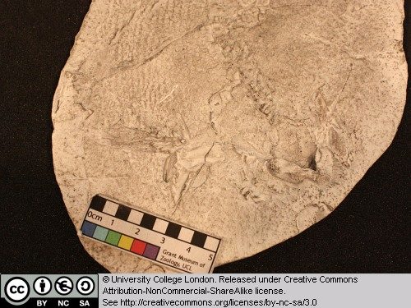

3.7 Megalocephalus

Megalocephalusis a member of a group of early tetrapods called loxommatids. Loxommatids (also called baphetids) appear in the Early Carboniferous, but were most common during the later part of this period. This group is known from a few skulls and mandibles, but virtually nothing is known about their postcranial skeletons. Baphetids can be recognised by the possession of one clear derived character state: the orbit (eye socket) is extended forward, giving this opening a ‘keyhole’ shape.

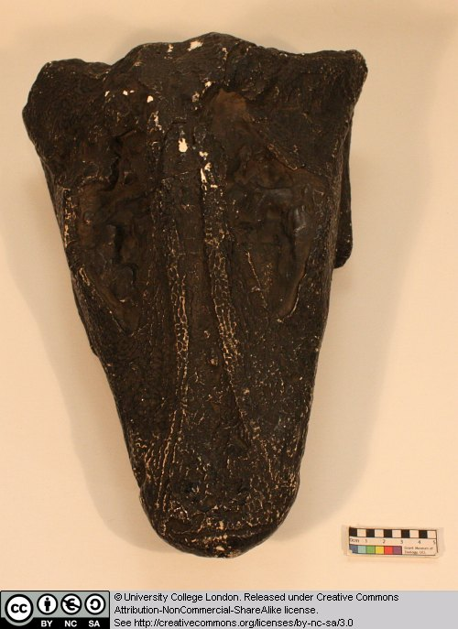

What animal does this skull remind you of – and what do you think Megalocephalus ate?

3.8 Trematosaurus sp.

This is a trematosaurid temnospondyl. Temnospondyls were a highly successful group during the Late Carboniferous, and several forms are also known from the Permian and later. During the Late Carboniferous, some temnospondyls became rather crocodile-like and developed an elongate snout.

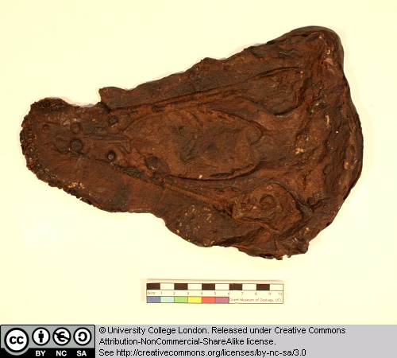

Can you detect the outlines of large openings on the palate (the roof of the mouth)? These large openings are characteristic of all temnospondyls.

3.9 Rhinesuchoides

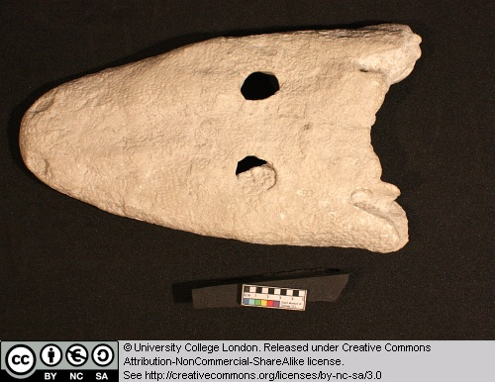

This is the skull of a temnospondyl from the Late Permian of South Africa. Note the presence of the small orbits on the top surface of the rather dorsoventrally flattened head. Can you detect the otic notch and large palatal vacuities that characterise temnospondyls?

Look for a small V-shaped notch along the back margin of the head [otic notch], and the outline of large oval openings on the roof of the mouth [palatal vacuities].The last image shows the skull in palatal view.

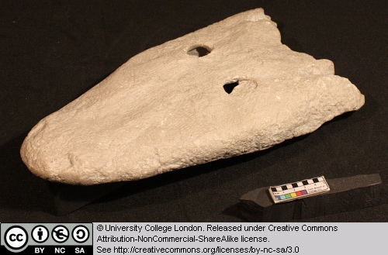

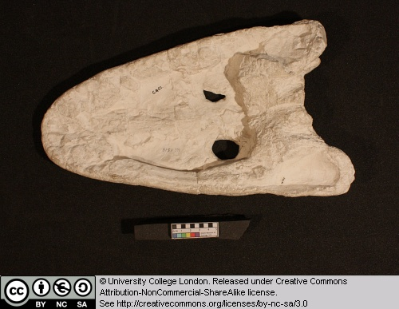

3.10 Paratosaurus peabodyi (Wellesaurus)

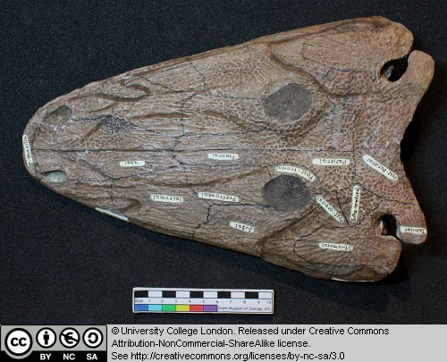

This is the skull of a temnospondyl. Make sure you can detect the large palatal vacuities on the roof of the mouth that characterise this group of early tetrapods.

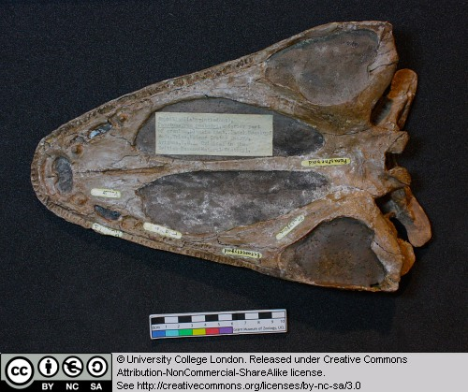

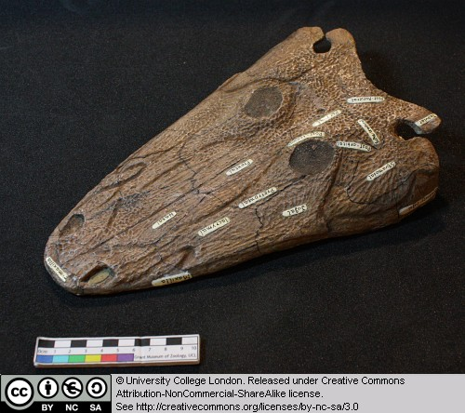

3.11 Dendrerpeton pyriticum

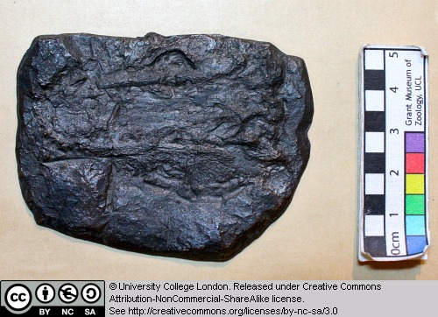

This is a cast of the skull of a temnospondyl from the Late Carboniferous. Can you identify the large palatal openings and otic notch that characterise this group of early tetrapods. The otic notch is a V-shaped slot, one on either side of the skull, on its back margin.

3.12 Cochleosaurus sp.

This is the cast of the skull of a cochleosaurid temnospondyl. Note the broadly rounded snout. It is thought that cochleosaurs were ‘gulping’ aquatic predators.

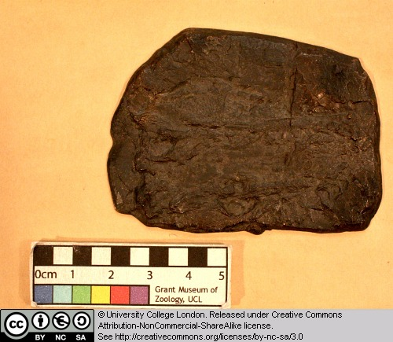

3.13 Broilellus texensis

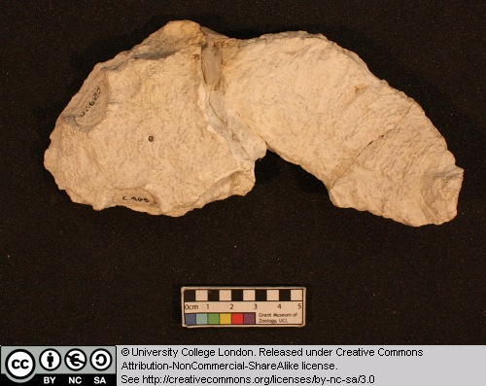

This is a cast of an eryopid temnospondyl. Eryopids were often terrestrial forms that were common during the Permian. They were broad-snouted forms that grew up to 2 metres in length.

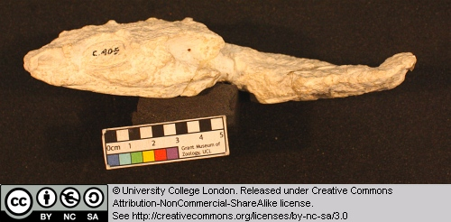

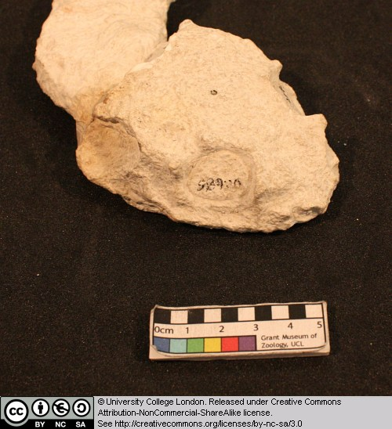

3.14 Diplocaulus sp.

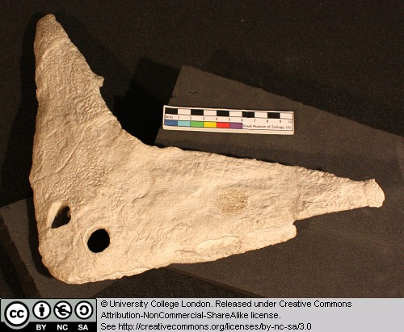

This is the skull of a nectridean. These strange early tetrapods lived during the Late Carboniferous and Early Permian. Note the way the skull is dorsoventrally flattened and possesses large prong-like horns from the posterolateral corners. These animals may have lurked at the bottom of rivers and lakes, waiting for prey to swim over them. Then, using a powerful tail and lift generated by water passing over the wing-like horns, they may have attacked the prey from below.

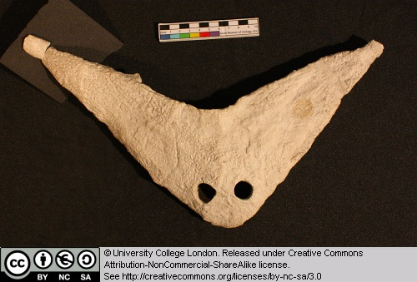

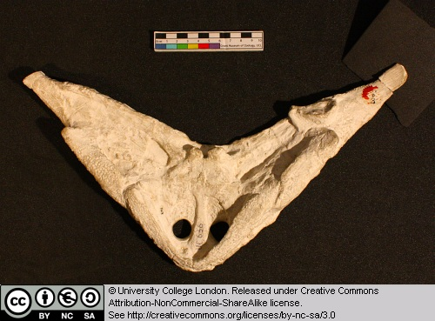

3.15 Palaeoherpeton sp.

Anthracosaurs appear in the early Late Carboniferous as small-to-medium terrestrial forms. During the Late Carboniferous they gave rise to the large, elongate, embolomeres – crocodile-like creatures that ate fish and lived in the coal swamps. The last anthraosaurs are known from the Early Triassic of Russia.

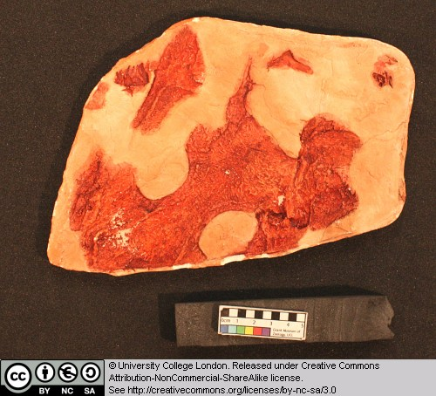

These specimens are casts of the skull of an anthracosaur in dorsal and ventral views. Note that there is no sign of large palatal vacuities on the palatal surface (the roof of the mouth).

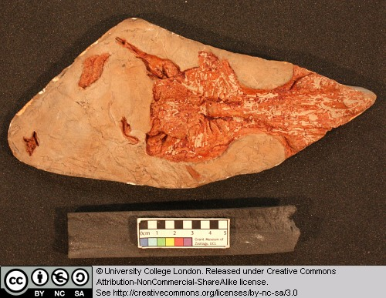

3.16 Seymouria

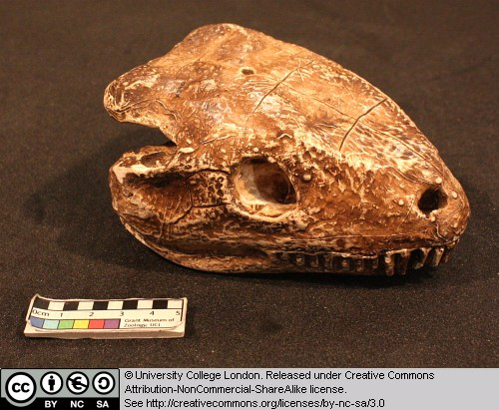

This specimen is a cast of the skull of Seymouria. Members of the Seymouriamorpha are thought to be close relatives of the amniotes (the group that contains mammals, lizards, snakes, crocodiles, turtles and birds).

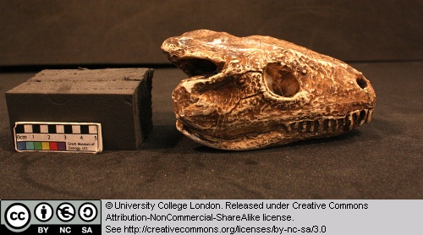

Observe the general form of the skull, the presence of orbits and the forwardly placed nostrils, the teeth etc.

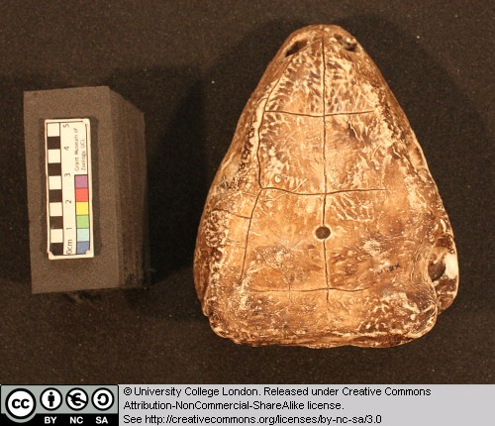

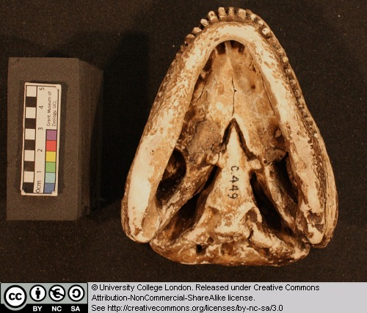

3.17 Other taxa

In this chapter we also revist Raja and Amia from Chapter 1 and Clupea and Pterapsis from Chapter 2.

Chapter 4: Amphibians & Amniotes

This chapter allows you to take a second look at some of the early tetrapods (temnospondyls, baphetids, nectrideans etc.), and introduces you to the modern amphibians and some amniotes. The chapter includes some extant material, especially frogs, salamanders and turtles.

4.1 Loxomma

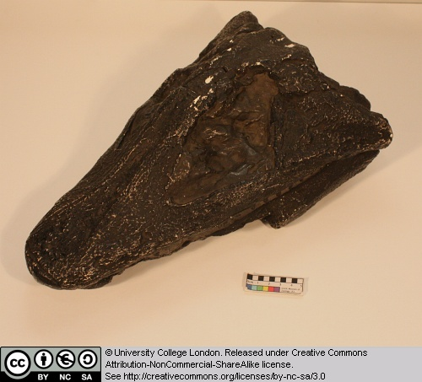

Loxomma is a member of a group of early tetrapods called loxommatids. Loxommatids (also called baphetids) appear in the Early Carboniferous, but were most common during the later part of this period. This group is known from a few skulls and mandibles, but virtually nothing is known about their postcranial skeletons. Baphetids can be recognised by the possession of one clear derived character state: the orbit (eye socket) is extended forward, giving this opening a ‘keyhole’ shape.

What animal does this skull remind you of – and what do you think Loxomma ate?

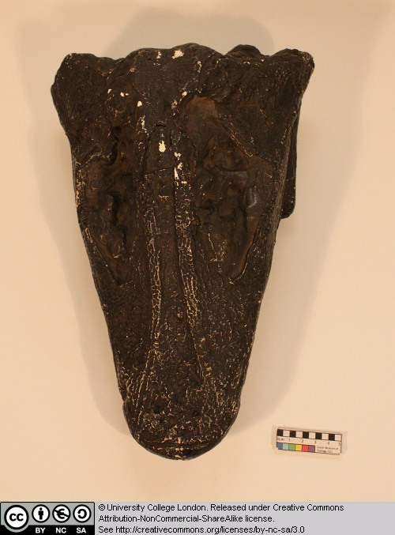

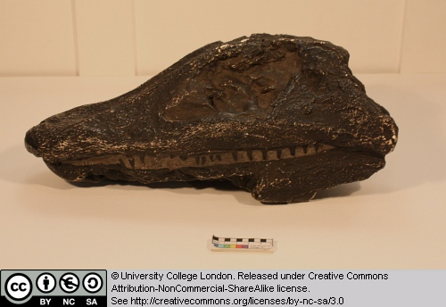

4.2 Amphibamus grandiceps

These two casts are of the anterior portions of two individuals. Amphibamus is a dissorophoid temnospondyl from the mid-Permian of North America. It is an interesting and important animal because dissorophoids have been suggested as potential ancestors of the frogs or perhaps all lissamphibians.

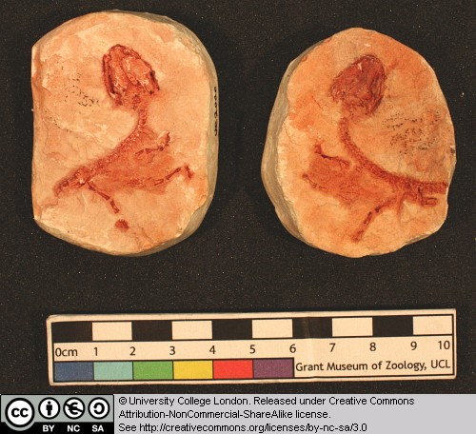

Note the structure of the skull, especially its large openings for the eyes etc. Compare one of these casts with one or more of the frog and salamander skeletons.

4.3 Dissorophus multicinctus

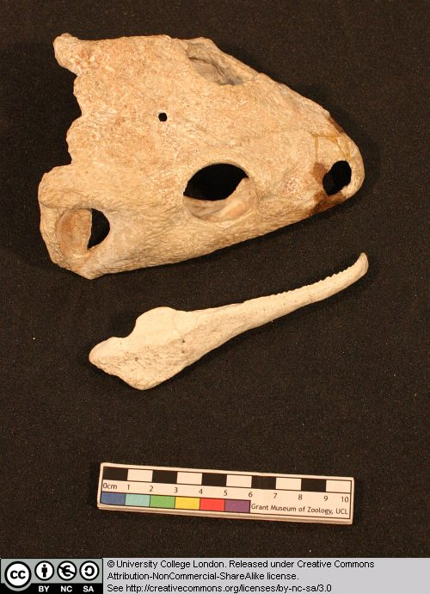

This is the skull of a dissorophoid temnospondyl. Dissorophoids may have given rise to the ancestors of frogs, or perhaps all lissamphibians.

Note the presence of large palatal vacuities. Identify the other major openings in the skull (what is the most posterioropening on the side of the skull, immediately behind the eye?).

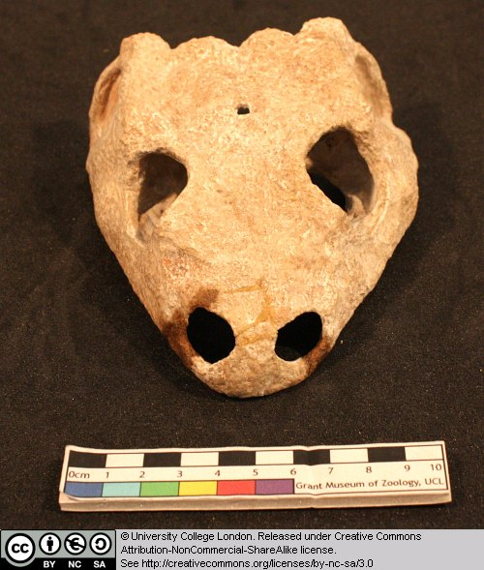

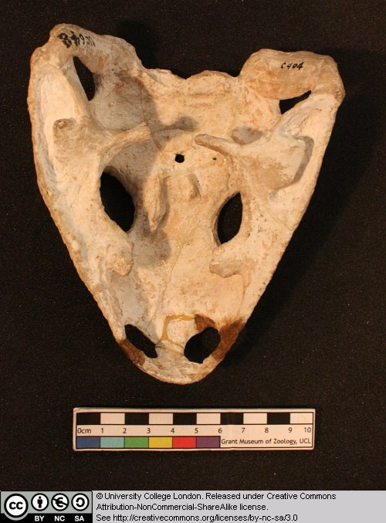

4.4 Palaeobatrachus goldfussi

This is a cast of a complete fossil frog.

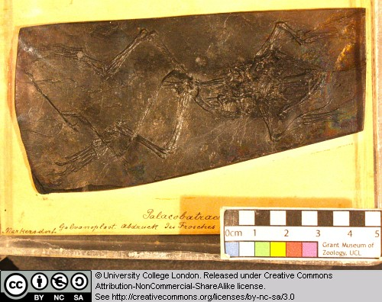

Note the presence of: the open and lightly built skull, the short trunk region (how many vertebrae can you count), the urostyle, the absence of ribs, the specialised ilium, and the long back legs.

4.5 Cryptobranchus [The giant salamander]

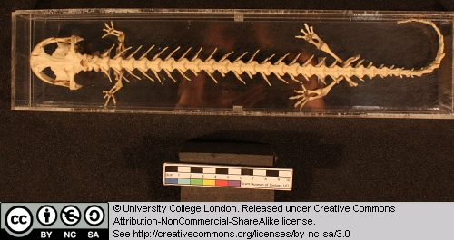

This is the skeleton of an extant salamander. Note the following features: the open structure of the skull, the elongate body and relative shortness of the hind limbs, the long tail.

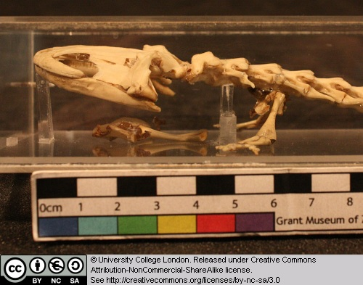

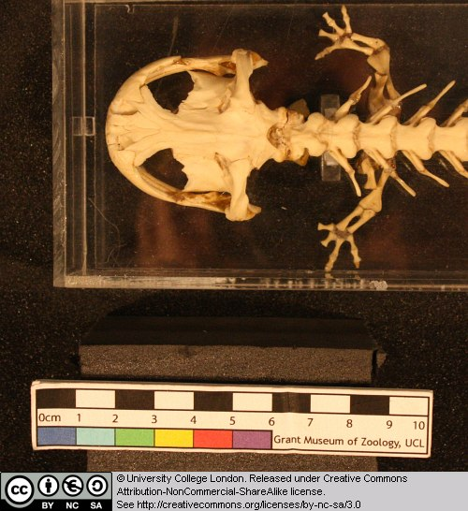

4.6 Amphiuma neaus

This specimen is partially obscured by the lables of the container.

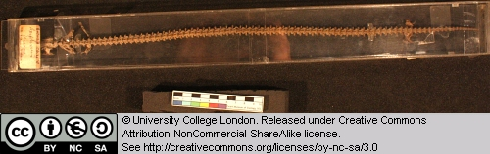

This is the skeleton of a highly aquatic extant salamander. What features suggest its adaption for life in water?

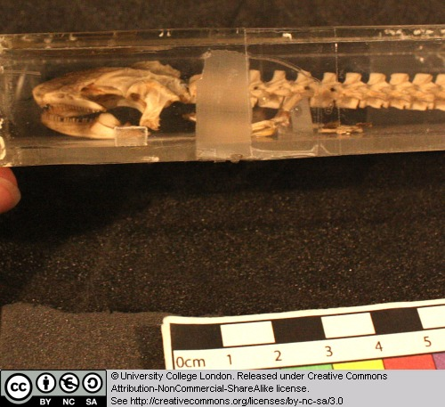

4.7 Ichthyophis

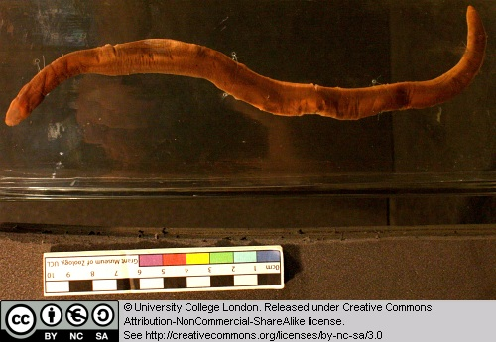

This is a preserved specimen of an extant caecilian. Note the following features: the complete absence of limbs, the elongate body that seems to be composed of numerous segments, the small head (can you see eyes? Can you detect a small tentacle-like structure in front of where the eyes should be?).

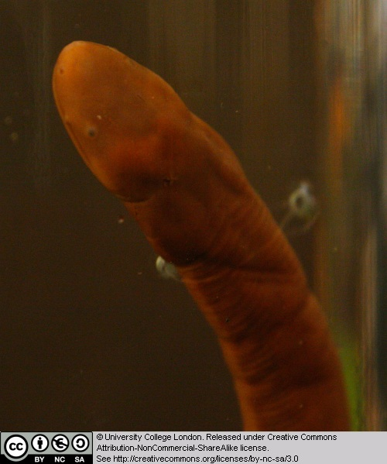

4.8 Diadectes sp.

This is the cast of a skull of a very close relative of the amniotes. Diadectomorphs lived during the Late Carboniferous and Permian.

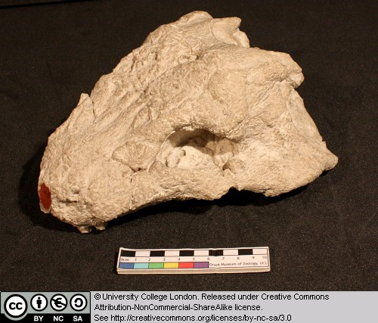

Make sure you can identify the main openings in the skull. Notice that there are no openings in the temporal region (the area immediately behind the eye). Compare this temporal area with its equivalent in one of the true amniotes, such as Dimetrodon [seen in Chapter 1] or the procolophonids).

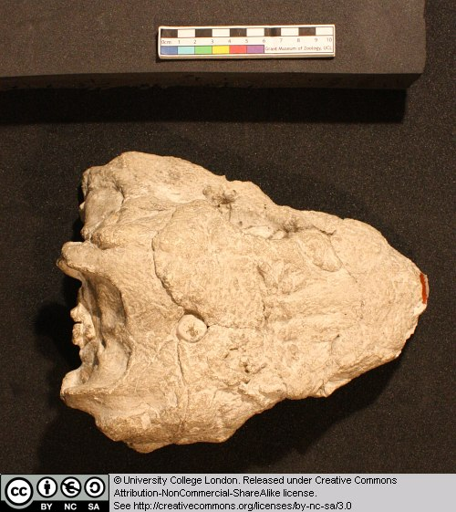

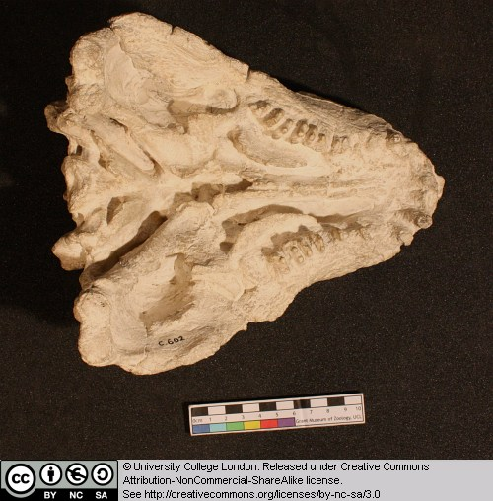

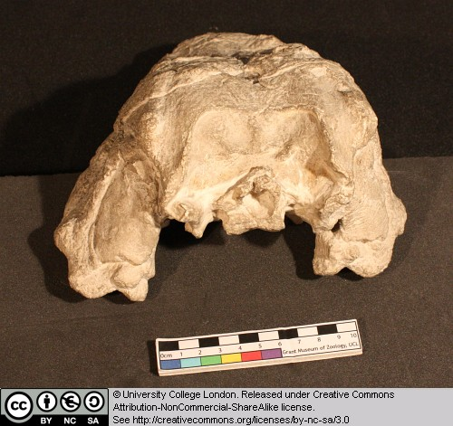

4.9 Labidosaurus sp.

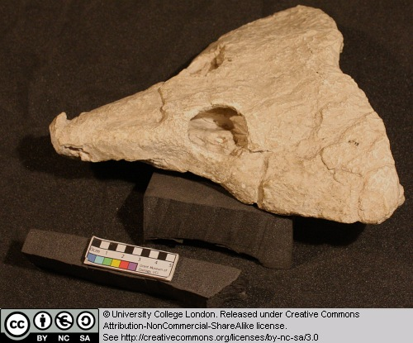

This is the skull of an early amniote from the Late Permian of North America. Labidosaurus is a captorhinid, a group of small to medium sized amniotes that probably fed on invertebrates and other small vertebrates.

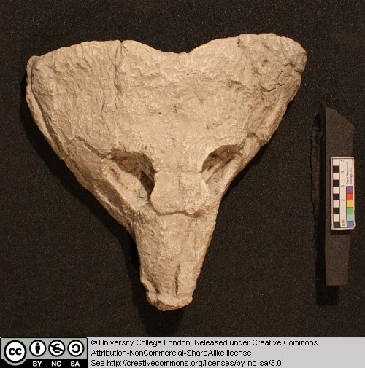

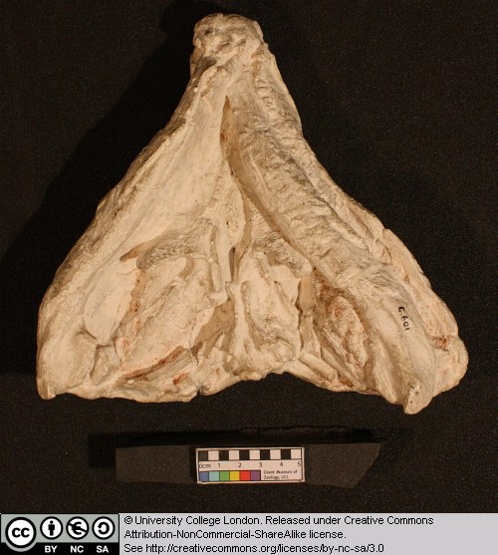

Note that there are no openings in the temporal region (the area immediately behind the eye on the side of the skull). Can you detect the transverse flange of the pterygoid which is characteristic of amniotes (look at the palate of the animal and see if you can detect paired downwardly projecting ridges at the back end of the palate).

4.10 Procolophon sp.

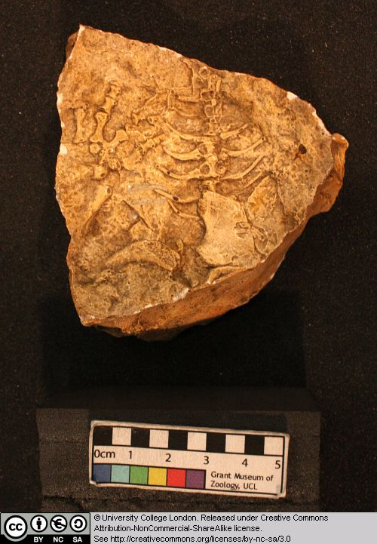

This is a cast of the skull, lower jaw and shoulder girdle of a procolophonid. This group includes fairly small amniotes from the Permian and Triassic. Procolophonids and pareiasaurs (see Bradysaurus and Scutosaurus) are thought to be closely related to each other according to several recent cladistic analyses. Together with a few other groups of early amniotes procolophonids and pareiasaurs are regarded as members of a clade called the parareptiles. Turtles may have evolved from parareptile ancestors: some authors have suggested the procolophonids, others have proposed the pareiasaurs (but these hypotheses remain controversial).

Procolophonids can be recognised by several features in the skull. Note: the skull is subtriangular in dorsal view, and is somewhat dorsoventrally flattened, the orbit is emarginated along its back edge (what might this feature have been for?), in some forms there are various spikes of bone on the head (see Hypsognathus): what function might these have served?

4.11 Hypsognathus fenneri

This is the cast of the skull and lower jaw of a procolophonid.

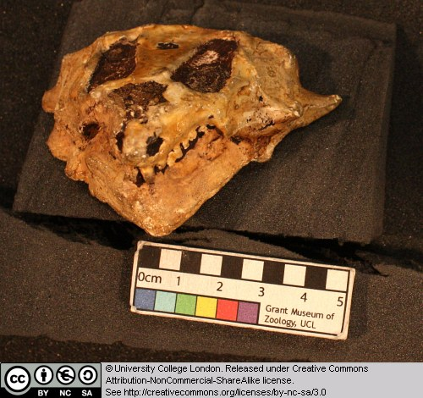

Procolophonids are members of a parareptile clade of amniotes which also includes the pareiasaurs and possibly turtles. Note the dorsoventrally flattened, subtriangular head, which possesses little bumps and spikes on its surface. These features, combined with the emargination of the posterior margin of the orbit, are highly characteristic of the procolophonids. (See also Procolophon).

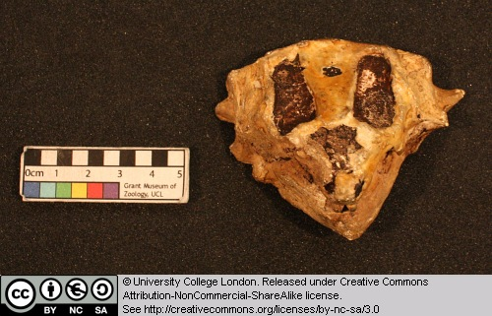

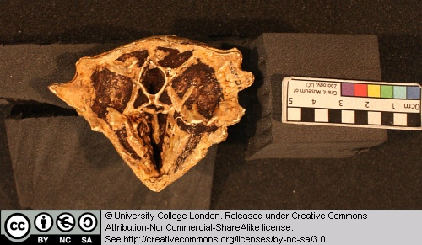

Can you identify the transverse flange of the pterygoid that tells you this animal is probably an amniote?

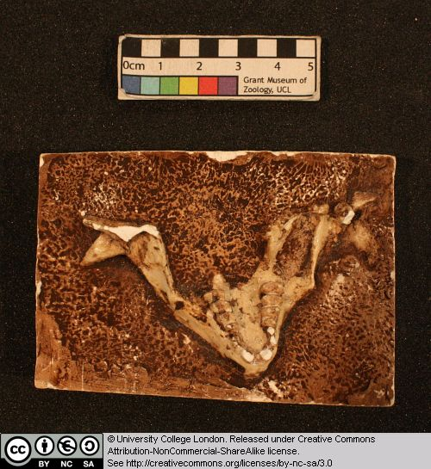

4.12 Other taxa

In this chapter we also revisit Diplocaulus and Seymouria from Chapter 3 and the toad and Dimetrodon from Chapter 1.

Chapter 5: Lepidosaurs and Chelonians

This chapter will look at lepidosaurs and Chelonians. When you look at the various specimens, focus on the femestration of the skulls, and their kinetic joints [if present].

5.1 Plesiosaurus microcephalus

This is a cast of the skull and mandible of a plesiosaur. The sauropterygian reptiles contain a variety of aquatic forms from the Mesozoic, including the plesiosaurs. The relationships of sauropterygians to other reptiles are still controversial, although many workers now believe that sauropterygians and lepidosaurs belong in the same clade (the Lepidosauromorpha).

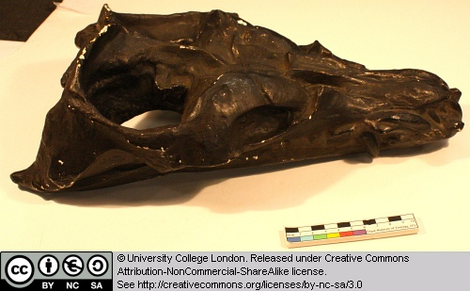

Identify the major openings of the skull. Can you find the temporal openings and bars? Note the narrow and forwardly projecting teeth. What kind of food might this animal have eaten?

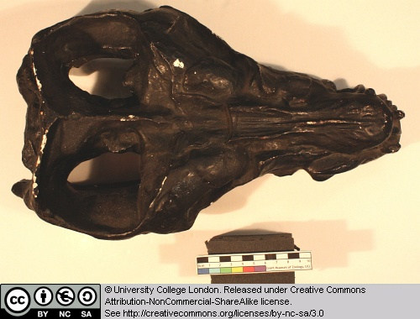

Can you find the external nostrils – these are typically retracted in plesiosaurs, reflecting their aquatic lifestyle.

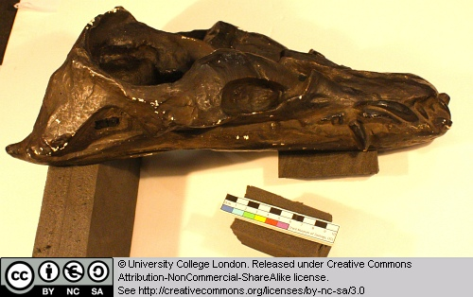

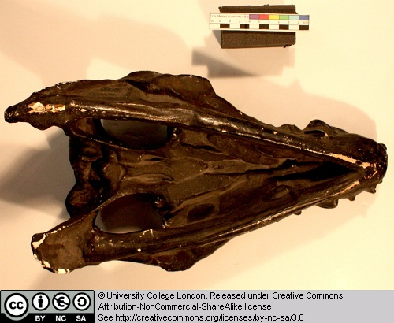

5.2 Plesiosaurus sp.

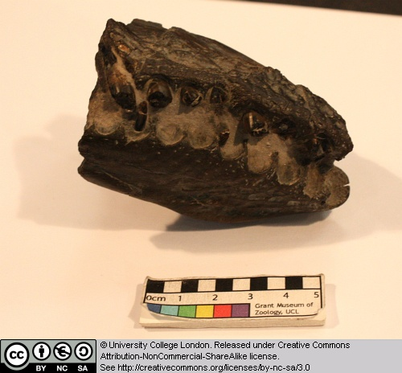

This is the front part of the skull and lower jaw of a plesiosaur. It is difficult to see details because of the state of preservation, but note the shape and orientation of the teeth.

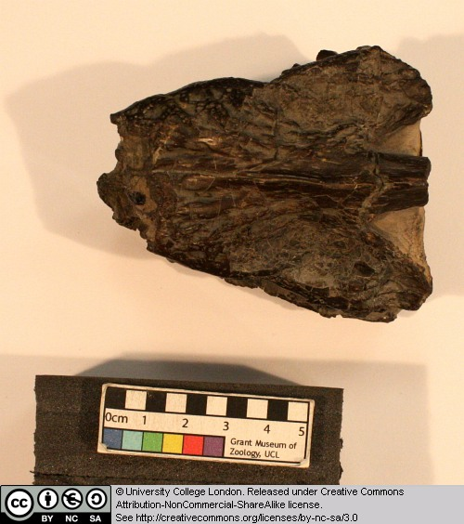

5.3 Sphenodon (the tuatara)

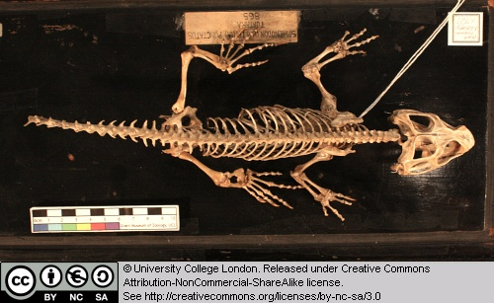

This is the skeleton of Sphenodon, the only extant member of the once diverse sphenodontids (members of the Rhynchocephalia). This group is believed to be the sister-group of the Squamata (lizards, snakes and amphisbaenids), together forming the Lepidosauria.

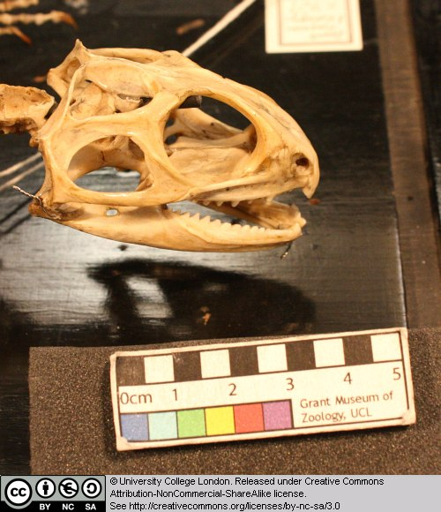

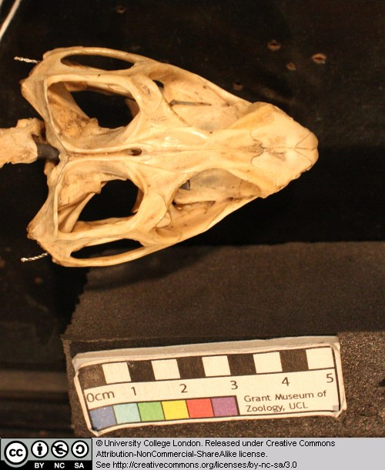

Note the structure of the skull, especially the temporal openings and temporal bars.

5.4 Homoeosaurus sp.

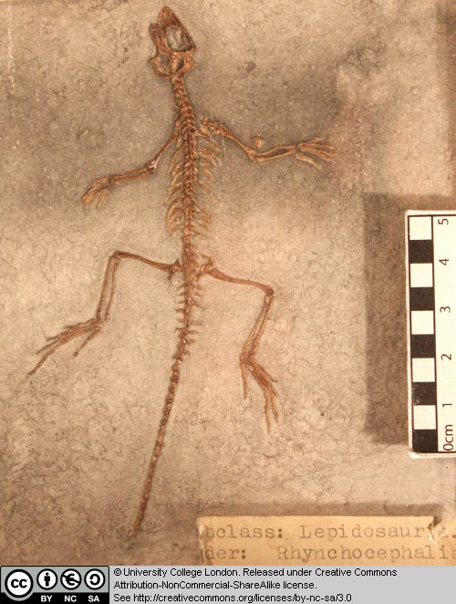

This is a cast of the skull and skeleton of a small sphenodontid from the Late Jurassic of Germany. It is difficult to see details on such a small specimen, but note the long tail and general body proportions.

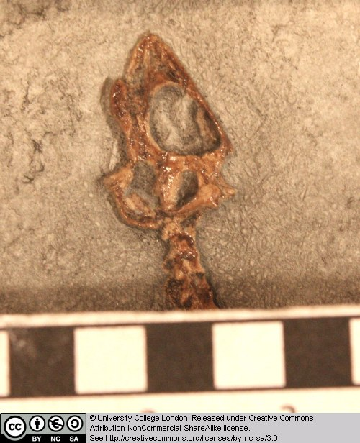

Which openings can you identify in the skull?

5.5 Homoeosaurus maximilliani

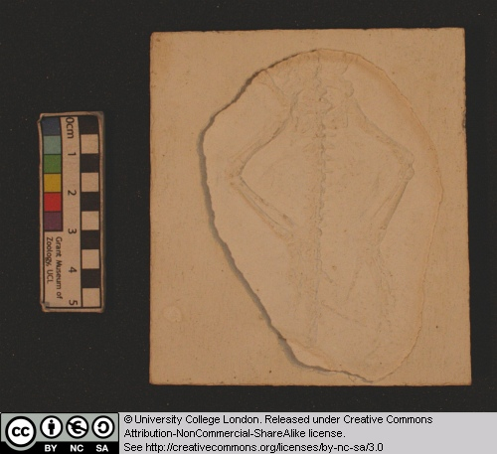

This is the skull and skeleton of a sphenodontid from the Late Jurassic of Germany. Note the general body proportions and the long tail. Can you identify the openings in the skull?

5.6 Amphisbaena sp.

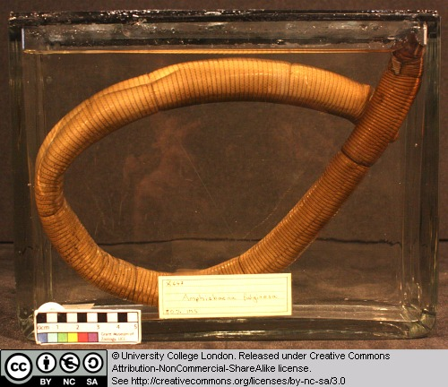

This is a preserved specimen of an extant amphisbaenid squamate. Amphisbaenids are limbless burrowing forms.

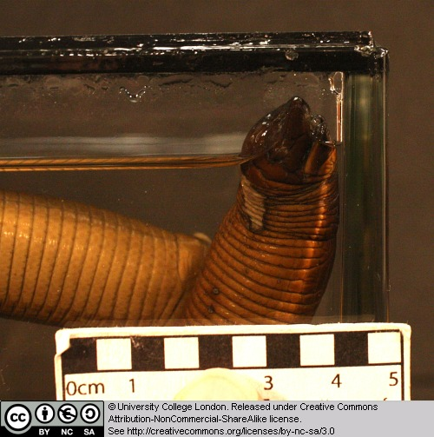

5.7 Amphisbaena skull

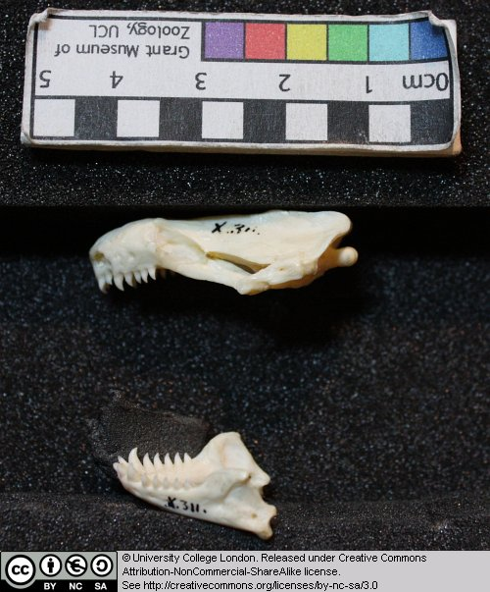

This is the skull of an extant amphisbaenid. Can you identify the openings in the skull, particularly the temporal openings?

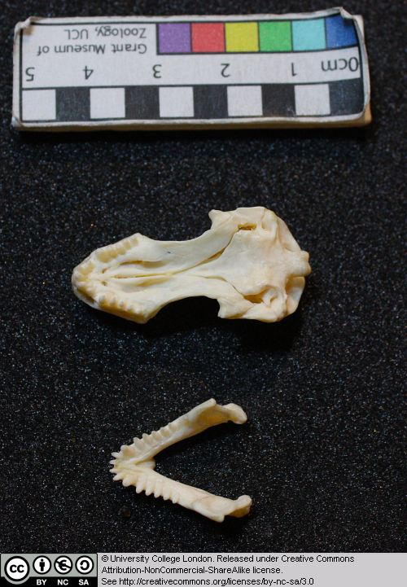

5.8 Eunectes murina (the anaconda)

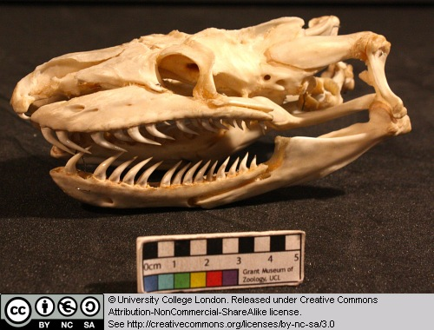

This is the skull of the anaconda – the world’s largest snake. Note the structure of the temporal region, including the absence of temporal bars. Note the shape and position of the teeth.

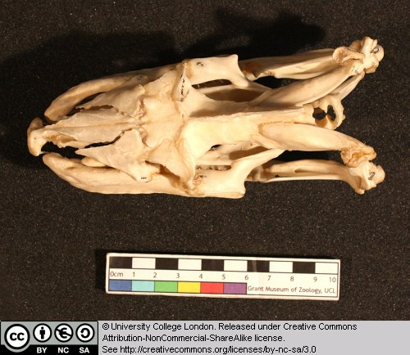

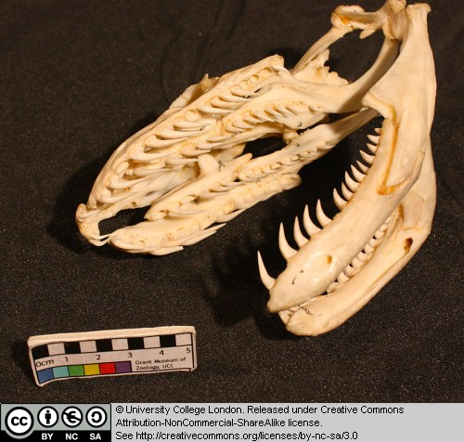

5.9 Cholydra serpentina (Ridley's sea turtle)

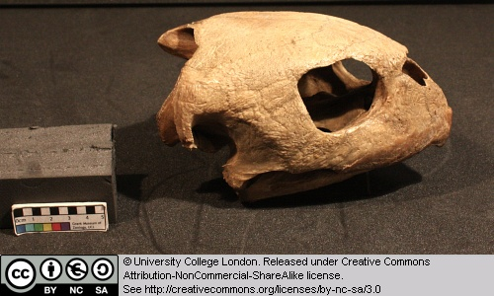

As the name suggests, this is a fully marine turtle. Turtles (the Chelonia) are amniotes, but their precise relationships are still controversial. Some workers have suggested that they evolved from the parareptiles, while others have argued that turtles are highly modified archosaurs (the latter being the group that contains crocodiles, dinosaurs and birds).

Note the main openings in the skull, emargination of the skull's back margin, and the ear region.

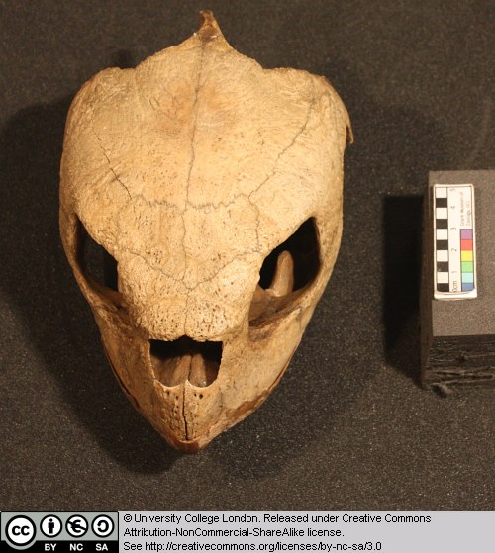

5.10 Eretmochelys imbricata (Hawksbill turtle)

Turtles (the Chelonia) are amniotes, but their precise relationships are still controversial.

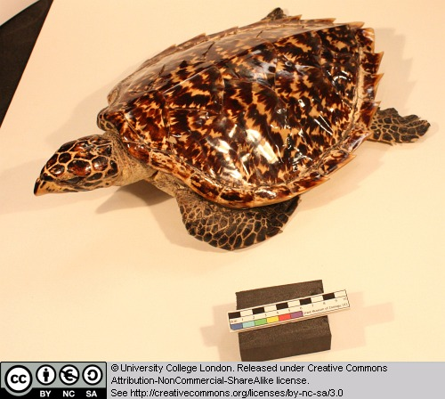

Note the following features: the low and relatively undomed carapace, marine turtles often reduce the carapace, compare the flipper-like structure of the feet in this form, with the less modified versions in the matamata.

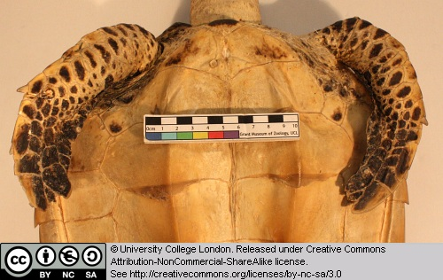

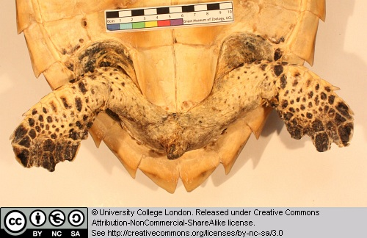

5.11 Testudo hermanni (a terrestrial tortoise)

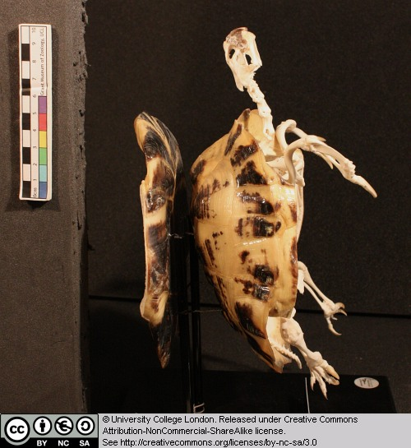

This is the skull, beak, skeleton and shell of a terrestrial tortoise. (Note: this specimen has the plastron [the ventralpice of chest armour] removed and mounted on the back). Look at the structure of the skill and beak – note the absence of teeth and the ridged edge of the beak. Examine the emarginations at the back margin of the skull – these embayments held large jaw closing muscles.

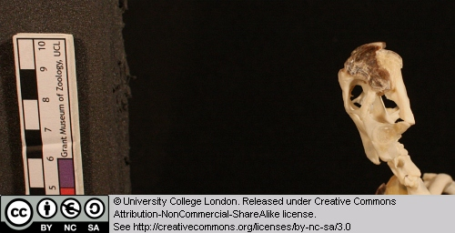

Note the way the pectoral and pelvic girdles are held within the shell, effectively within the rib cage.

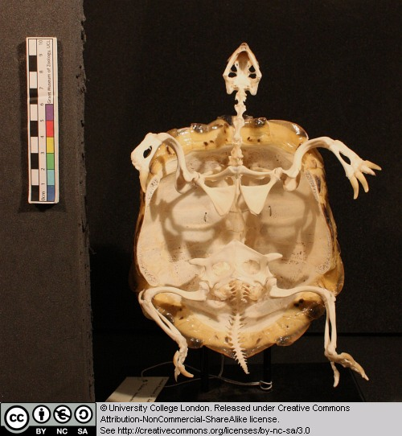

Compare the limbs of this tortoise with those of the aquatic forms. The shell here is more domed that in aquatic forms.

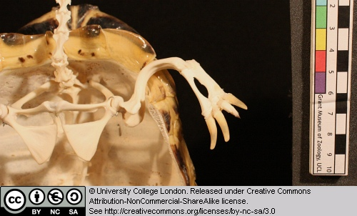

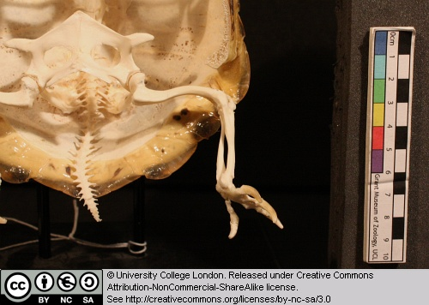

5.12 Other taxa

A number of previously seen species are revisited in this chapter. The toad Bufo, monitor lizard Varanus and matamata Chelys from Chapter 1, and Cryptobranchus and Hypsognathus from Chapter 4.

Chapter 6: Archosaurs

This chapter will look at archosaurs. As you look at the various specimens, focus on the fenestration of the skull.

6.1 Hyperodapedon gordoni

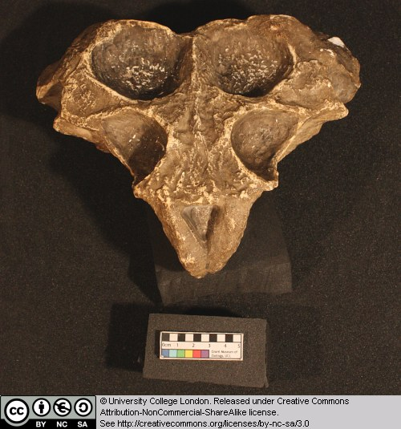

This is a cast of the skull and lower jaw of a rhynchosaur. Rhynchosaurs are basal archosauromorphs. They are characterised by a beak-like snout. Note the single external nostril at the front of the snout – in life the flesh of the nose probably divided this into two openings.

Although rhynchosaurs are archosauromorphs, they lack the antorbital opening and external mandibular opening. Identify the orbits and the temporal openings and bars.

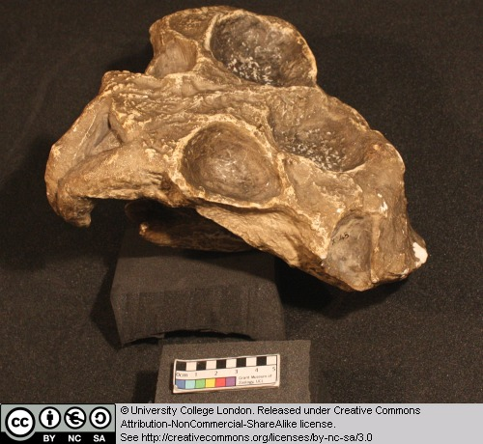

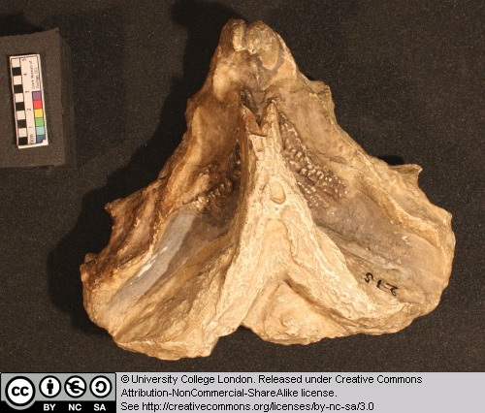

6.2 Euparkeria

This is a cast of the partial skull of Eurparkeria, an archosauriform reptile from South Africa. Don’t expect to get too many anatomical details from this one as it is disarticulated and incomplete, but it is worth examining.

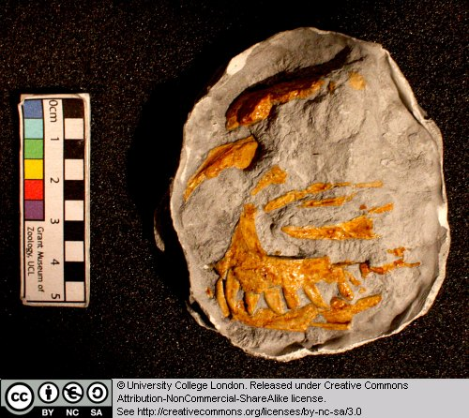

Here are two web resources for this taxon. The first is a brief review and contains a life reconstruction. The second includes anatomical reconstructions of the skull and the whole body.

6.3 Sphenosaurus

This is a cast of the head, vertebral column and ribs of an extinct eusuchian crocodile from the Late Cretaceous of North America and Europe.

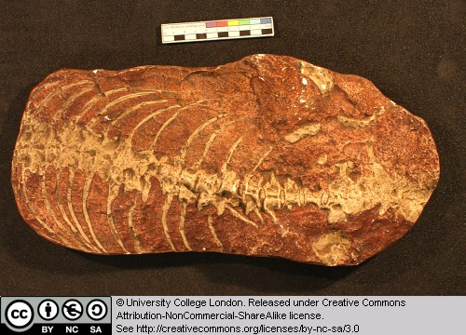

6.4 Crocodylus

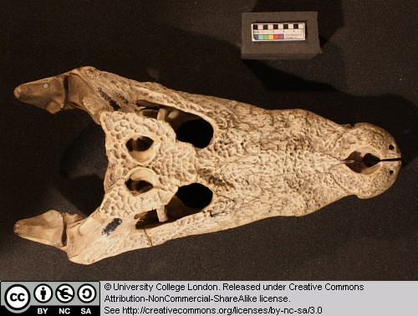

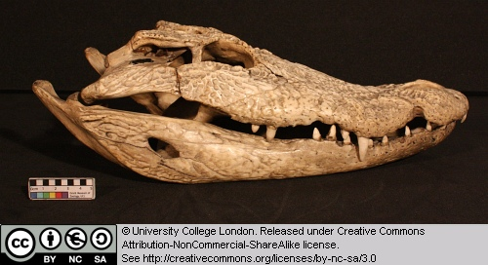

This is the skull of an extant crocodile, though a different specimen from that seen in Chapter 1.

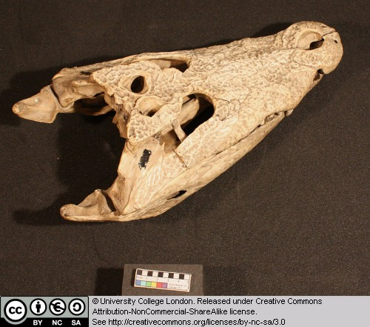

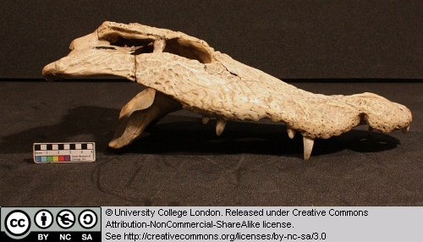

Identify as many of the openings in the skull as you can. Note the absence of the antorbital fenestra. Note the complex sculpturing of the external dermal bone surfaces.

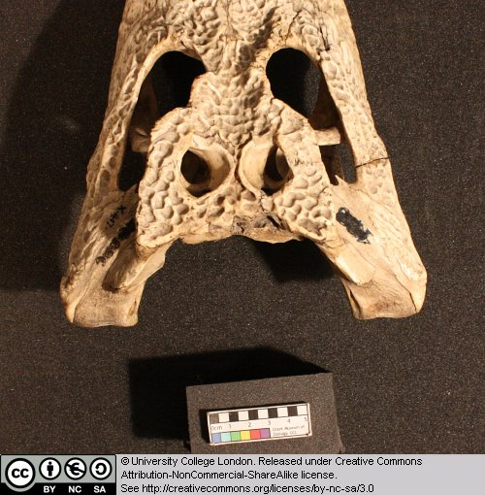

Look at the simple tooth shape and note how the upper and lower sets of teeth interdigitate.

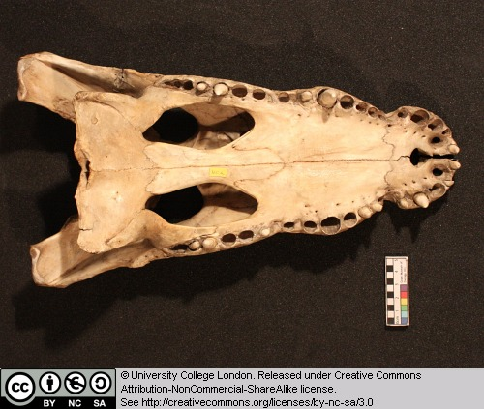

Examine the bony secondary palate and consider which bones are involved in its formation. Locate the internal nares and work out where the nasal passages must run in order to link internal and external nares. Where would the major jaw closing and opening muscles be located?

Note that the snout is relatively broad and flat and compare its general shape with that seen in Tomistoma later in this practical. Note how the jaw margin undulates along its length – why would this be a useful adaptation?

6.5 Tomistoma

This is a typical ‘longirostrine’ form specialised for eating a more exclusively fish-based diet. Elongation of the snout in a manner similar to this seems to have occurred several times during the evolution of crocodiles and today the forms with the longest snouts include the gavial, false gavial (shown here), Johnston’s crocodile, the African long-snouted crocodile and the New Guinea crocodile. Tomistoma is found in south-east Asia and northern Australasia.

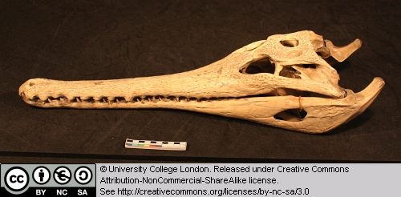

Examine the long snout, external and internal nares, tooth crown shape, and the manner in which upper and lower sets of teeth interact.

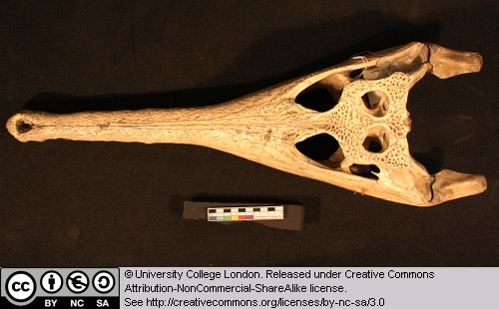

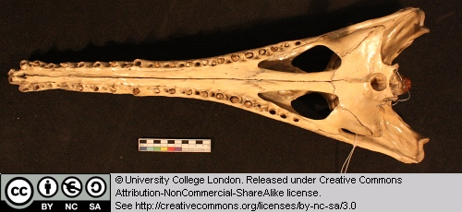

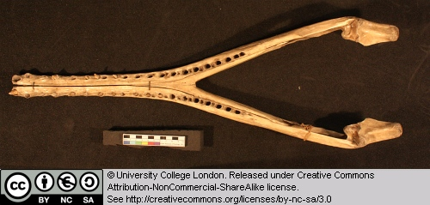

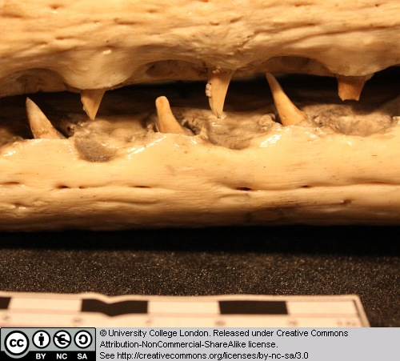

Photographs of a wide variety of living crocodiles including Tomistoma are shown here. Note the differing jaw and skull shapes present.

6.6 Scaphognathus crassirostrus

Pterosaurs were flying archosaurs. Their wing membrane was supported by the forelimb, including a long fourth digit on the hand. This small form is known from the Late Jurassic of Europe.

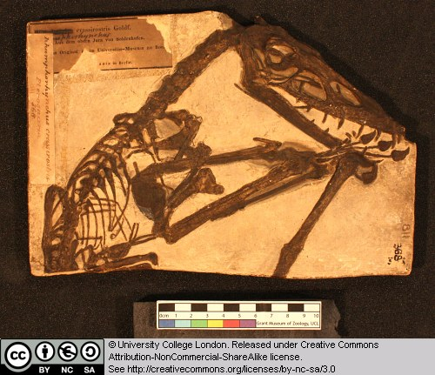

Note the presence of long, forward slanting teeth. The skull is long and low. Study the elements of the forelimb.

6.7 Pterodactylus antiquus

Pterosaurs were flying archosaurs. Their wing membrane was supported by the forelimb, including a long fourth digit on the hand. This is a cast of a representative pterodactyloid from the Late Jurassic of Europe.

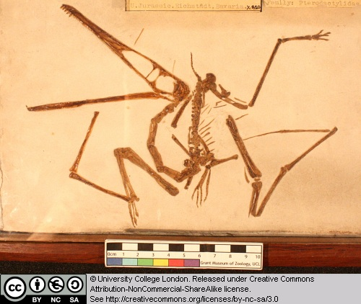

This website has a great deal more on pterosaurs and their evolution.

6.8 Coelophysis sp.

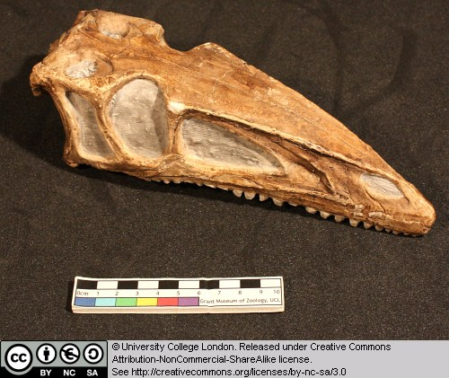

This is a cast of the skull and mandible of a small theropod dinosaur from the Late Triassic of New Mexico and Arizona. Note the long low shape of the skull, with its numerous small teeth and highly fenestrate construction.

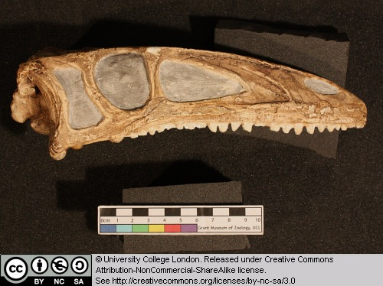

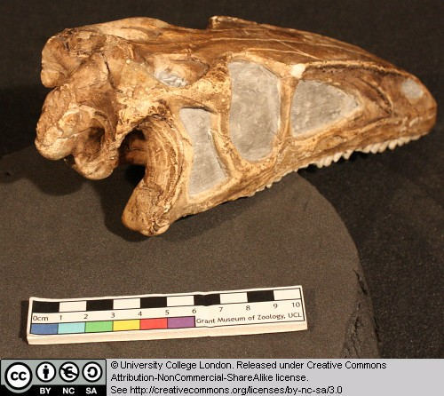

Identify the major openings in the skull. Can you find the choanae (the internal nostrils – on the palate)?

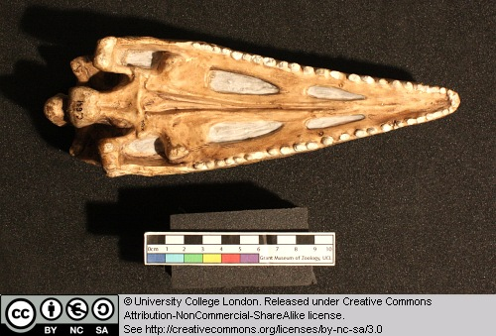

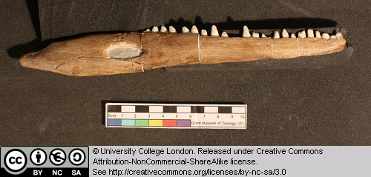

6.9 Megalosaurus bucklandi

This is a cast of the premaxilla and maxilla of a large theropod dinosaur from the Middle Jurassic of Oxfordshire.Megalosaurus is a poorly understood form, partly because it is known from a large quantity of fragmentary and disarticulated material. Recent studies suggest that it is a basal tetanuran theropod. Megalosaurus is of considerable historical interest because it is the first dinosaur genus to be named – William Buckland published the name in 1824.

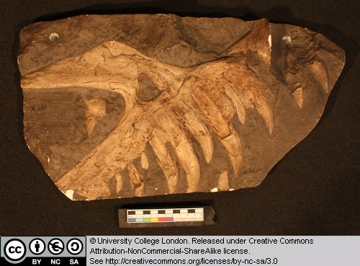

Note the presence of large recurved tooth crowns. Can you identify the ‘ascending process’ of the maxilla, which forms the anterior margin of the antorbital fenestra?

6.10 Dinosaur footprint

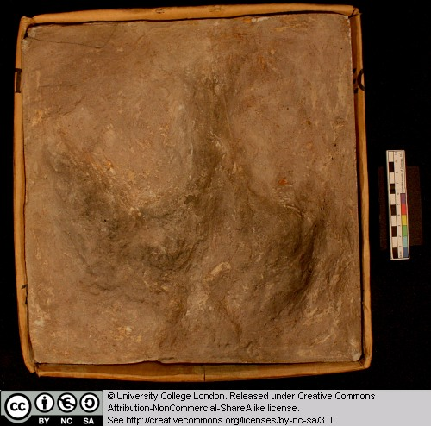

This is the cast of a footprint from a large theropod dinosaur. Such footprints are usually ‘three-toed’, although their structure is highly variable because of variations in the substrate combined with the way the foot was emplaced during the stepping motion. Ornithopods often produce large three-toed tracks, and it is sometimes difficult to distinguish them from those of theropods.

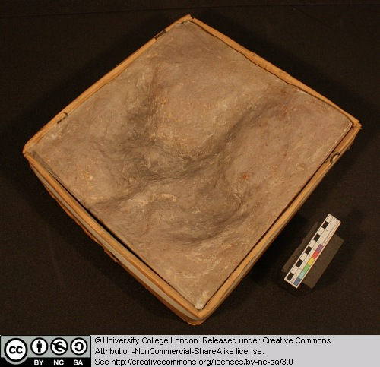

6.11 Theropod egg

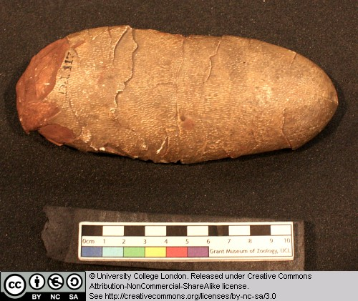

This is a cast of part of an oviraptorosaur dinosaur egg. Note the elongate shape of the egg. Egg shape is highly variable in dinosaurs, with some being spherical and others more elongate. This variation may partly reflect the type of dinosaur that produced the egg (e.g. sauropods tend to lay spherical eggs), and may also indicate the way the eggs were stacked in the nest.

There are now several specimens known with an adult animal brooding on the nest of eggs as seen here.

6.12 Iguanodon sp.

This is a femur of Iguanodon, an Early Cretaceous ornithopod dinosaur from southern England and Belgium.

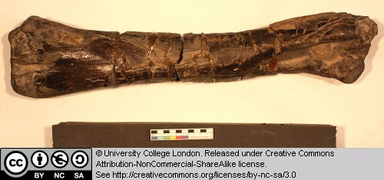

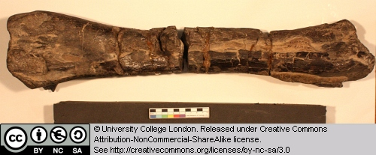

Note the presence of two articular condyles at the end of the femoral shaft, which form part of the knee joint.

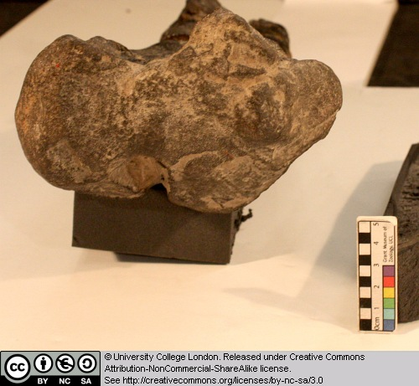

6.13 Dinosaur skin

This is a cast of the skin impression of a hadrosaur dinosaur.

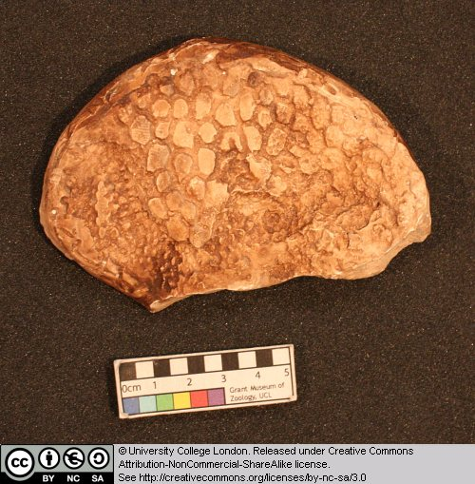

6.14 Other taxa

A number of taxa were also covered in this chapter that had appeared in previous chapters.

The dinosaur Compsognathus.

The crocodilian Alligator.

These are detailed in Chapter 1.

Chapter 7: Birds and flight

This chapter will look at the anatomy of birds, especially with regard to the structure of their skulls and locomotor systems. Some non-birds are also included for revision and comparison.

7.1 Noctule bat

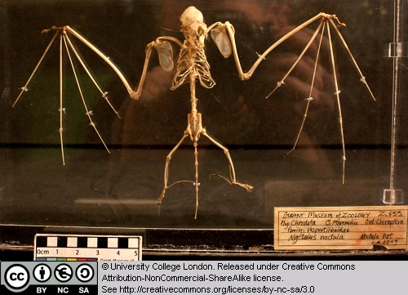

This is the skeleton of a bat. Look at the skeleton support for the wing membranes and compare it with the system used by birds and pterosaurs.

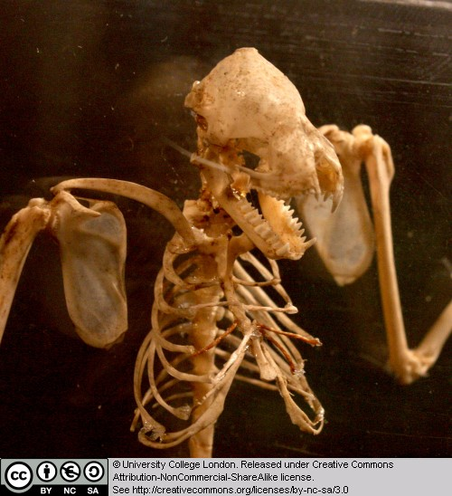

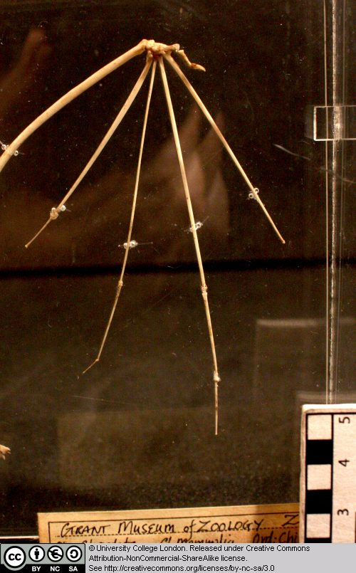

7.2 Archaeopteryx

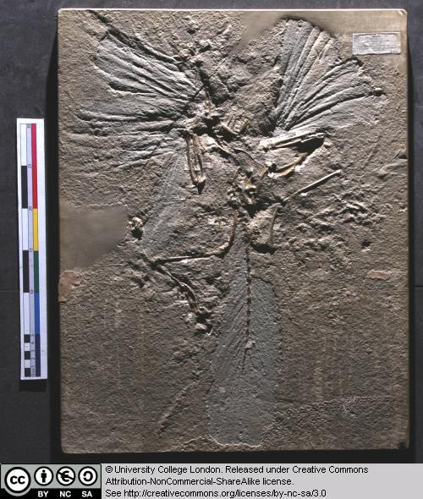

This is a cast of the London Archaeopteryx specimen. Look at the feathers – which parts of the animal do they cover? Examine the wing feathers – are they symmetrical or asymmetrical?

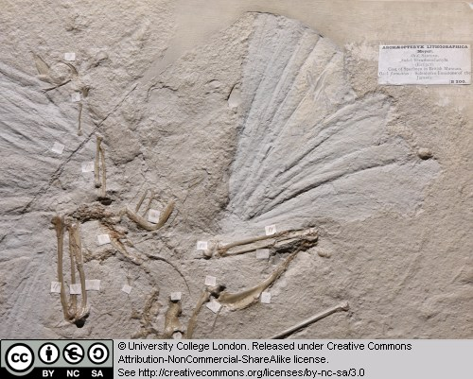

Compare the anatomy of Archaeopteryx with that of Compsognathus and the modern birds. What differences and similarities can you detect?

There are now ten specimens of Archaeopteryx known and occaionally new specimens come to light. Some of the previous ones can be seen here, here, and here.

7.3 Rhea

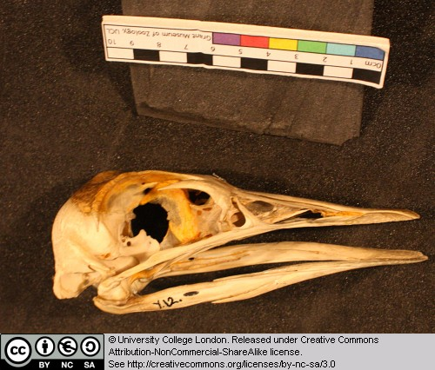

The Rhea is a large flightless bid from South America. Examine the light construction of the skull and beak region.

Try to identify as many of the openings in the skull as you can. Note the enlarged braincase – birds have large brains compared to their reptilian ancestors.

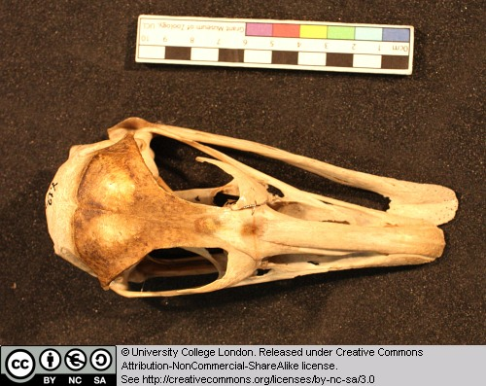

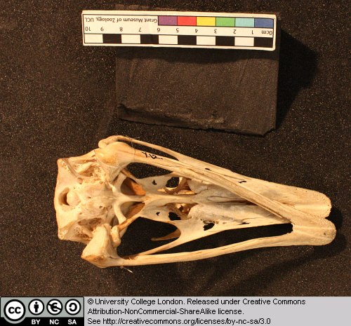

7.4 Fulmaris glacialis (the Fulmar)

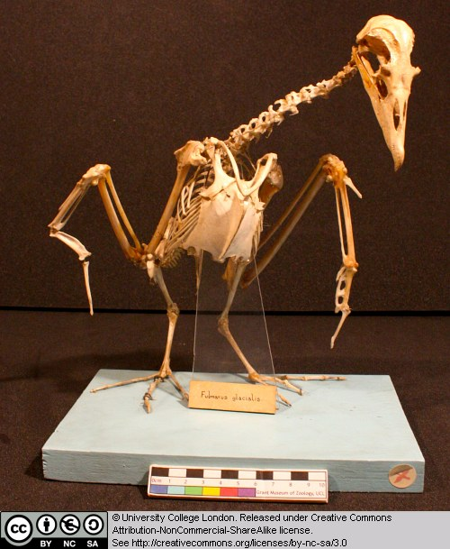

This is the skeleton of a sea bird found around the coasts of western and northern Europe. Examine the following: the rib cage and sternum (breast bone area) where the major flight muscles attach, the furcula (wish-bone), the form of the wing bones (try to identify the humerus, ulna and radius, and fused finger bones), the pygostyle (fused bones at the base of the tail), the short femur, the openings in the skull – note how the diapsid skull has been modified through the loss of some of the struts.

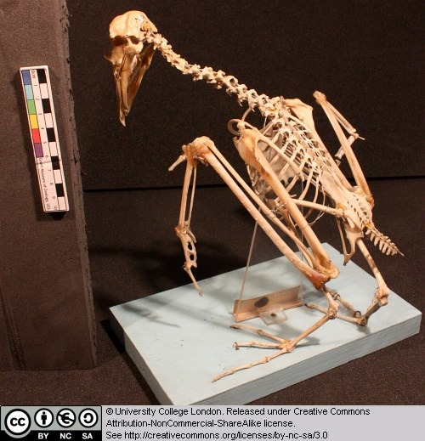

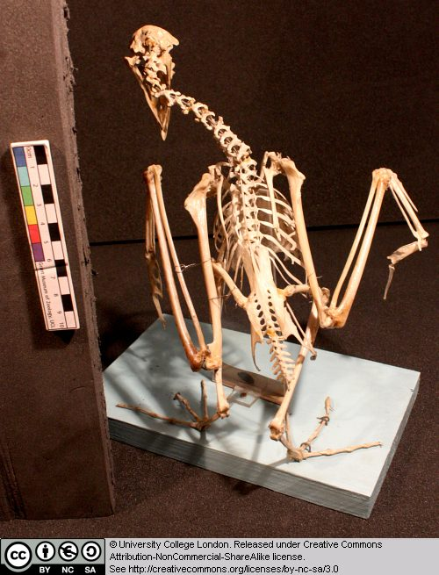

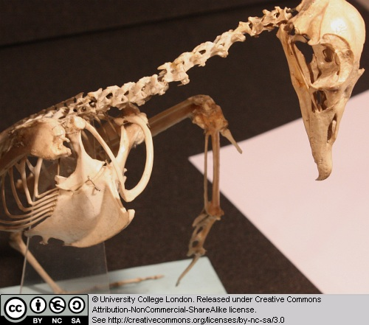

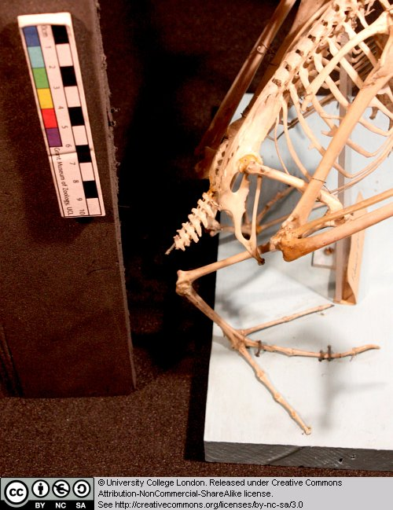

While you are here, look at the skeleton of Archaeopteryx, and those of extant birds, in the cases. Try to identify some of the features listed above while looking at these specimens.

7.5 Penguin (species unknown)

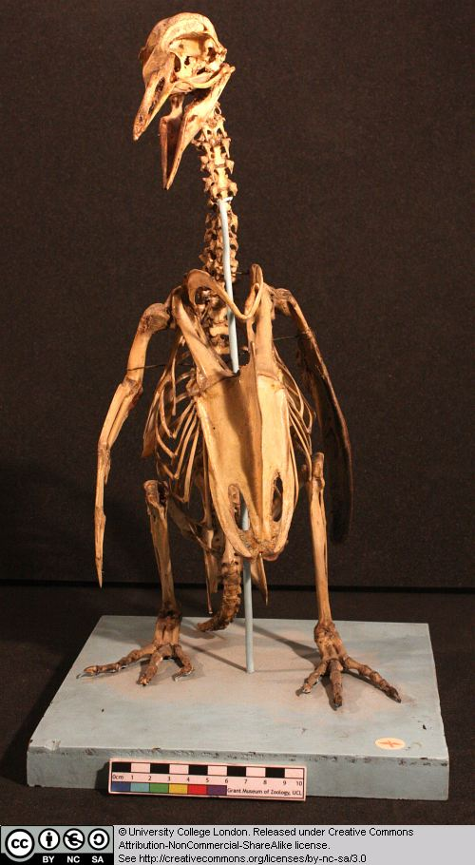

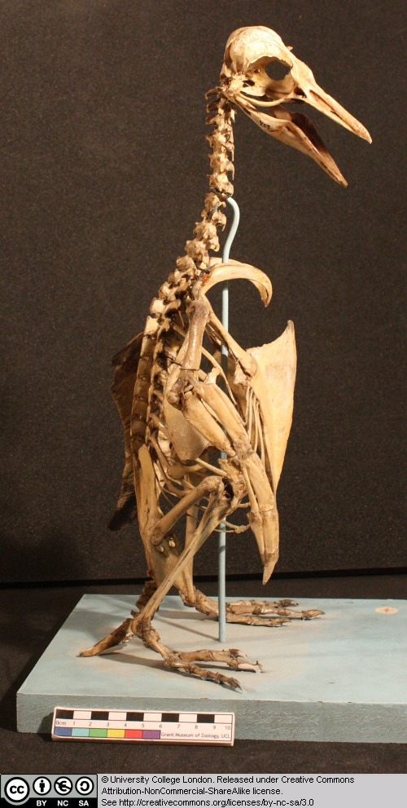

Penguins are flightless birds found around the coast of Antarctica, and also South America and Africa. Note the structure of the skull, including the openings.

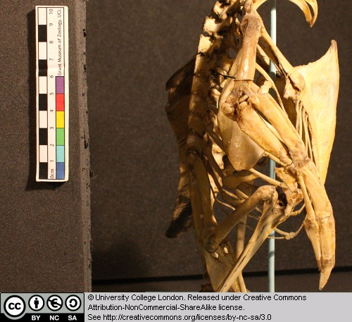

Penguins are unusual because of their relatively upright posture – compare with the other bird skeletons. The wings are used for underwater swimming – compare their structure with that in the Fulmar.

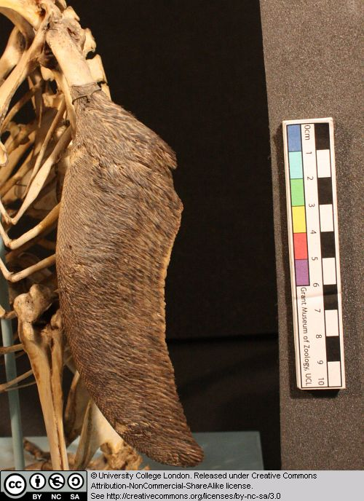

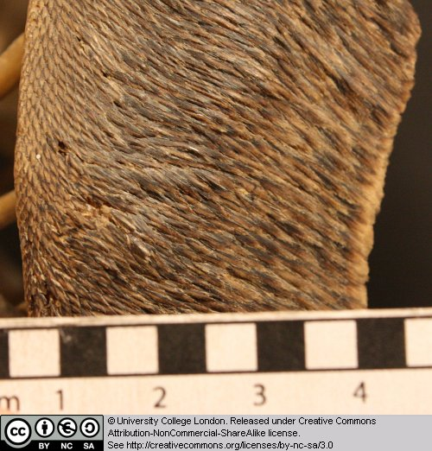

7.6 Gallus

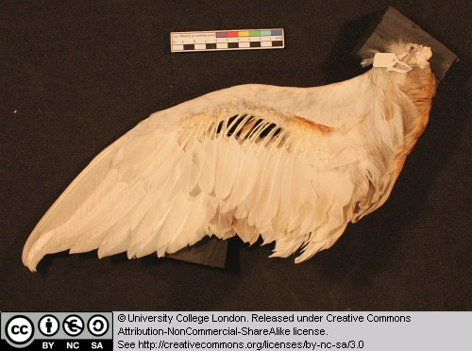

This is the wing of the chicken. Note the insertion points for the large ‘primary’ flight feathers. Examine feather structure. Not the central rachis and the barbs on either side. Are the large flight feathers symmetrical or asymmetrical?

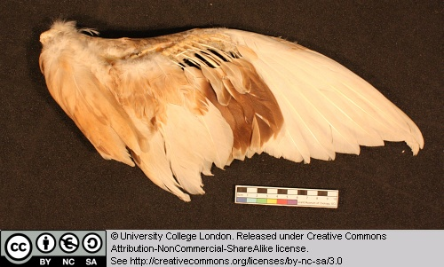

7.7 Other taxa

A good number of taxa from previous chapters were revisited in this session. These were the monitor lizard, the dinosaur Compsognathus and the parrot from Chapter 1, the tuatara, Amphisbaena, the annaconda, and the tortoise from Chapter 5, and finally the pterosaurs Scaphognathus and Pterodactylus from Chapter 6.

Glossary

A

akinetic
In anatomy, this refers to a low level of flexibility in a structure due to a lack of moveable joints.

amniote
Those vertebrates with an amniotic egg. The extant clades are Testudines (turtles), Diapsida (lepidosaurians, crocodilians, and birds), and Synapsida (mammals).

anapsid
Skull possessing no temporal fenestrae (NB. an- = without).
Amniotes with this skull condition form a paraphyletic group including the Parareptilia (turtles and their extinct relatives), the extinct common ancestor of all amniotes, and basal eureptiles (the extinct precursors of diapsids).
Note that the Testudines (turtles and relatives) have modified the anapsid condition through a reduction (emargination) of the posterior region of the skull.

Apatite
Calcium phosphate: the crystalline component of bone.

apomorphy
A derived or specialised character.

Appendicular skeleton
The endoskeletal element of the fins or limbs of a vertebrate, and their associated girdles (pectoral or pelvic).

Axial skeleton
All parts of the vertebrate endoskeleton except the limbs or fins and their associated girdles. That is, the cranium, visceral skeleton, notochord, vertebrae, and ribs.

B

Basal
Of, relating to, located at, or forming a base.

Bicuspid
A tooth bearing two cusps.

C

Calcified cartilage
Cartilage strengthened with a scattering of apatite crystals (calcium phosphate), as seen in Chondrichthians.

Cartilage
A tough, elastic, fibrous connective tissue composed of collagen fibres. Used as skeletal tissue in vertebrates, it is non-mineralised and is often the developmental precursor of bone.

Clade
A phylogenetic lineage comprising a common ancestor and all its descendant species.
Note that the difference between a taxon and a clade is that a clade must include all descendant species from a common ancestor, whereas a taxon need not.

cladistic
Relating to the branching sequences of phylogeny.

cladogram
A branching tree-like diagram representing the phylogenetic relationships (evolutionary history) of a lineage.

cloaca
The common opening for the reproductive, urinary, and digestive tracts, seen in all vertebrates except therian mammals (marsupials and placental mammals).

The term comes from the Latin for sewer.

Cursorial
Adapted for running.

Cusp
The biting point of a tooth.

D

Dentary
The anterior bone of the lower jaw which bears the teeth. It forms the whole of the lower jaw in mammals.

Dentine
A bone-like substance, lacking cell bodies and consisting mainly of calcium phosphate (apatite) in a fibrous matrix.

Dermal bone
A type of bone forming within the dermis - the deep layer of vertebrate skin cells below the surface layer, the epidermis.

diapsid
Skull possessing both an upper and a lower temporal fenestra (NB. di- = two).
Amniotes with this skull condition form the monophyletic clade Diapsida, which includes the lepidosaurs (lizards, snakes, and tuatara), archosaurs (crocodilians, dinosaurs, and birds), and their other extinct relatives.
Note that some diapsids, such as lizards, have lost the temporal bar separating the fenestrae to form one large window. Others, such as the Aves (birds), have merged both fenestrae with the orbit.

E

Enamel
The crystalline material covering the crown of a tooth, or certain scales.

Endopterygota
A clade of insects charachterised by their undergoing complete metamorphosis (i.e. holometabolous).
See Insect Diversity WebBook for the clades within (from Neuroptera down).

Epidermal
Pertaining to, or originating from, the epidermis - the surface layer of skin cells in vertebrates

euryapsid
Skull possessing an upper temporal fenestra only.
However, animals with this skull condition do not represent an important amniote lineage, as they are likely to be a polyphyletic group, originating a least twice within the Diapsida. Euryapsids include the plesiosaurs and ichthyosaurs - Mesozoic marine reptiles.

extant
Not extinct.

F

fossorial
Specialised for burrowing.

furcula
The fused clavicle bones of a bird, also known as the wishbone.

H

Hemimetabolous
Refers to a type of insect development that is categorised by three distinct, progressive life stages: egg, nymph, imago (adult). Changes are gradual, with no pupal stage.
Some hemimetabolous insects include grasshoppers, cicadas, cockroaches, termites, earwigs, and dragonflies.
Also termed incomplete metamorphosis.

Holometabolous
Refers to a type of insect development that is categorised by four distinct, progressive life stages: embryo, larva, pupa, imago (adult).
Seen exlusively in the Endopterygota, which includes beetles, butterflies, wasps, bees, ants, and others.
Also termed complete metamorphosis.

Horny
Consisting of horn - a tough material composed mainly of keratin.

I

ilium
In tetrapods, the dorsal section of the pelvis, which articulates with one or more sacral vertebrae.

K

Kinetic
In anatomy, referring to a high level of flexibility afforded by numerous moveable joints.

L

Lymph heart
Muscular dilation in a lymph vessel, which pumps lymph (fluid containing white blood cells called lymphocytes important in immune response) around the body of some lungfishes, amphibians and reptiles.

M

Metacone
In mammals, the metacone is the distobuccal (rear-most and cheek side) cusp of an upper molar tooth.

monophyletic
Having a single evolutionary origin. A taxon is monophyletic if it contains all the descendants of a common ancestor.

For example, mammals are a monophyletic group, as all species descended from the first known mammal are considered mammals.

See paraphyletic and polyphyletic for alternative terms.

Myrmecophagy
Feeding behaviour categorised by an exclusive (or near exclusive) diet of ants ant termites.

O

Orbit
The bony socket of the eye.

Osteosclerosis
An increase in the density of bone.

P

Pachyostosis
A thickening of the bone, often associated with a reduction in the volume of marrow tissue contained within.

Paracone
In mammals, the paracone is the mesiobuccal (front-most and cheek side) cusp of an upper molar tooth.

Paraphyletic
A taxon including a common ancestor and some but not all of its descendants.
For example, the class Reptilia is paraphyletic, as it does not include birds, who are considered a separate class: Aves. However, birds evolved from theropod dinosaurs, and are therefore reptiles themselves. Similarly, all tetrapods are, evolutionarily speaking, lobe-finned fish.
Importantly, reptiles can be made monophyletic through the addition of birds to the taxon.
See monophyletic and polyphyletic for alternative terms.

Pectoral girdle
In vertebrates, the skeletal structure that provides support for the fore limbs or fins.

Pelvic girdle
In vertebrates, the skeletal structure that provides support for the hind limbs or fins, which also fuses with the sacral vertebrae.

phylogeny
The evolutionary history of organismal lineages as they develop through time.

plesiomorphy
An ancestral character.

polyphyletic
Referring to a group that does not contain the common ancestor of all the taxa within. Therefore, this is not a true taxonomic group, but is often a term used to categorise organisms with a similar ecology, such as insectivorious mammals, or marine mammals.
It is also used when the evolutionary origin of a group, such as snakes, is unsure, and characteristic species within may have originated separately.

Protocone
In mammals, the protocone is the mesiolingual cusp of an upper molar tooth.

Pulp cavity
The space within a tooth, or a dentine scale, occupied by blood vessels and nerves.

S

symplesiomorphy
A character that is shared between groups but was inherited from an ancestor prior to the last common ancestor.
These are characters that - at the level at which they are referred to as symplesiomorphies - are not used to form cladistic groupings, or clades.

synapomorphy
A derived or specialised character that is shared between two or more groups, and was inherited from the common ancestor in which it originated.
These are the characters that morphological systematists use to support the existence of particular clades, forming the basis of the field of cladistics.

synapsid
Skull possessing a lower temporal fenestra only.
Amniotes with this skull condition form the monophyletic clade Synapsida, which includes the mammals and their extinct ancestors, the non-mammalian reptile-like synapsids.
Note that in the Mammalia, the lower temporal fenestra has merged with the orbit.

T

taxon
A group of organisms sharing a common ancestry.
Note that the difference between a taxon and a clade is that a clade must include all descendant species from a common ancestor, whereas a taxon need not.
Pl. taxa.

temporal fenestra
An opening in the temporal region of the skull seen in amniotes, providing a flat edge for the attachment of strong lower jaw closing muscles to the skull.
Amniotes show four skull types, based on the position and number of these temporal fenestrae, two of which define two major lineages of the amniotes. The skull types and associated groups are as follows:
1) Synapsid - Skull possessing a lower temporal fenestra only. Amniotes with this skull condition form the monophyletic clade Synapsida, which includes the mammals and their extinct ancestors, the mammal-like reptiles. Note that in the Mammalia, the lower temporal fenestra has merged with the orbit.
2) Diapsid - Skull possessing both an upper and a lower temporal fenestra (NB. di- = two). Amniotes with this skull condition form the monophyletic clade Diapsida, which includes the lepidosaurs (lizards, snakes, and tuatara), archosaurs (crocodilians, dinosaurs, and birds), and their other extinct relatives. Note that some groups within the Diapsida, such as lizards, have lost the temporal bar separating the fenestrae to form one large window. Others, such as the Aves (birds), have merged both fenestrae with the orbit.
3) Anapsid - Skull possessing no temporal fenestrae (NB. an- = without). Amniotes with this skull condition form a paraphyletic group including the Parareptilia (turtles and their extinct relatives), the extinct common ancestor of all amniotes, and basal eureptiles (the extinct precursors of diapsids). Note that the Testudines (turtles and relatives) have modified the anapsid condition through a reduction (emargination) of the posteriorregion of the skull.
4) Euryapsid - Skull possessing an upper temporal fenestra only. However, animals with this skull condition do not represent an importantamniote lineage, as they are likely to be a polyphyletic group, originating a least twice within the Diapsida. Euryapsids include the plesiosaurs and ichthyosaurs - Mesozoic marine reptiles.

V

vertebrae
From anterior to posterior:
Cervical vertebrae: Facilitate the mobility of the head. The first two, the atlas and the axis are highly specialised, the former articulating with the occipital region of the skull.
Thoracic vertebrae: Articulate with the ribs that fuse with the sternum.
Lumbar vertebrae: Generally larger, with small ribs not attached to the sternum, which support the posterior musculature.
Sacral vertebrae: Fused to the pelvic girdle, allowing the transfer of force from the appendicular skeleton (limbs) during locomotion.
Caudal vertebrae: Small and less specialised, forming the tail.

Vertebrate anatomical directions and axes
The image below illustrates the terms used for anatomical directions and axes in vertebrates.
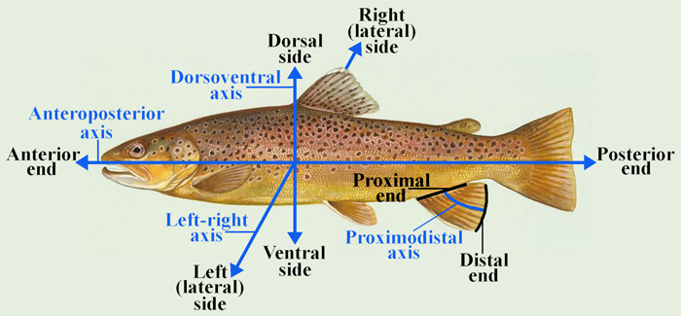

Vestigial
Occurring as a structure that, once functional (whether during development or in earlier evolutionary forms), is now reduced or degenerate. An example is the vestigial pelvic girdle seen in many snakes, including the boas and pythons, which bears no function.

Z

Zygapophysis
Articular process of a vertebra that articulates with the corresponding process of an adjacent vertebra.
Plural = zygapophyses

