Vertebrate Palaeontology and Evolution study pack

This resource is designed to familiarise you with the structure, diversity and evolutionary history of vertebrates through analysing images of specimens held at UCL’s Grant Museum of Zoology. It contains seven chapters: an introduction to vertebrate diversity, Fishes, the fish-tetrapod transition, Amphibians and Amniotes, Lepidosaurs and Chelonians, Archosaurs, and Birds and flight. All images have accompanying text, including information about the specimen plus hints about what to look for and the questions to consider when analysing the images. Please note that this resource does not look at mammals in detail – instead, this fascinating group are given a more thorough treatment in another Object Based Learning for Higher Education (OBL4HE) resource entitled ‘Vertebrate Diversity’ and the Virtual Educational Resource for the Biosciences (VERB) resource ‘Eutherians’.

- Verb Diversity: https://open-education-repository.ucl.ac.uk/id/eprint/204
- Eutherians (VERB): https://open-education-repository.ucl.ac.uk/id/eprint/210

Scalebars are provided throughout (except for models). Please note that there are two different scale bars used, one with 1cm divisions and one with 0.5cm divisions.

Multiple images of specimens are provided to try to illustrate the various anatomical features. However, please note that the limitations of photography (especially for specimens in cases or bottles) means that some distortion may occur or parts may be concealed or generally hard to determine.

To download this resource in its entirety, see the resource's collection page: https://open-education-repository.ucl.ac.uk/195/

Disclaimer: 'Vertebrate Palaeontology and Evolution' was originally designed by UCL staff as an internal teaching resource. The subsequent release of 'Vertebrate Palaeontology and Evolution' as an OER means that any changes to the product received relative to the original content may not reflect the desires of UCL teaching staff, or the original quality of the resource.

CC BY-NC-SA 4.0 International Licence: 'Vertebrate Palaeontology and Evolution' has been released as an open educational resource (OER) on a Creative Commons 'Attribution Non-commercial Share Alike' license. This means that once downloaded, content can be modified and improved to complement a particular course. This requires, however, that improvements are recycled back into the OER community, and full attribution is made to UCL. All content present at the time of download must be accordingly credited and, in turn, novel content must be appropriately licensed. For more information, please refer to the license deed by visiting: https://creativecommons.org/licenses/by-nc-sa/4.0/legalcode

Chapter 3: The fish-tetrapod transition

This chapter examines the lobe-finned fish and some early tetrapods.

Contents
Chapter 3: The fish-tetrapod transition 2
3.1 Coelocanth 5
3.2 Dipterus 6
3.3 Dipnoi 6
3.4 Rhizodus 7
3.5 Osteolepis 8
3.6 Eusthenopteron 9
3.7 Megalocephalus 11
3.8 Trematosaurus sp. 12
3.9 Rhinesuchoides 13
3.10 Paratosaurus peabodyi (Wellesaurus) 15
3.11 Dendrerpeton pyriticum 17
3.12 Cochleosaurus sp. 17
3.13 Broilellus texensis 18
3.14 Diplocaulus sp. 20
3.15 Palaeoherpeton sp. 21
3.16 Seymouria 23
3.17 Other taxa 25
Glossary 26

3.1 Coelocanth

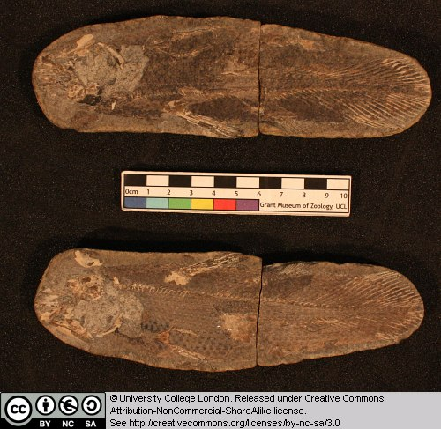

This is a fossil coelacanth from a nodule, preserved in four parts. Note the presence of some skull bones, scales, vertebrae and fin rays. Can you identify the dorsal fins and symmetrical tail that are typical of derived sarcopterygians?

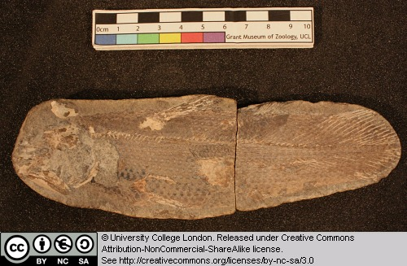

Coelocanths are still alive today (as seen here for example) with populations in the Indian Ocean around South Africa and Indonesia.

3.2 Dipterus

This is a lungfish from the Devonian. It is essentially complete. Try to find the following features: the head and eye region, the paired fins, the dorsal fins, the tail (is it symmetrical or heterocercal?).

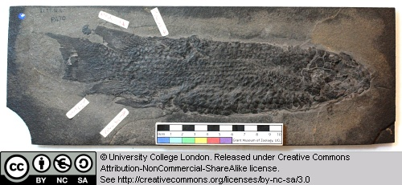

Note the scale pattern on this animal.

3.3 Dipnoi

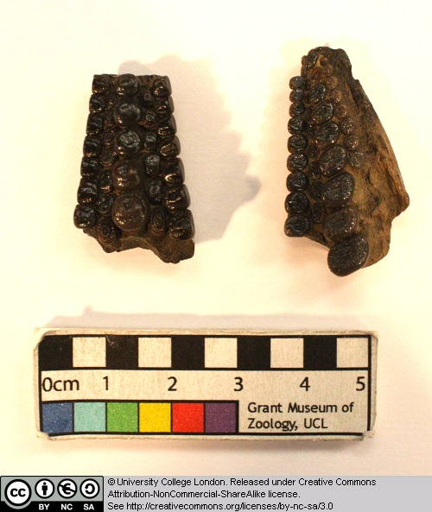

These specimens are tooth plates belonging to lungfish. What types of food can lungfish tackle with such a dentition?

3.4 Rhizodus

Rhizodonts were large sarcopterygian fish from the Carboniferous. Some grew to gigantic sizes (7 metres long), and can be recognised by their large rounded plate-like scales and their long curved teeth. It has been proposed that rhizodonts may have lunged up onto shores and river banks in order to grab terrestrial prey.

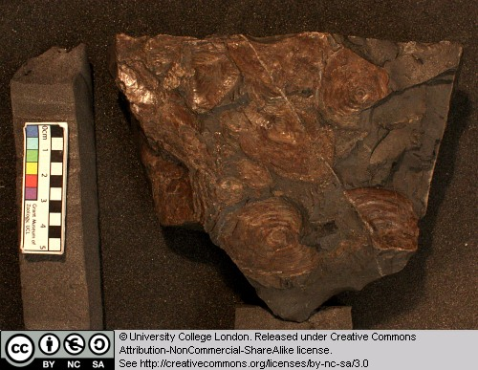

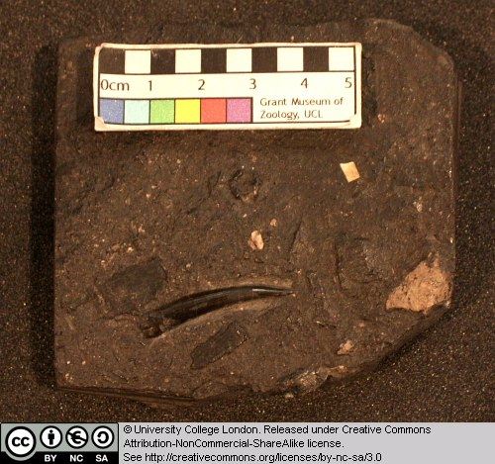

3.5 Osteolepis

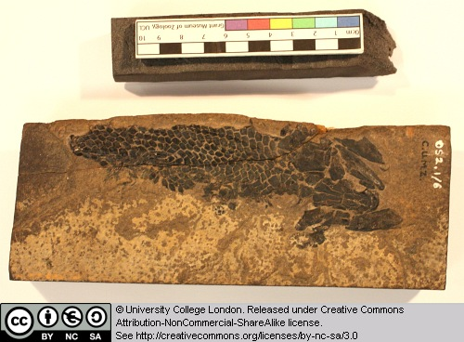

This is a nearly complete specimen, lacking the tail. Osteolepis is a relatively primitive member of the osteolepiform fish group that includes Eusthenopteron, Panderichthys and tetrapods. Note the scales and the general form of the head.

3.6 Eusthenopteron

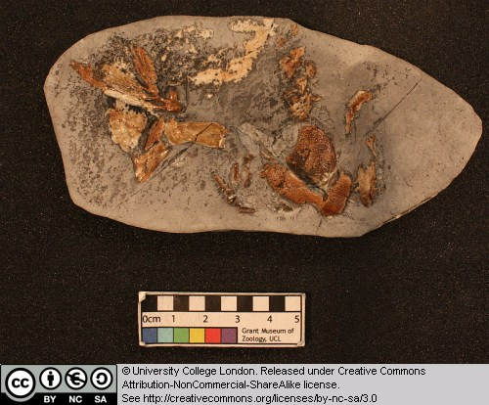

This is the skull and pectoral fin of a derived osteolepiform fish. Pay particular attention to the structure of the main fin elements. Can you identify the three main bones that, in tetrapods, would be called the humerus, radius and ulna?

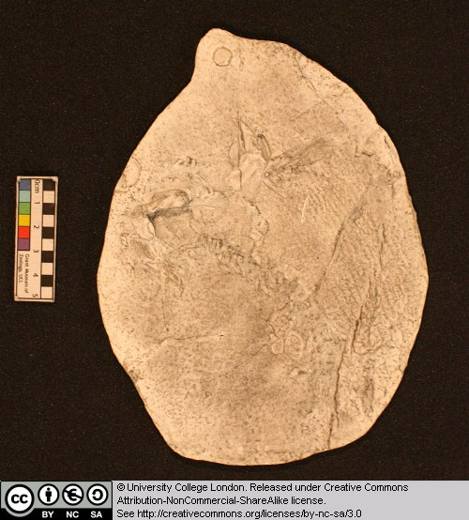

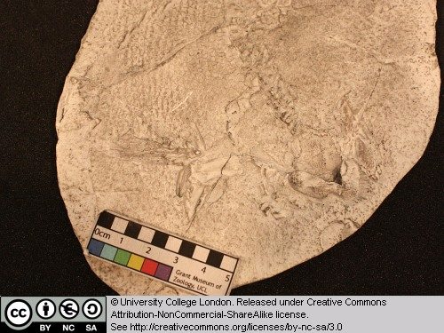

3.7 Megalocephalus

Megalocephalusis a member of a group of early tetrapods called loxommatids. Loxommatids (also called baphetids) appear in the Early Carboniferous, but were most common during the later part of this period. This group is known from a few skulls and mandibles, but virtually nothing is known about their postcranial skeletons. Baphetids can be recognised by the possession of one clear derived character state: the orbit (eye socket) is extended forward, giving this opening a ‘keyhole’ shape.

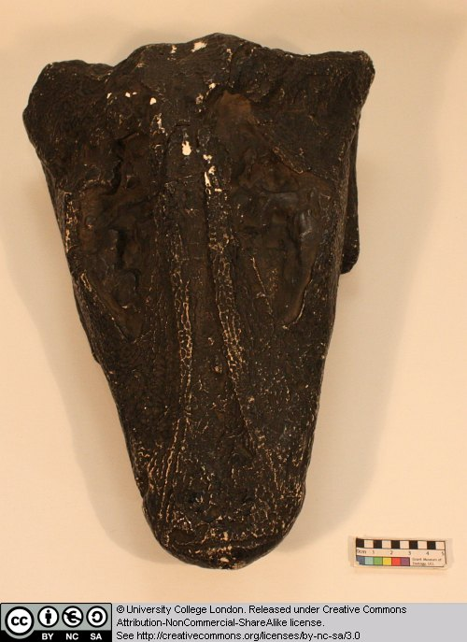

What animal does this skull remind you of – and what do you think Megalocephalus ate?

3.8 Trematosaurus sp.

This is a trematosaurid temnospondyl. Temnospondyls were a highly successful group during the Late Carboniferous, and several forms are also known from the Permian and later. During the Late Carboniferous, some temnospondyls became rather crocodile-like and developed an elongate snout.

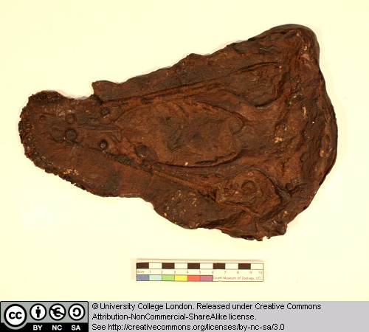

Can you detect the outlines of large openings on the palate (the roof of the mouth)? These large openings are characteristic of all temnospondyls.

3.9 Rhinesuchoides

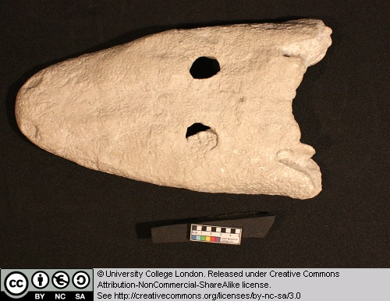

This is the skull of a temnospondyl from the Late Permian of South Africa. Note the presence of the small orbits on the top surface of the rather dorsoventrally flattened head. Can you detect the otic notch and large palatal vacuities that characterise temnospondyls?

Look for a small V-shaped notch along the back margin of the head [otic notch], and the outline of large oval openings on the roof of the mouth [palatal vacuities].The last image shows the skull in palatal view.

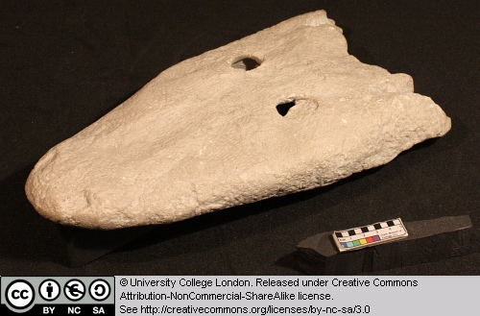

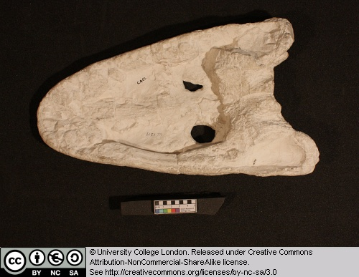

3.10 Paratosaurus peabodyi (Wellesaurus)

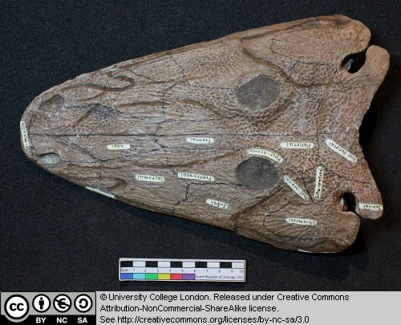

This is the skull of a temnospondyl. Make sure you can detect the large palatal vacuities on the roof of the mouth that characterise this group of early tetrapods.

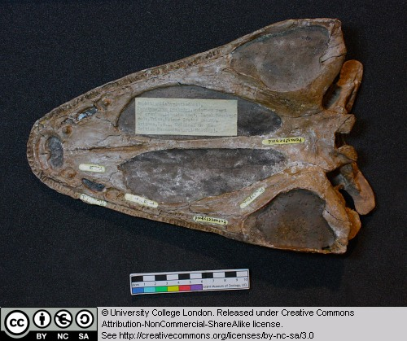

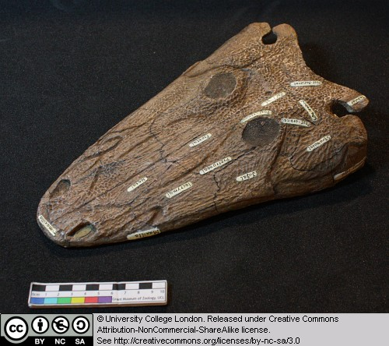

3.11 Dendrerpeton pyriticum

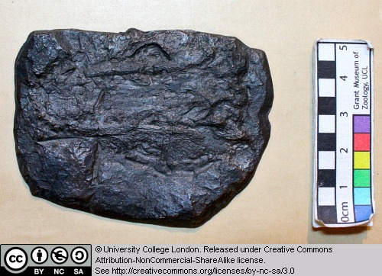

This is a cast of the skull of a temnospondyl from the Late Carboniferous. Can you identify the large palatal openings and otic notch that characterise this group of early tetrapods. The otic notch is a V-shaped slot, one on either side of the skull, on its back margin.

3.12 Cochleosaurus sp.

This is the cast of the skull of a cochleosaurid temnospondyl. Note the broadly rounded snout. It is thought that cochleosaurs were ‘gulping’ aquatic predators.

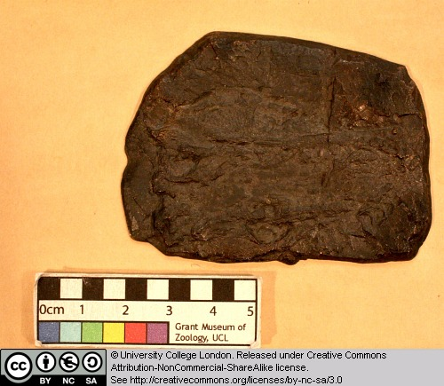

3.13 Broilellus texensis

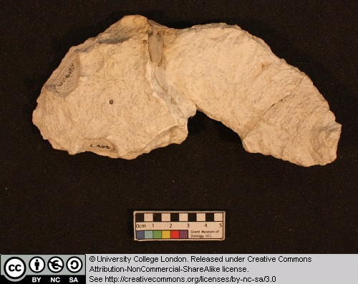

This is a cast of an eryopid temnospondyl. Eryopids were often terrestrial forms that were common during the Permian. They were broad-snouted forms that grew up to 2 metres in length.

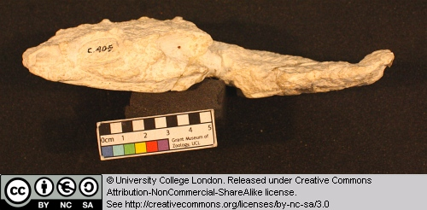

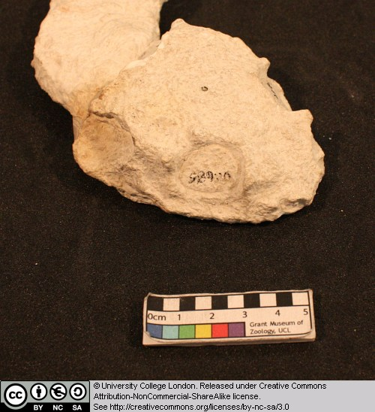

3.14 Diplocaulus sp.

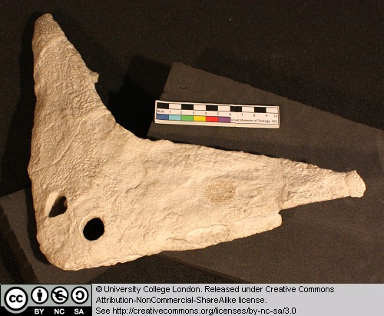

This is the skull of a nectridean. These strange early tetrapods lived during the Late Carboniferous and Early Permian. Note the way the skull is dorsoventrally flattened and possesses large prong-like horns from the posterolateral corners. These animals may have lurked at the bottom of rivers and lakes, waiting for prey to swim over them. Then, using a powerful tail and lift generated by water passing over the wing-like horns, they may have attacked the prey from below.

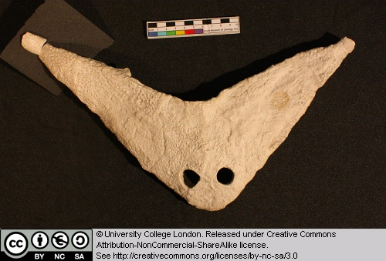

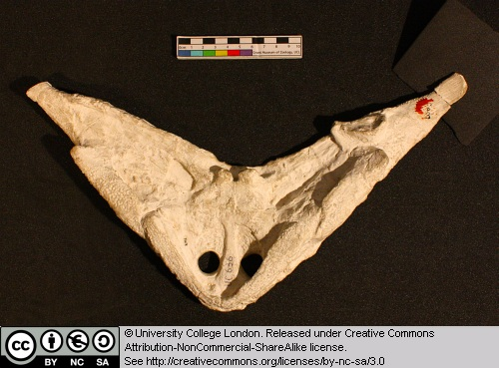

3.15 Palaeoherpeton sp.

Anthracosaurs appear in the early Late Carboniferous as small-to-medium terrestrial forms. During the Late Carboniferous they gave rise to the large, elongate, embolomeres – crocodile-like creatures that ate fish and lived in the coal swamps. The last anthraosaurs are known from the Early Triassic of Russia.

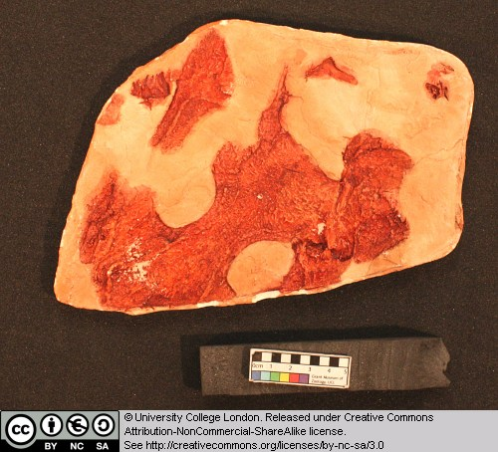

These specimens are casts of the skull of an anthracosaur in dorsal and ventral views. Note that there is no sign of large palatal vacuities on the palatal surface (the roof of the mouth).

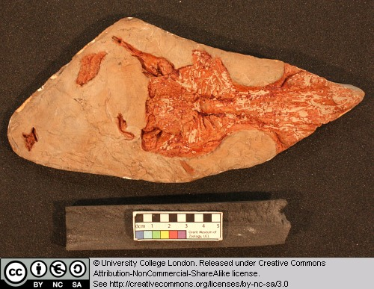

3.16 Seymouria

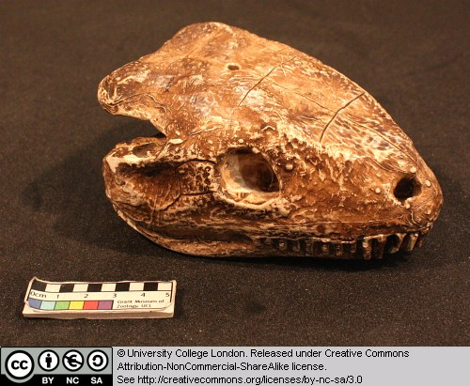

This specimen is a cast of the skull of Seymouria. Members of the Seymouriamorpha are thought to be close relatives of the amniotes (the group that contains mammals, lizards, snakes, crocodiles, turtles and birds).

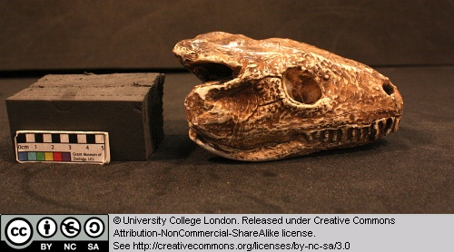

Observe the general form of the skull, the presence of orbits and the forwardly placed nostrils, the teeth etc.

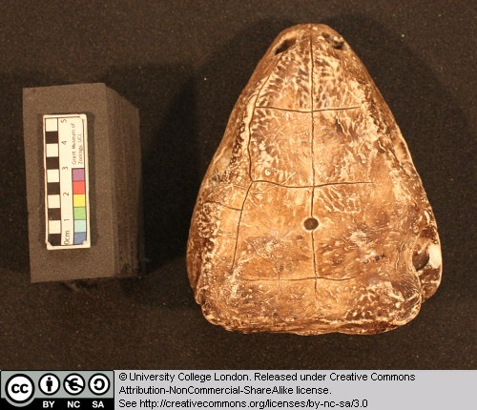

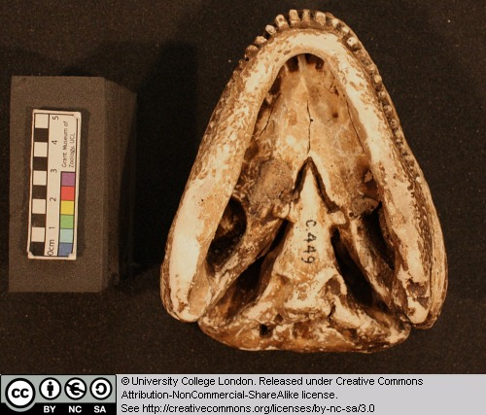

3.17 Other taxa

In this chapter we also revist Raja and Amia from Chapter 1 and Clupea and Pterapsis from Chapter 2.

Glossary

A

akinetic
In anatomy, this refers to a low level of flexibility in a structure due to a lack of moveable joints.

amniote
Those vertebrates with an amniotic egg. The extant clades are Testudines (turtles), Diapsida (lepidosaurians, crocodilians, and birds), and Synapsida (mammals).

anapsid
Skull possessing no temporal fenestrae (NB. an- = without).
Amniotes with this skull condition form a paraphyletic group including the Parareptilia (turtles and their extinct relatives), the extinct common ancestor of all amniotes, and basal eureptiles (the extinct precursors of diapsids).
Note that the Testudines (turtles and relatives) have modified the anapsid condition through a reduction (emargination) of the posterior region of the skull.

Apatite
Calcium phosphate: the crystalline component of bone.

apomorphy
A derived or specialised character.

Appendicular skeleton
The endoskeletal element of the fins or limbs of a vertebrate, and their associated girdles (pectoral or pelvic).

Axial skeleton
All parts of the vertebrate endoskeleton except the limbs or fins and their associated girdles. That is, the cranium, visceral skeleton, notochord, vertebrae, and ribs.

B

Basal
Of, relating to, located at, or forming a base.

Bicuspid
A tooth bearing two cusps.

C

Calcified cartilage
Cartilage strengthened with a scattering of apatite crystals (calcium phosphate), as seen in Chondrichthians.

Cartilage
A tough, elastic, fibrous connective tissue composed of collagen fibres. Used as skeletal tissue in vertebrates, it is non-mineralised and is often the developmental precursor of bone.

Clade
A phylogenetic lineage comprising a common ancestor and all its descendant species.
Note that the difference between a taxon and a clade is that a clade must include all descendant species from a common ancestor, whereas a taxon need not.

cladistic
Relating to the branching sequences of phylogeny.

cladogram
A branching tree-like diagram representing the phylogenetic relationships (evolutionary history) of a lineage.

cloaca
The common opening for the reproductive, urinary, and digestive tracts, seen in all vertebrates except therian mammals (marsupials and placental mammals).

The term comes from the Latin for sewer.

Cursorial
Adapted for running.

Cusp
The biting point of a tooth.

D

Dentary
The anterior bone of the lower jaw which bears the teeth. It forms the whole of the lower jaw in mammals.

Dentine
A bone-like substance, lacking cell bodies and consisting mainly of calcium phosphate (apatite) in a fibrous matrix.

Dermal bone
A type of bone forming within the dermis - the deep layer of vertebrate skin cells below the surface layer, the epidermis.

diapsid
Skull possessing both an upper and a lower temporal fenestra (NB. di- = two).
Amniotes with this skull condition form the monophyletic clade Diapsida, which includes the lepidosaurs (lizards, snakes, and tuatara), archosaurs (crocodilians, dinosaurs, and birds), and their other extinct relatives.
Note that some diapsids, such as lizards, have lost the temporal bar separating the fenestrae to form one large window. Others, such as the Aves (birds), have merged both fenestrae with the orbit.

E

Enamel
The crystalline material covering the crown of a tooth, or certain scales.

Endopterygota
A clade of insects charachterised by their undergoing complete metamorphosis (i.e. holometabolous).
See Insect Diversity WebBook for the clades within (from Neuroptera down).

Epidermal
Pertaining to, or originating from, the epidermis - the surface layer of skin cells in vertebrates

euryapsid
Skull possessing an upper temporal fenestra only.
However, animals with this skull condition do not represent an important amniote lineage, as they are likely to be a polyphyletic group, originating a least twice within the Diapsida. Euryapsids include the plesiosaurs and ichthyosaurs - Mesozoic marine reptiles.

extant
Not extinct.

F

fossorial
Specialised for burrowing.

furcula
The fused clavicle bones of a bird, also known as the wishbone.

H

Hemimetabolous
Refers to a type of insect development that is categorised by three distinct, progressive life stages: egg, nymph, imago (adult). Changes are gradual, with no pupal stage.
Some hemimetabolous insects include grasshoppers, cicadas, cockroaches, termites, earwigs, and dragonflies.
Also termed incomplete metamorphosis.

Holometabolous
Refers to a type of insect development that is categorised by four distinct, progressive life stages: embryo, larva, pupa, imago (adult).
Seen exlusively in the Endopterygota, which includes beetles, butterflies, wasps, bees, ants, and others.
Also termed complete metamorphosis.

Horny
Consisting of horn - a tough material composed mainly of keratin.

I

ilium
In tetrapods, the dorsal section of the pelvis, which articulates with one or more sacral vertebrae.

K

Kinetic
In anatomy, referring to a high level of flexibility afforded by numerous moveable joints.

L

Lymph heart
Muscular dilation in a lymph vessel, which pumps lymph (fluid containing white blood cells called lymphocytes important in immune response) around the body of some lungfishes, amphibians and reptiles.

M

Metacone
In mammals, the metacone is the distobuccal (rear-most and cheek side) cusp of an upper molar tooth.

monophyletic
Having a single evolutionary origin. A taxon is monophyletic if it contains all the descendants of a common ancestor.

For example, mammals are a monophyletic group, as all species descended from the first known mammal are considered mammals.

See paraphyletic and polyphyletic for alternative terms.

Myrmecophagy
Feeding behaviour categorised by an exclusive (or near exclusive) diet of ants ant termites.

O

Orbit
The bony socket of the eye.

Osteosclerosis
An increase in the density of bone.

P

Pachyostosis
A thickening of the bone, often associated with a reduction in the volume of marrow tissue contained within.

Paracone
In mammals, the paracone is the mesiobuccal (front-most and cheek side) cusp of an upper molar tooth.

Paraphyletic
A taxon including a common ancestor and some but not all of its descendants.
For example, the class Reptilia is paraphyletic, as it does not include birds, who are considered a separate class: Aves. However, birds evolved from theropod dinosaurs, and are therefore reptiles themselves. Similarly, all tetrapods are, evolutionarily speaking, lobe-finned fish.
Importantly, reptiles can be made monophyletic through the addition of birds to the taxon.
See monophyletic and polyphyletic for alternative terms.

Pectoral girdle
In vertebrates, the skeletal structure that provides support for the fore limbs or fins.

Pelvic girdle
In vertebrates, the skeletal structure that provides support for the hind limbs or fins, which also fuses with the sacral vertebrae.

phylogeny
The evolutionary history of organismal lineages as they develop through time.

plesiomorphy
An ancestral character.

polyphyletic
Referring to a group that does not contain the common ancestor of all the taxa within. Therefore, this is not a true taxonomic group, but is often a term used to categorise organisms with a similar ecology, such as insectivorious mammals, or marine mammals.
It is also used when the evolutionary origin of a group, such as snakes, is unsure, and characteristic species within may have originated separately.

Protocone
In mammals, the protocone is the mesiolingual cusp of an upper molar tooth.

Pulp cavity
The space within a tooth, or a dentine scale, occupied by blood vessels and nerves.

S

symplesiomorphy
A character that is shared between groups but was inherited from an ancestor prior to the last common ancestor.
These are characters that - at the level at which they are referred to as symplesiomorphies - are not used to form cladistic groupings, or clades.

synapomorphy
A derived or specialised character that is shared between two or more groups, and was inherited from the common ancestor in which it originated.
These are the characters that morphological systematists use to support the existence of particular clades, forming the basis of the field of cladistics.

synapsid
Skull possessing a lower temporal fenestra only.
Amniotes with this skull condition form the monophyletic clade Synapsida, which includes the mammals and their extinct ancestors, the non-mammalian reptile-like synapsids.
Note that in the Mammalia, the lower temporal fenestra has merged with the orbit.

T

taxon
A group of organisms sharing a common ancestry.
Note that the difference between a taxon and a clade is that a clade must include all descendant species from a common ancestor, whereas a taxon need not.
Pl. taxa.

temporal fenestra
An opening in the temporal region of the skull seen in amniotes, providing a flat edge for the attachment of strong lower jaw closing muscles to the skull.
Amniotes show four skull types, based on the position and number of these temporal fenestrae, two of which define two major lineages of the amniotes. The skull types and associated groups are as follows:
1) Synapsid - Skull possessing a lower temporal fenestra only. Amniotes with this skull condition form the monophyletic clade Synapsida, which includes the mammals and their extinct ancestors, the mammal-like reptiles. Note that in the Mammalia, the lower temporal fenestra has merged with the orbit.
2) Diapsid - Skull possessing both an upper and a lower temporal fenestra (NB. di- = two). Amniotes with this skull condition form the monophyletic clade Diapsida, which includes the lepidosaurs (lizards, snakes, and tuatara), archosaurs (crocodilians, dinosaurs, and birds), and their other extinct relatives. Note that some groups within the Diapsida, such as lizards, have lost the temporal bar separating the fenestrae to form one large window. Others, such as the Aves (birds), have merged both fenestrae with the orbit.
3) Anapsid - Skull possessing no temporal fenestrae (NB. an- = without). Amniotes with this skull condition form a paraphyletic group including the Parareptilia (turtles and their extinct relatives), the extinct common ancestor of all amniotes, and basal eureptiles (the extinct precursors of diapsids). Note that the Testudines (turtles and relatives) have modified the anapsid condition through a reduction (emargination) of the posteriorregion of the skull.
4) Euryapsid - Skull possessing an upper temporal fenestra only. However, animals with this skull condition do not represent an importantamniote lineage, as they are likely to be a polyphyletic group, originating a least twice within the Diapsida. Euryapsids include the plesiosaurs and ichthyosaurs - Mesozoic marine reptiles.

V

vertebrae
From anterior to posterior:
Cervical vertebrae: Facilitate the mobility of the head. The first two, the atlas and the axis are highly specialised, the former articulating with the occipital region of the skull.
Thoracic vertebrae: Articulate with the ribs that fuse with the sternum.
Lumbar vertebrae: Generally larger, with small ribs not attached to the sternum, which support the posterior musculature.
Sacral vertebrae: Fused to the pelvic girdle, allowing the transfer of force from the appendicular skeleton (limbs) during locomotion.
Caudal vertebrae: Small and less specialised, forming the tail.

Vertebrate anatomical directions and axes
The image below illustrates the terms used for anatomical directions and axes in vertebrates.
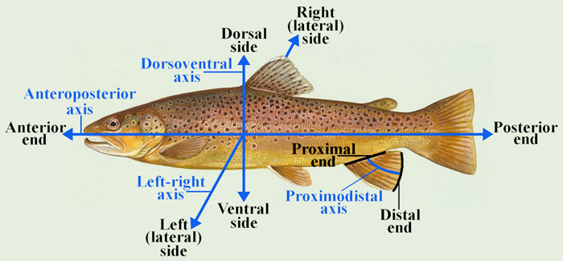

Vestigial
Occurring as a structure that, once functional (whether during development or in earlier evolutionary forms), is now reduced or degenerate. An example is the vestigial pelvic girdle seen in many snakes, including the boas and pythons, which bears no function.

Z

Zygapophysis
Articular process of a vertebra that articulates with the corresponding process of an adjacent vertebra.
Plural = zygapophyses

