Man: A Course of Study (MACOS)

Audio and Visual Materials

Collection of eleven portraits of a Netsilik family

- Materials can be downloaded or purchased from the MACOS Online Site

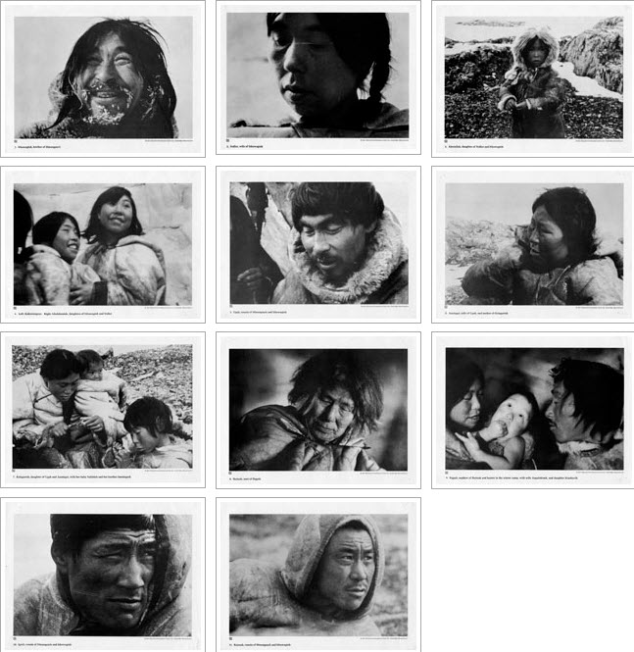

Articles listed in the database ERIC (Education Resource Information Centre)

- BOOST YOUR BATTERY Opens in a new window Collins, Barry PC Pro [London] 01 Mar 2019 : pp. 30 (Jan 18, 2019)
  - Formats: Citation/Abstract, FindIt@UCL
- One last thing... Opens in a new window Honeyball, Jon PC Pro [London] 01 Mar 2019 : pp. 130 (Jan 18, 2019)
  - Formats: Citation/Abstract, FindIt@UCL
- Did I mention there's no 'select all' feature? Yet another symptom of a lack of basic business thinking Opens in a new window Honeyball, Jon PC Pro [London] 01 Mar 2019: pp. 110-113 (Jan 18, 2019)
  - Formats: Citation/Abstract, FindIt@UCL
- Switch your business to Chrome OS Opens in a new window Winder, Davey PC Pro [London] 01 Mar 2019 : pp. 104-107 (Jan 18, 2019)
  - Formats: Citation/Abstract, FindIt@UCL
- I'm guessing that there will be cars in their hundreds and thousands that will never get patched Opens in a new window Winder, Davey PC Pro [London] 01 Mar 2019 : pp. 118-120 (Jan 18, 2019)
  - Formats: Citation/Abstract, FindIt@UCL

Newsam Library Holdings
The Newsam Library has the following materials from the MACOS curriculum project:
Two complete sets of Netsilik Eskimo family images
Twelve 8 mm film cartridges:

- At the Autumn River Camp. Parts 1, 2, 3, 4
- At the Winter Sea Ice Camp. Parts 1, 2 3, 4
- Fishing at the stone weir. Parts 1, 2
- Life cycles of the salmon
- Herring gull behaviour

Course Materials

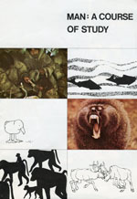

Link: http://www.macosonline.org/course/

