Man: A Course of Study (MACOS)

The Controversy

MACOS: Controversy

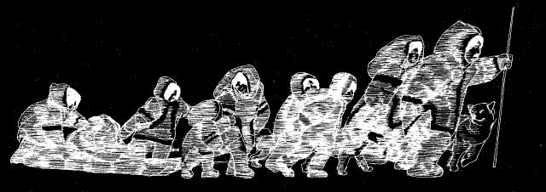

The MACOS curriculum developers began with the idea that if children were taught how to understand human behaviour, they would be more likely to become better adults and ensure the survival of the (American) human race against "the catalogue of problems they will face: the rising crime rate, the breakdown of urban life; the population boom; the energy crunch; the ecocrisis; health care; ethnic and racial conflicts;and our global economic, political and military challenges - not to mention the search for useful employment", as Peter Dow, the Project Director stated a decade after the MACOS programme was launched.*

MACOS attempted to promote scientific literacy, i.e. "to help children learn to think like social scientists". However by the early 1970s under the Nixon administration in America, there was a widespread distrust of government funded educational projects and MACOS received a lot of negative publicity. As Dow explains, the first sign of impending trouble appeared in a school (the Minnie J. Niblack Elementary) in Lake City (a small town in northern Florida) which was under court integration order and which had implemented the MACOS programme to ease existing racial tensions. A sixth-grade pupil's father (a Baptist Minister by the name of Reverand Don Glenn) asked for copies of the MACOS materials from the teacher (Dow 1991, p.178).

Reverend Glenn formed a study group to examine the MACOS materials in detail and then claimed that the materials were a threat to democracy, he said in a four-hour long programmes on radio that they advocated evolution, a 'hippie-yippee philsophy', pornography and gun control and tried to prove his case by reading from the teacher and pupil materials. This led to much negative publicity with the programme being debated in Congress in 1975 and the National Science Foundation, the government department that had funded the programme, being audited for its management of the project which resulted in the downsizing of the Education Directorate and a cut in the number of funded programmes for a whole decade following this controversy.
*Source: Dow, P.B. (1975). "MACOS: The Study of Human Behaviour as One Road to Survival. The Phi Delta Kappan, 57(2), pp.79–81. Available via JSTOR at: http://www.jstor.org/stable/20298151 [Accessed June 29, 2017].

Documentary Film on MACOS: 'Through These Eyes' (Charles Laird, 2004)
Through These Eyes Charles Laird, National Film Board of Canada

Comments by Parents & Teachers
- Comments on the (Hu)mans: A Course of Study site
- Comments on the film 'Through These Eyes'
- Metafilter Community Weblog

