**INSERT MODULE TITLE**

**Formative Assignment – Guidance Notes**

**Create a Google Account**

To create your LRS you will need a Google account. If you already have a Google account you can skip these steps and go directly to ‘Creating your Learning Record Sheet’ below.

There are two ways to create a Google account.

1. Create a Google account using your INSERT INSTITUTION’S NAME email address. To do this click on the following link and complete all the required fields: <https://tinyurl.com/jmp8vpl>

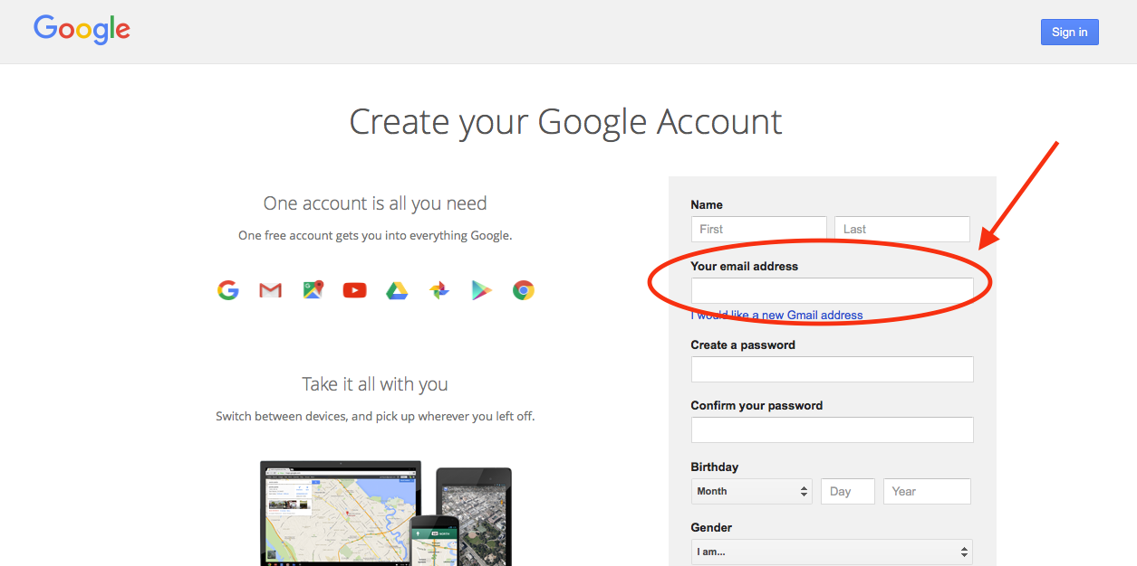

In the ‘Your email address’ box, fill in your INSERT INSTITUTION’S NAME email address.

1. Create a Google account and email address. To do this click on the following link and complete all the required fields: <https://tinyurl.com/jcuawgx>

**Creating your Learning Record Sheet**

1. You will receive an email from the Module Leader with a link to the template of the INSERT MODULE TITLE LRS. Click on the link. This will open the template in ‘view only’ mode.
2. Click on ‘File’.

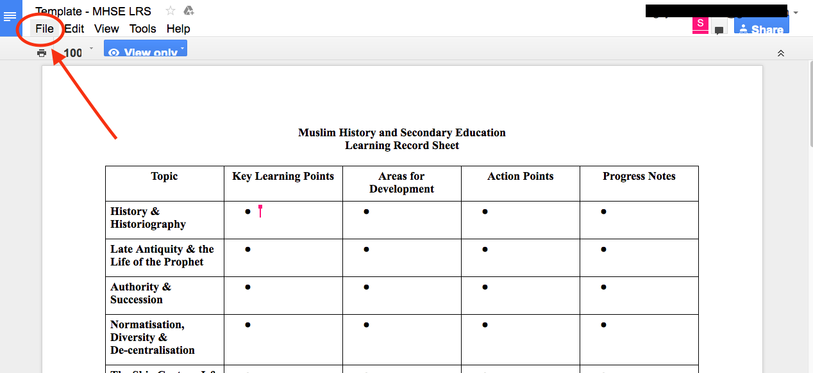

1. Click on ‘Make a copy’.

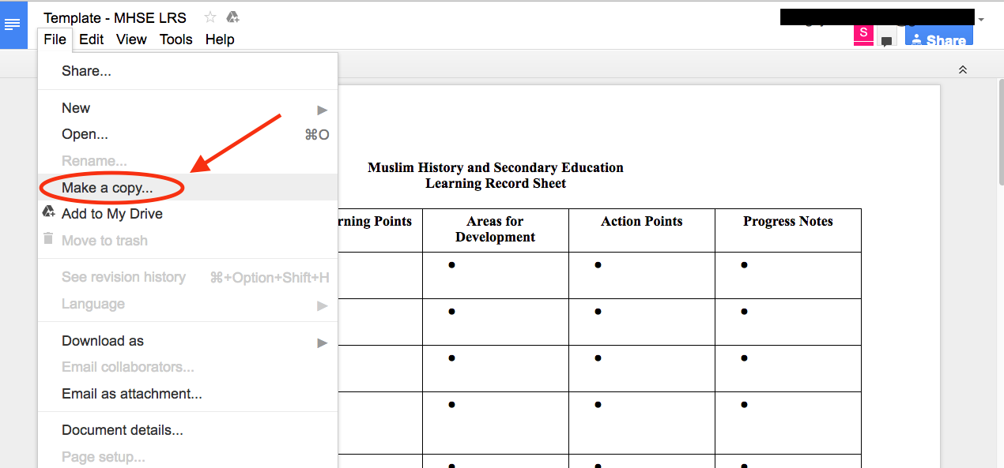

1. Save the file as follows: [First Name] [Last Name] – INSERT MODULE TITLE LRS

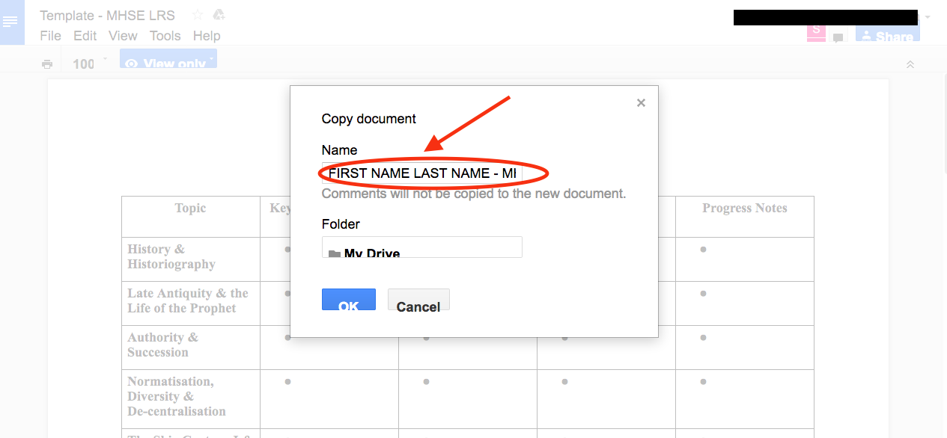

1. So that I can see your LRS, you will have to share the file with me. Click on ‘Share’.

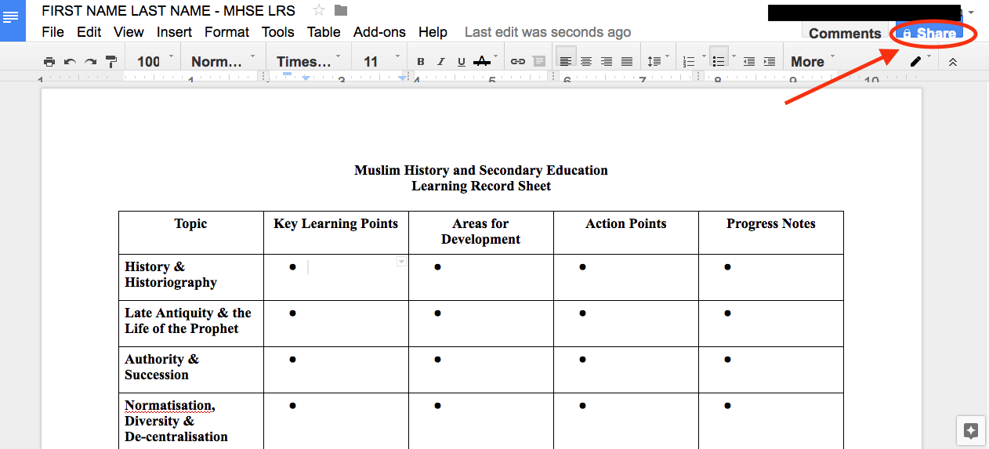

1. Type in my email address – INSERT LECTURER’S EMAIL ADDRESS

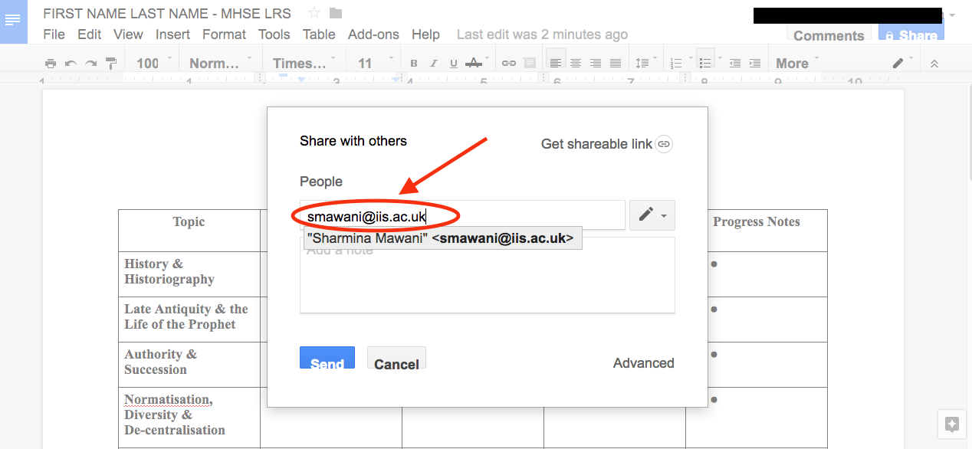

1. Select ‘Can edit’ and click on ‘Send’.

